Atomic structure and the Sun

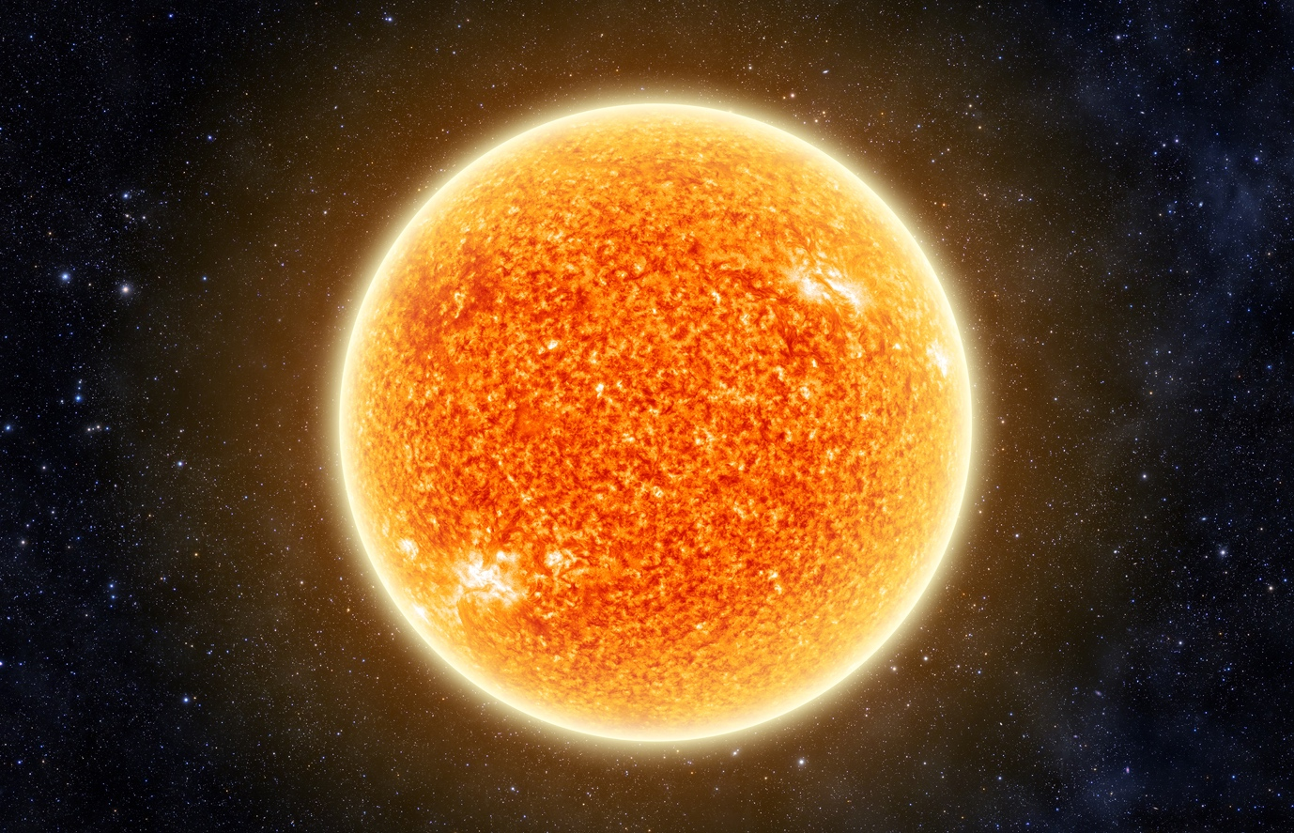

Source: © Shutterstock

The Sun is our star. Most stars in our galaxy, including the Sun, are 74% hydrogen, 24% helium with the other 2% being made up of other elements such as carbon, nitrogen and oxygen.

1. Hydrogen has three isotopes. All three isotopes are found in the Sun.

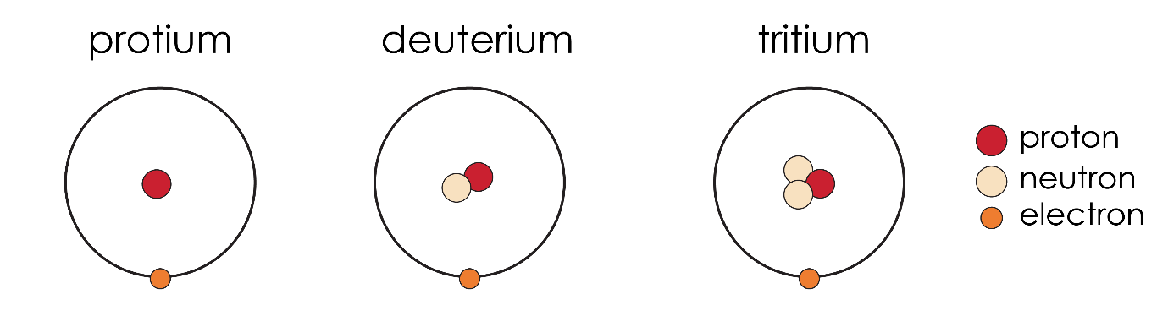

* 1. Complete the table to show the number of protons, neutrons and electrons in each of the hydrogen isotopes.

|  |  |  |  |
| --- | --- | --- | --- |
| **Isotope** | **Number of protons** | **Number of neutrons** | **Number of electrons** |
| protium |  |  |  |
| deuterium |  |  |  |
| tritium |  |  |  |

* 1. The symbol for protium is .

Label the diagram to show the meaning of each of the numbers in the symbol using two of the following words:

mass neutron atomic electron

________________ number

________________ number

* 1. The symbol for deuterium . Write a similar symbol for tritium.
  2. Explain why protium, deuterium and tritium are isotopes.

1. Chemistry happens in the high temperatures of the Sun that would not normally take place on earth. Hydrogen atoms lose their electrons to become hydrogen nuclei.
   1. The symbol for a protium nucleus is +.

Explain why a protium nucleus has a positive charge.

* 1. Write symbols for:
     1. a deuterium nucleus ________________________________________________
     2. a tritium nucleus ____________________________________________________

In the high temperatures of the Sun, hydrogen nuclei combine to form larger nuclei. These are nuclei of a different element. They will have different numbers of protons and neutrons.

* 1. If two hydrogen nuclei combine, how many protons will the new nucleus have?
  2. Use the periodic table to find the name of the new element produced.

1. The reactions in the Sun are called fusion reactions. They are very exothermic. Scientists are attempting to develop fusion reactions using deuterium and tritium as a source of energy on Earth.
   1. What is an exothermic reaction?
   2. One out of every 6420 hydrogen atoms on Earth is deuterium. What percentage of naturally occurring hydrogen is deuterium? Give your answer to three significant figures.

Scientists are investigating using sea water as a source of deuterium. Water containing deuterium is sometimes called heavy water.

* 1. What is the relative formula mass of heavy water?

Assume a molecule of heavy water contains two atoms of deuterium.

*A*r deuterium 2; *A*r oxygen 16

* 1. What is the percentage by mass of deuterium in this heavy water?

Which question(s) did you get wrong? Why?

What will you do next time you’re asked a similar question?