Bonding bingo: bonds and properties of substances

This resource is from the Assessment for learning series which can be viewed at: rsc.li/44jTX18. This series contains lesson plans and associated resources to actively involve students in their learning.

Resource components
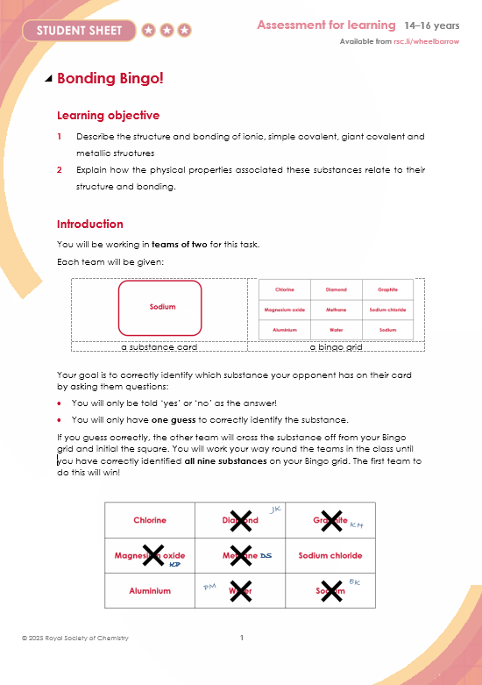 | 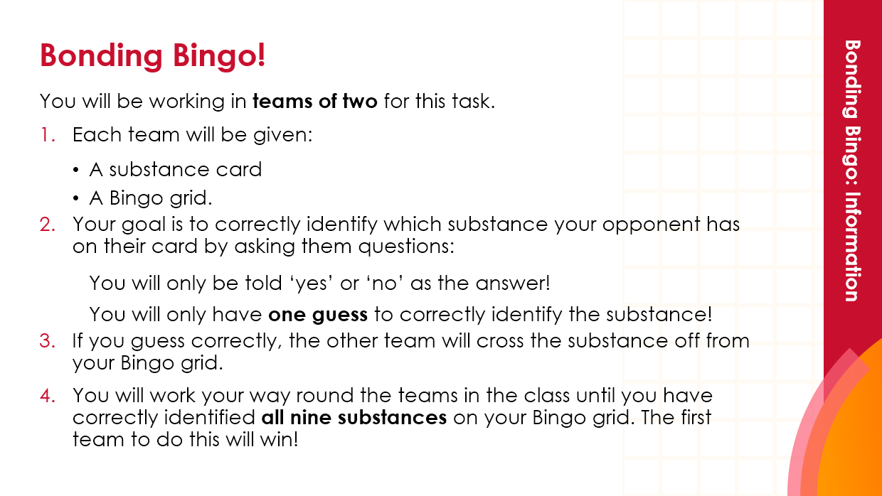
Student sheet: instructions on how to play the game and a blank sheet to write down yes/no questions. | Presentation: slides include learning objectives, introductory task, learner-facing instructions and reflection task.

Learning objectives
- Describe the structure and bonding of ionic, simple covalent, giant covalent and metallic structures.
- Explain how the physical properties associated with these substances relate to their structure and bonding.

In the introduction task, learners will identify key similarities and differences between the structure, bonding and physical properties of sodium chloride and iron.

Learners will answer ‘yes’ and ‘no’ to questions about an allocated structure type, which will check their understanding of key structure and bonding characteristics. Learners will also need to construct their own series of questions to help them to identify a peer’s substance. This will require them to fully understand the key identifying characteristics of different structures and their chemical bonding.

Teaching sequence

Introduction: sodium chloride vs iron (slides 3–6)
- Introduce the two key substances, sodium chloride and iron. Distribute mini whiteboards.
- Ask learners to write down on their mini whiteboards one similarity between the structure or properties of sodium chloride and iron.
As a challenge, specify if learners have to find a similarity between bonding, structure or properties.
- Ask learners to compare their answers to their neighbours’ responses.
Encourage learners to identify if their statements are a comparison of the bonding, structure or properties of the two substances.
- Come together as a group and review the key similarities.
- Repeat the task, but this time ask learners to identify one difference between the structure or properties of sodium chloride and iron.

Bonding bingo: information (slide 7)
- Group learners into teams of two.
- Explain the goal of the task: to identify the substances that opposing teams have on their card, eventually crossing off all nine substances from their bingo grid.

Bonding bingo: preparation (slide 8)
- Emphasise that teams have 10 minutes before the game starts to devise and write down questions:
- which have a yes or no answer,
- that will help to identify which substance is being described.
- Give each team a ‘Bonding bingo student sheet’ to write down their questions, available to download from: rsc.li/3lLvZ67. For extra support, move around the teams as they devise their questions and offer prompts as needed.
- Display the nine possible substances to guide learner thinking.

Bonding bingo: rules (slide 9)
- Give each team one ‘Bingo grid’ and one ‘Substance name card’ (several pairs may have the same name).
- Explain the rules of Bonding bingo:
- A team sits with another team.
- They toss a coin to decide which team asks questions first.
- The questioners have to find out what substance is on the other team’s substance name card by asking the questions on their sheet. They will only be told ‘yes’ or ‘no’ as the answer to each question. They will only have one guess to correctly identify the substance.
- If it is correct, the other team initials the substance square on the questioners’ bingo card.
- The roles are now reversed with the opposite team asking and answering questions.
- The process is repeated around the room until one team correctly identifies all nine substances and shouts ‘bingo’!

Reflections (slide 10)

Bring learners together in a plenary. Ask:
- Which substances did you find easy to identify?
- Which substances did you find more difficult to identify?
- Which questions helped you the most and which were less useful?

Provide suitable small prizes for the winners of Bonding bingo.

Encourage learners to reflect on this activity by rating their confidence (‘red’, ‘amber’ or ‘green’) to identify the structure and properties of each substance. Red = low confidence, amber = medium confidence and green = high confidence.

Commentary

As learners devise and discuss their questions, they will reassess what they understand about the structure and properties of the substances. During the game, this is constantly tested by the other member of their pair and by the other teams, as they seek or give answers to the yes/no questions.

The plenary and personal reflection will give you an indication of the overall level of understanding and allow learners to think about how confident they are with this topic.

Scaffolding
- For the introduction task, specify that learners identify similarities and differences between the bonding, then the structures, then the properties. This will encourage learners to deepen their understanding of each concept.
- For the Bonding bingo, provide learners with example questions as a prompt.
- Additionally, come together as a group after the 10 minutes’ preparation time to share suggestions or questions.
- Consider breaking this task into two; stop when the first group achieve ‘three in a row’, to discuss which questions work well. Then ask learners to compete again until they cross off all nine.

Challenge opportunities
- Ask learners to note down how many questions they asked before identifying the substance. Reward teams who asked the least number of questions.
- Limit the number of questions learners are allowed to ask before making a guess e.g. ‘You may only ask five questions.’
- Limit the amount of time learners have for asking questions, e.g. to two minutes, before a guess must be made.
- Specify how many structure, bonding and property questions can be asked
e.g. ‘You can only ask two questions about the chemical bonding on the substance’.
- Change the substances, e.g. incorporate graphene, which requires learners to understand the difference between graphene and graphite.

Answers

Similarities and differences

Some observations learners might make about the similarities and differences between sodium chloride and iron:

Similarities
- Both are giant structures
- Both have lattice arrangements
- Bonding involves positive ions
- Both have high melting points
- Both can be electrical conductors

Differences
- Only iron has ‘delocalised electrons’.
- Sodium chloride’s bonding involves positive and negative ions; iron’s bonding only involves positive ions.
- Only sodium chloride is soluble in water.
- Iron is a shiny grey solid at room temperature; sodium chloride is a white crystalline solid.
- Iron conducts electricity as a solid; sodium chloride only conducts when molten or dissolved.

Bonding bingo: possible learner questions
- Does the substance have a giant lattice?
- Does the substance contain ions?
- Does the substance contain simple molecules?
- Does the substance have a high melting point?
- Is the substance a gas at room temperature?
- Does the substance conduct electricity?
- Does the substance dissolve in water?
- Is there more than one delocalised electron per ion?

Substance name cards
Chlorine | Diamond | Graphite
Sodium | Magnesium oxide | Methane
Sodium chloride | Water | Aluminium

Bonding bingo cards
Chlorine | Diamond | Graphite
Magnesium oxide | Methane | Sodium chloride
Aluminium | Water | Sodium

Chlorine | Diamond | Graphite
Magnesium oxide | Methane | Sodium chloride
Aluminium | Water | Sodium

Chlorine | Diamond | Graphite
Magnesium oxide | Methane | Sodium chloride
Aluminium | Water | Sodium

