Bonding models

This resource is from the **Stretch and challenge** series. This series contains extension resources designed to fit into regular topics as either individual differentiation or whole class challenges.

Resource components

|  |  |
| --- | --- |
| A preview of one slide from the lesson presentation slides. | A preview of the first page of the student worksheet. |
| **Presentation:** four learner activities including questions to help explore an alternative model, physical modelling activity, group discussion task and a research task. | **Student worksheet:** questions for Activity 1 can be printed as a student worksheet. |

Learning objectives

1. Model elements and compounds using an alternative representation of electron configuration.
2. Compare this alternative model with the dot and cross model of bonding.
3. Evaluate this alternative model for electron configuration and bonding.

Introduction

Many learners complain during their post-16 chemistry course that their teachers ‘lied’ to them in their pre-16 course. This is particularly true when revisiting atomic structure and bonding in post-16 courses. What learners do not appreciate (and perhaps we don’t teach them) is the nature of scientific models and how they are used in science. The general principle is that we use the simplest model available that works for the situation under consideration. We refine or replace the model when it fails to explain or predict observed phenomena. A model should not be regarded as ‘truth’ but as a useful systematic way of explaining or predicting events. Learners may be aware of an example of this in physics, that at low speeds Newtonian mechanics works fine but at speeds approaching the speed of light Einstein’s special theory of relativity needs to be used.

Some learners will develop the skill of holding alternative models together in their minds and choosing which to use based on the particular question – e.g. alternative models of the bonding in benzene.

This activity gets learners to think of the model that they have been taught as a model rather than the ‘truth’.

How to use this resource

Explain to learners that the aim of the activity is to learn about the nature of models rather than giving them a new model of bonding.

|  |  |  |  |  |
| --- | --- | --- | --- | --- |
| **When to use?** | Enter with solid fill Introduce | Watering pot with solid fill **Develop** | Arrow circle with solid fill **Revise** | Clipboard Mixed with solid fill Assess |
| Use after initial teaching or discussion of dot and cross diagrams and covalent and ionic bonding. | | | |
| **Group size?** | Head with gears with solid fill **Independent** | Group brainstorm with solid fill **Small group** | Classroom with solid fill **Whole class** | Work from home house with solid fill **Homework** |
| This could be used with a whole class or as a differentiated activity for part of a class. Learners work in small groups for the modelling and discussion activities. | | | |
| **How long?** | Stopwatch 75% with solid fill | | Whole lesson | |
| **Materials?** | Each group will need some modelling clay (preferably two colours) and several cocktail sticks. | | | |

This symbol on the PowerPoint means those questions are best tackled as a discussion if a group of learners are doing this activity.

When learners have completed the questions in Activity 1 (either on the printed worksheet or via the questions on the presentation slides) give them the answers(either as a printout or use the presentation slides to discuss as a class). They can check their own work or conduct a peer review of the work of another learner or group.

Answers

Worksheet (Activity 1)

1. Learners’ answers may include:

* Cubes have eight corners which fits nicely with the idea of having eight electrons in a shell.
* Cubes could stack easily together like crates in a warehouse.
* Perhaps Lewis was influenced by the visible shape of crystals and imagined the atoms as tiny versions of these.

1. 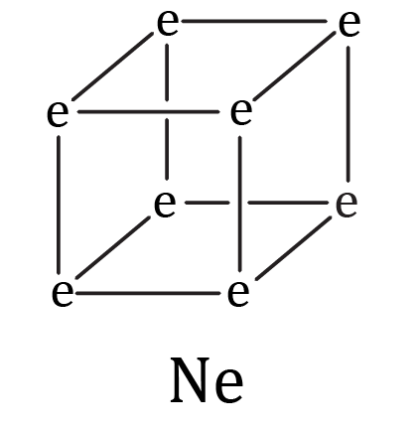
2. Two diagrams. The first consists of two alternatives for Na+. One is a cube and the other is a cube with a black e in every corner.

   The second diagram is Cl-. This is another cube with an e in every corner. Seven of the es are black and one is light orange.
3. Each cube has six faces so could have six oppositely charged ions all equidistant alongside each face.

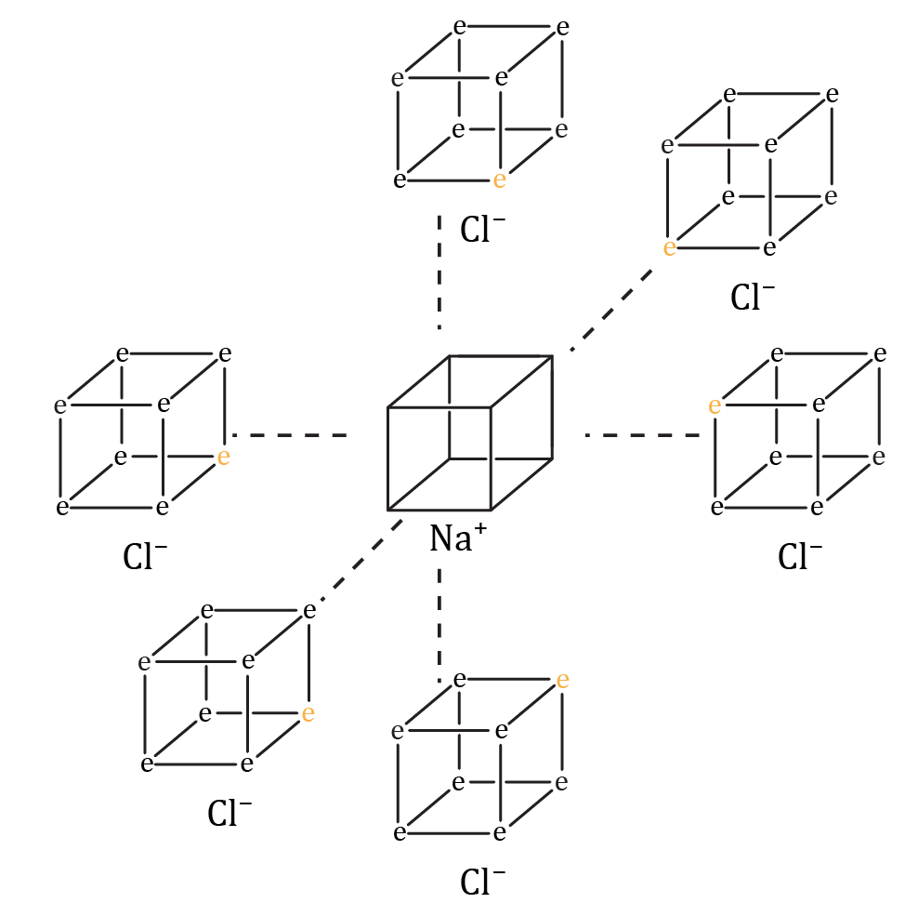

1. Two diagrams.

   The first diagram consists of Three cubes arranged in a line, joined along one edge. The central cube is labelled O. the two outer cubes are labelled F. Each cube has an e at each corner. The es in the cube on the left and right are black and the es in the cube in the centre are light orange. At the intersecting edge the higher e is black and the lower e is light orange. 

   The second diagram consists of Two cubes joined along one side. Each cube is labelled O. Each cube has an e at each corner. The es in the cube on the left are black and the es in the cube on the right are light orange. At the intersecting side two of the es are black and two of the es are light orange. 
2. No, the most electrons that two atoms could share could be two each as the cubes touch faces.

Modelling activity (Activity 2)

Please see the presentation slides for photos of completed models: [rsc.li/430a2bN](https://rsc.li/430a2bN)

The preferred arrangement for is the one where the atoms are not all in the same plane as this allows the chlorine atoms more space. The molecule is really three dimensional, not flat. However, this is more tricky to build using modelling clay as the structure is not self-supporting.

Discussion activity (Activity 3)

|  |  |
| --- | --- |
| **Advantages of the Lewis cube model** | **Disadvantages of the Lewis cube model** |
| * Highlights that atoms and molecules are three dimensional, not two dimensional. * Easy to show a double bond. * Gives a rationale for eight electrons in the outer shell. | * Does not show that electrons go in pairs. * Very hard to draw complex molecules. * Cannot represent triple bonds. * Cannot represent hydrogen and helium, which only have space for two electrons in their outer shell. * Atoms lower down the periodic table can have more than eight electrons in their outer shell – so you need to abandon the cube for a polyhedron with more corners. |

All of the disadvantages listed above would have contributed to Lewis abandoning the cube model but importantly:

* The cubes are too hard to draw in complex molecules.
* Atoms are certainly not cuboid in shape, but neither are they circular, or even truly spherical.