Ionic bonding in sodium chloride: Johnstone’s triangle

Learning objectives

1. Describe an ionic compound based on observations.
2. Use symbolic models to represent an ionic compound.
3. Explain how the bonding in an ionic compound relates to the properties you can observe.

Introduction

Sodium chloride is the chemical name for common table salt. It is an ionic compound.

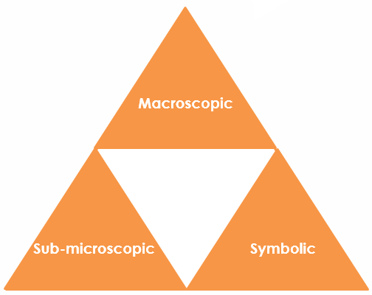Johnstone’s triangle

In chemistry we make sense of the things that we can see by representing what we can’t see using formulas, equations, diagrams and models.

Johnstone’s triangle is a way of thinking about these different concepts as different corners of a triangle:

* Macroscopic – what we can see
* Symbolic – what we use to represent what we’ve seen
* Sub-microscopic – smaller than we can see

Being able to connect and move between these three different levels is important for scientific understanding.

****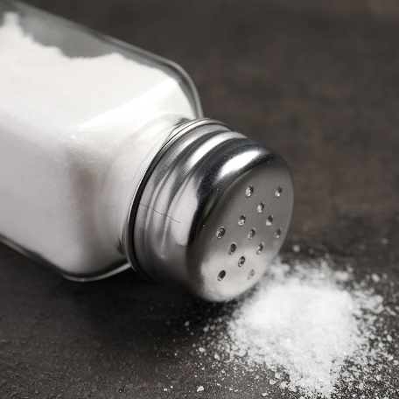

Macroscopic - What do we observe?

Describe table salt:

Task: watch the teacher demonstration. What are the properties of salt that you have observed?



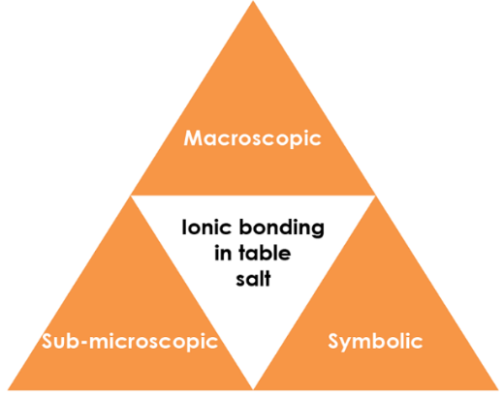

Symbolic - How do we represent it?

Write a word and symbol equation to represent the formation of table salt from its elements.

Draw a dot and cross diagram to represent the formation of table salt from its constituent ions.

Identify the metal and non-metal ions.

Sub-microscopic - What is happening that we can’t see?

Explain the electrical conductivity of salt using diagrams.

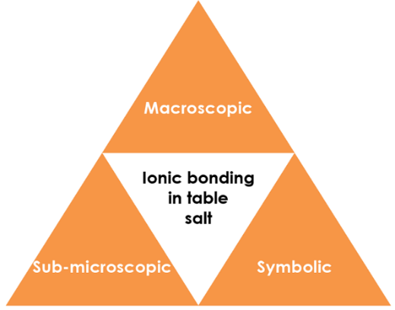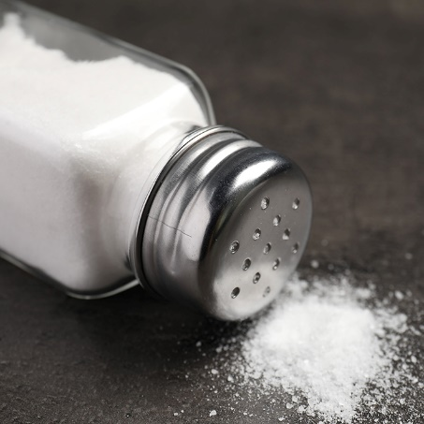****

Symbolic - How do we represent it?

Write a word and symbol equation to represent the formation of table salt from its elements.

Complete the dot and cross diagram to represent the formation of table salt from its constituent ions.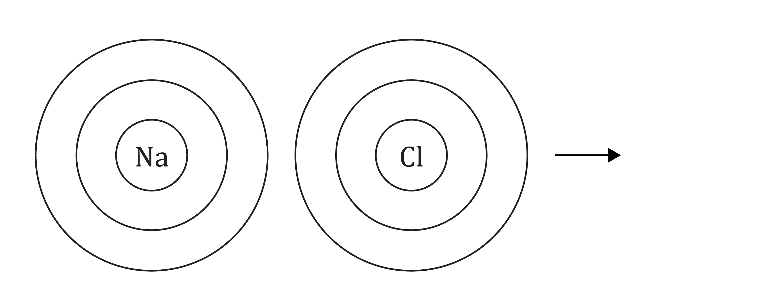

Identify the metal and non-metal ions.

Sub-microscopic - What is happening that we can’t see?

Using the diagram explain why molten salt and salt solution can conduct electricity.

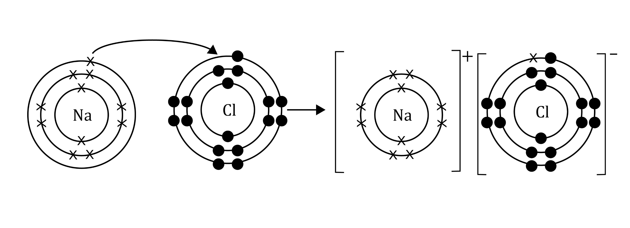

Using the diagram explain why solid salt does not conduct electricity.

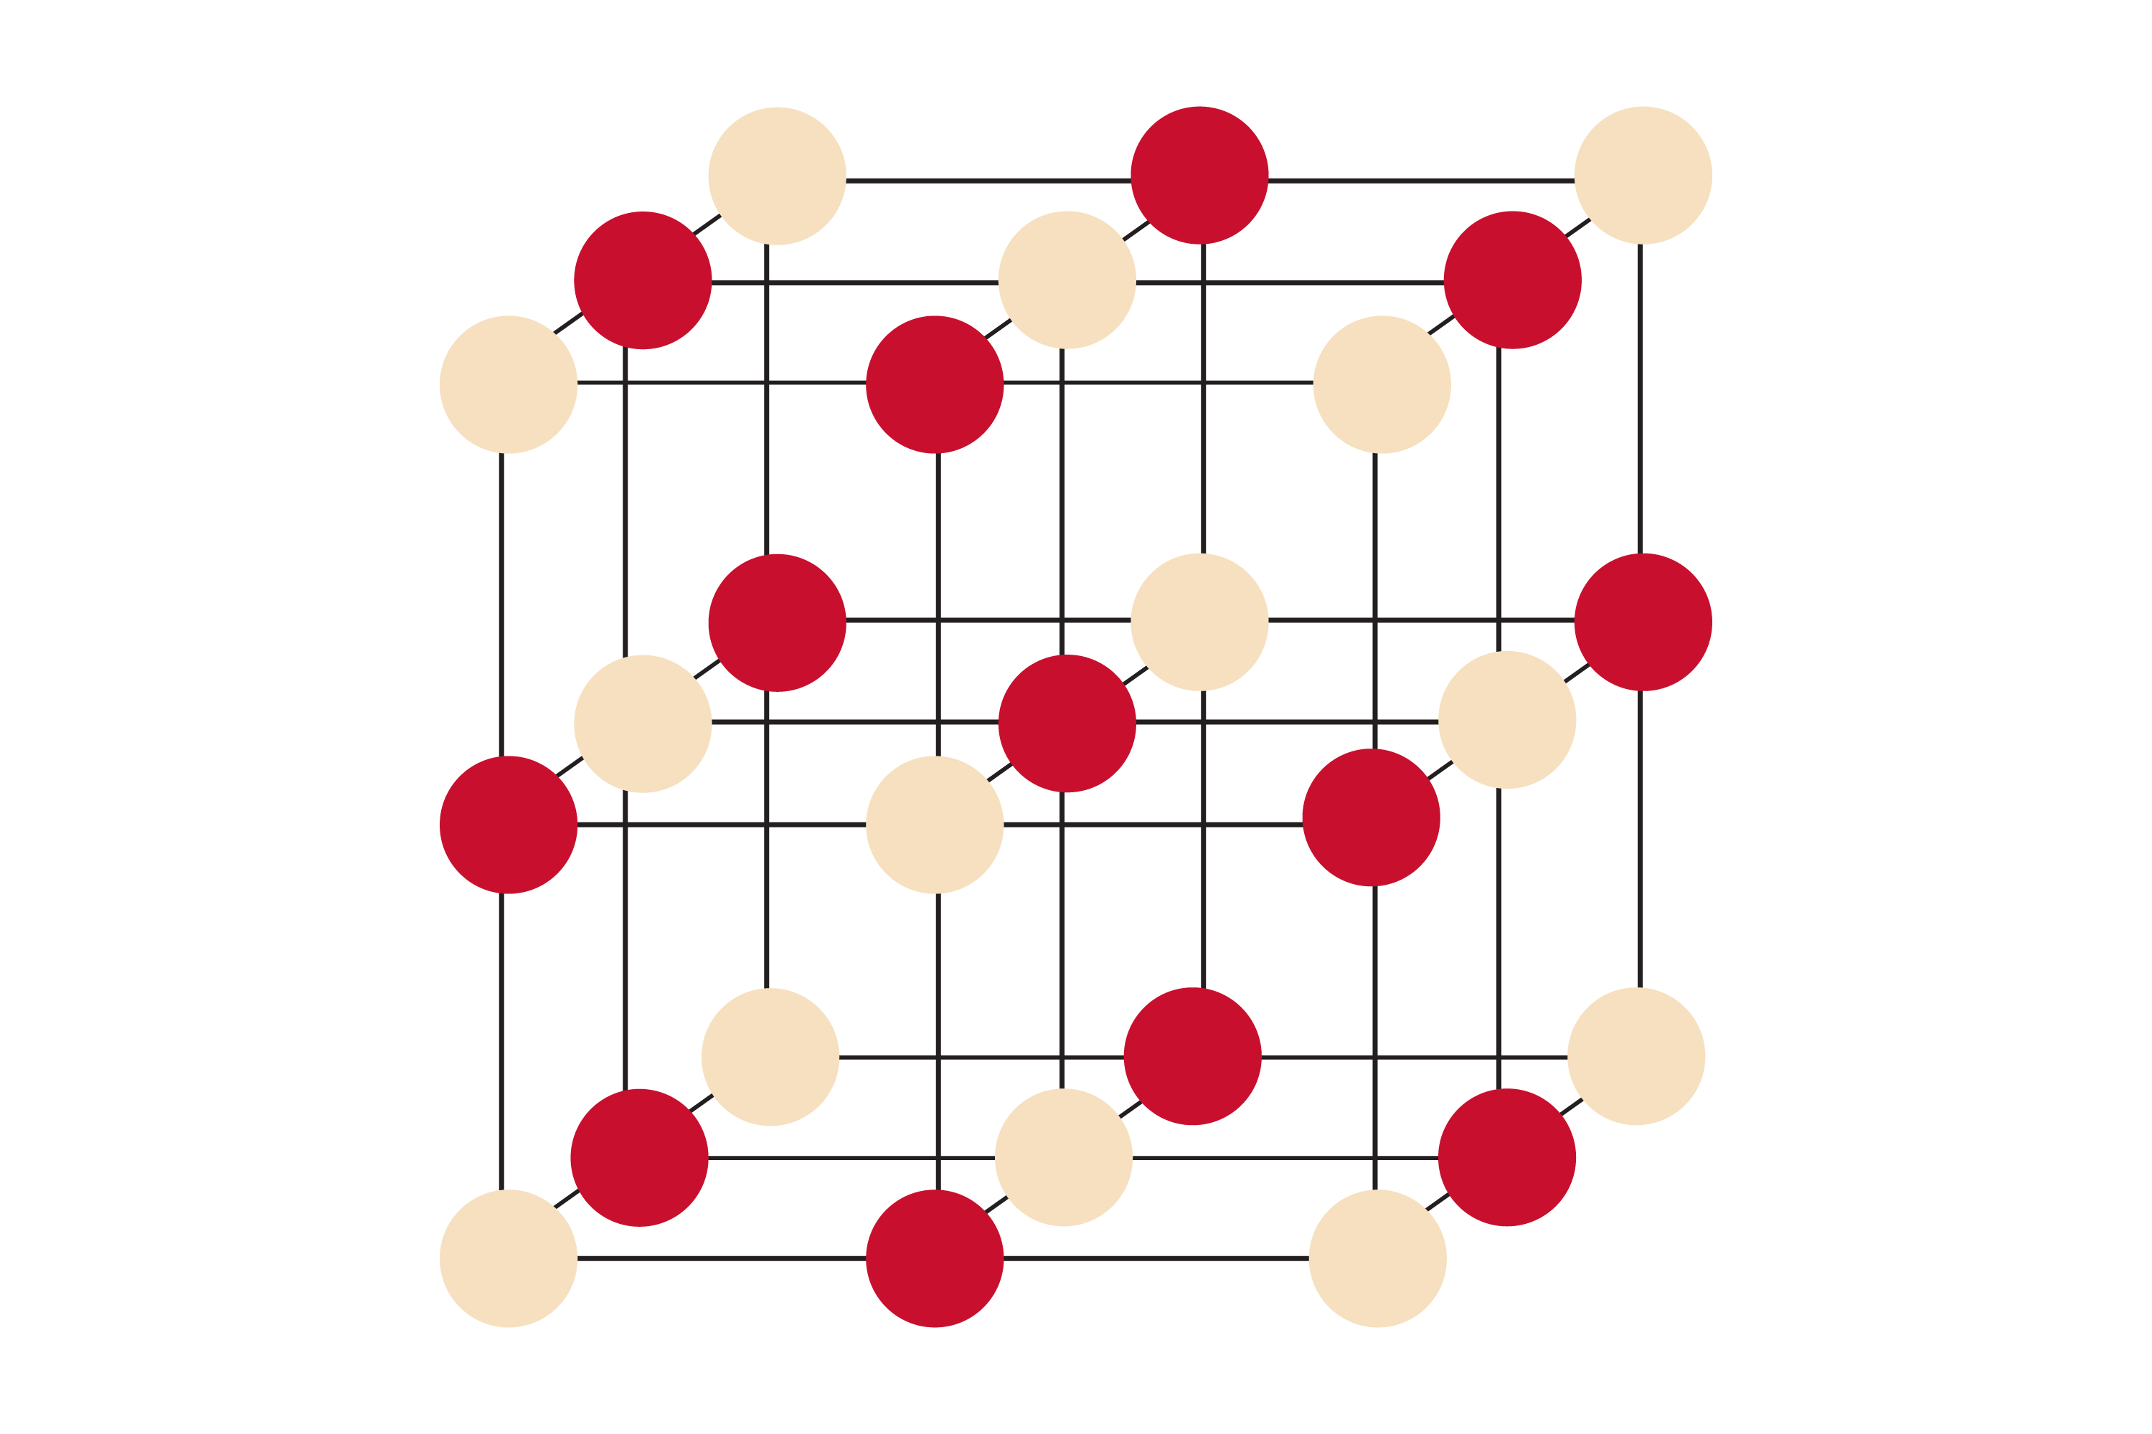

Macroscopic - What do we observe?

Describe table salt:

Task: watch the teacher demonstration. Record your observations.

1. Does the solid salt conduct electricity?
2. Does the salt solution conduct electricity?