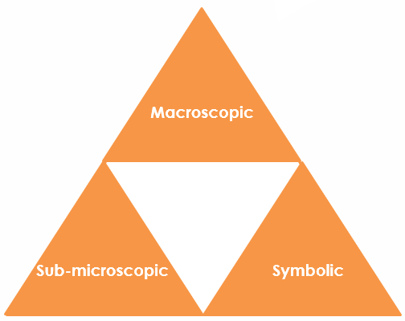The atomic structure of lithium: Johnstone’s triangle

Learning objectives

1. Describe macroscopic properties of a substance.
2. Describe the arrangement of subatomic particles within an atom.
3. Calculate the number of protons, neutrons and electrons present for a given element.

Introduction

Lithium is an element with a small number of subatomic particles that we can use to think about the structure of an atom.

Johnstone’s triangle

In chemistry we make sense of the things that we can see by representing what we can’t see using formulas, equations, diagrams and models.

Johnstone’s triangle is a way of thinking about these different concepts as different corners of a triangle:

* Macroscopic – what we can see. Think about the properties we can observe, measure and record.
* Sub-microscopic – smaller than we can see. Think about the particle or atomic level.
* Symbolic – representations. Think about how we represent chemical ideas, including symbols and diagrams.

Being able to connect and move between these three different levels is important for scientific understanding.

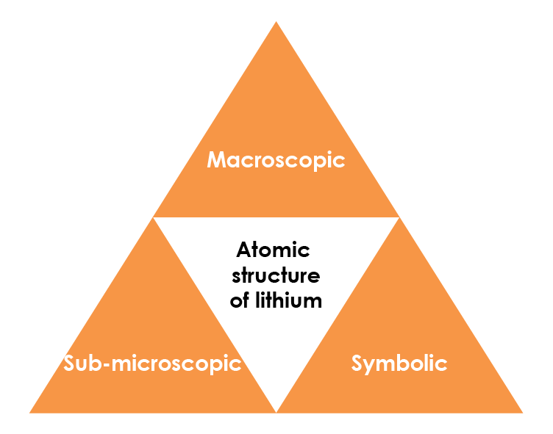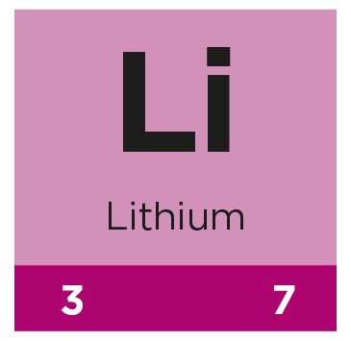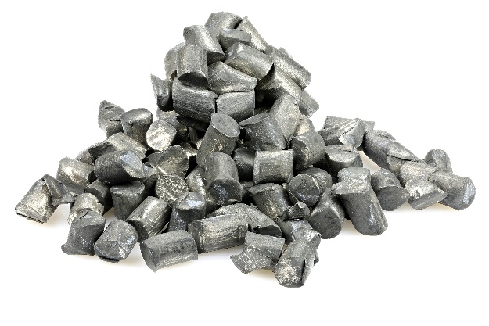

Symbolic – representations

Lithium is shown in the periodic table as:

The atomic number gives the number of protons and electrons. State the number of:

|  |  |
| --- | --- |
| **Protons** |  |
| **Electrons** |  |

The number of neutrons is found from:

= mass number – atomic number

Calculate the number of neutrons:

|  |  |
| --- | --- |
| **Neutrons** |  |

Sub-microscopic – smaller than we can see

A lithium atom can be represented as:

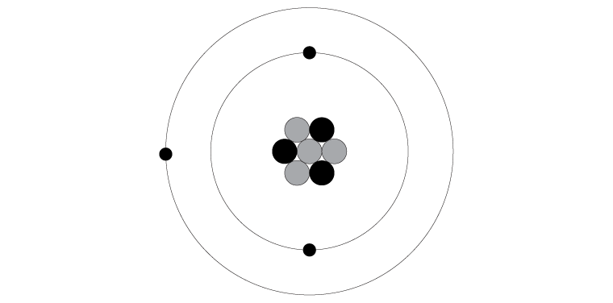

Describe where in an atom of lithium each type of subatomic particle is found:

Proton: _____________________________________________________

Neutron: _____________________________________________________

Electron: _____________________________________________________

Suggest a connection between the number of protons and number of electrons:

Macroscopic – what we can see

The image shows lithium metal. It is made from lithium atoms. Using the image and your prior knowledge, list some macroscopic properties of lithium: