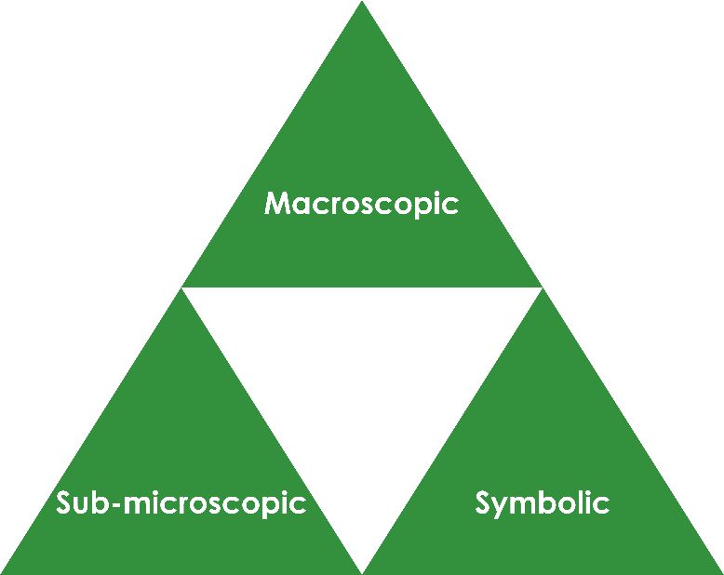States of matter: Johnstone’s triangle

Learning objectives

1. Recall the three states of matter.
2. Compare the properties of solids, liquids and gases.
3. Use the particle model to explain why different states of matter have different properties.

Introduction

Substances can exist in the solid, liquid or gas state. Each state has specific properties that determine how each behaves.

Johnstone’s triangle

In chemistry we make sense of the things that we can see by representing what we can’t see using formulas, equations, diagrams and models.

Johnstone’s triangle is a way of thinking about these different concepts as different corners of a triangle:

* Macroscopic – what we can see. Think about the properties we can observe, measure and record.
* Sub-microscopic – smaller than we can see. Think about the particle or atomic level.
* Symbolic – representations. Think about how we represent chemical ideas, including symbols and diagrams.

Being able to connect and move between these three different levels is important for scientific understanding.

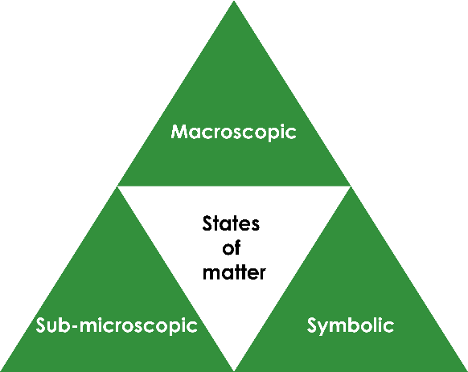

Image adapted from © Shutterstock

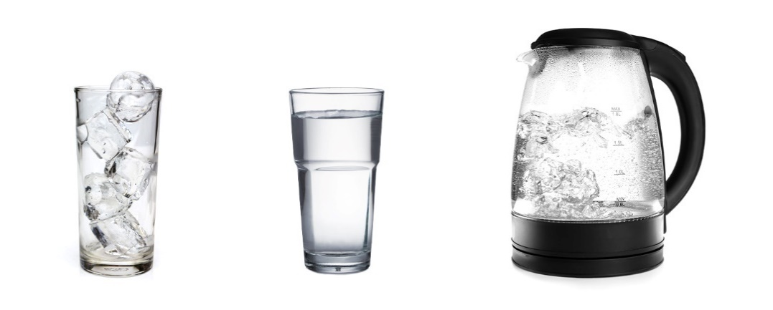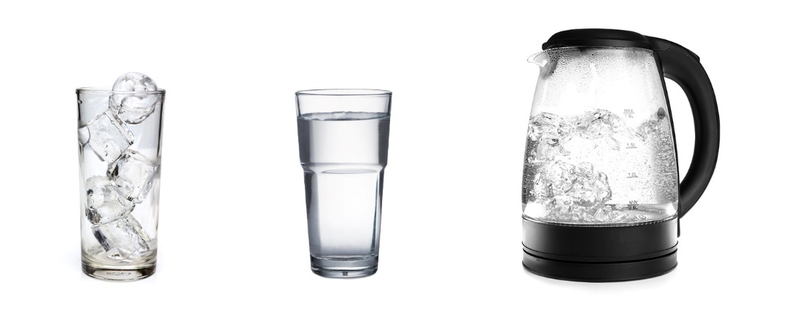

Macroscopic – what we can see

Watch the demonstration. Complete the table for the three states of matter using your observations:

|  |  |  |
| --- | --- | --- |
| **State** | **Does it have a fixed shape?** | **Can it be compressed?** |
| Gas |  |  |
| Liquid |  |  |
| Solid |  |  |

Symbolic – representations

The solid, liquid and gas state can be represented using particle diagrams.

Complete the diagrams to show how the particles are arranged in each state:

Three square boxes that are empty for learners to add their particle diagrams.

Solid Liquid Gas

Sub-microscopic – smaller than we can see

Using your knowledge of how the particles are arranged in the different states, explain why gases can be compressed but liquids and solids can’t: