Covalent structure and bonding: teacher guidance

These In context worksheets ask learners to use their knowledge of covalent structure and bonding in an applied context, building their confidence and capability to face exam questions. Calculation questions are included to give opportunities to practise mathematical skills within this topic. They are available at Foundation and Higher level and as fully editable versions, giving you the flexibility to select the questions most relevant to a particular lesson.

Also available to assess this topic:

* **Review my learning** **worksheets**: available with three levels of scaffolded support to help build confidence in every learner. Use before, during or after teaching the relevant topic to understand progress and identify misconceptions, **rsc.li/44igB7V**.
* **Knowledge check worksheets: select from Foundation and Higher level** to assess learners’ knowledge and understanding of this topic at the end of a period of teaching or as revision, **rsc.li/3z76C9T**.

Answers

Foundation

1. (a) **A** Electrons are shared in a covalent bond.

(b) Diagram A does not show the electronic configurations/how electrons are shared.

(c) Diagram B does not show the 3D structure.

1. (a)

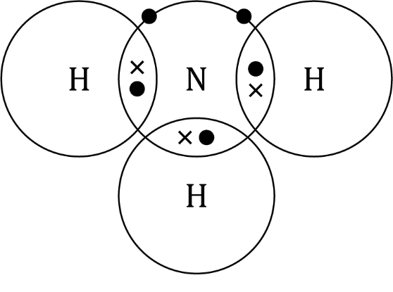

* 1. NH3
  2. *M*r ammonia

* 1. percentage by mass of nitrogen in ammonia

1. (a) 50 oxygen molecules
   1. A suitable example of an answer is: Oxygen has **simple molecules**. These are attracted to each other with **intermolecular forces**. Intermolecular forces are **weak forces**. Little **energy** is required to overcome these forces.
2. (a) number of times larger

* 1. starch molecule
  2. Starch will have a higher melting point than oxygen.

1. (a)

single covalent bond

silicon atom

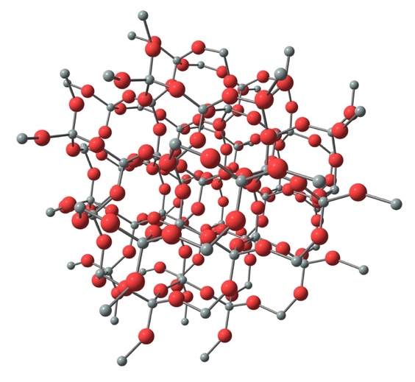

oxygen atom

Source: © Shutterstock

(b) covalent bonds

(c) **B** Silicon dioxide has strong bonds.

**C** It requires a lot of energy to break the bonds of silicon dioxide.

Higher

1. (a) oxygen molecule → double covalent bond

nitrogen molecule → triple covalent bond

hydrogen molecule → single covalent bond

(b)

|  |  |
| --- | --- |
| Oxygen molecule  Dot and cross diagram for an oxygen molecule showing the outer shells of two oxygen atoms with their shells overlapping in the middle. | Nitrogen molecule  Dot and cross diagram for an nitrogen molecule showing the outer shells of two nitrogen atoms with their shells overlapping in the middle. |

1. (a) number of times larger

* 1. starch molecule
  2. Starch will have a higher melting point than oxygen.
  3. Oxygen has simple molecules. These are attracted to each other with intermolecular forces. Intermolecular forces are weak forces. Little energy is required to overcome these forces.

(e) It is the number of repeating units in the polymer chain (which can be a larger number).

(f) relative formula mass

(h) Mr glucose

* 1. six moles
  2. Any three of:
* the type of atoms in carbon dioxide
* the number of each type of atom in a molecule of carbon dioxide
* the order in which the atoms are bonded together
* the type of covalent bonds.

1. (a) giant covalent structure
   1. four
   2. covalent bonds
   3. Covalent bonds are strong bonds. A lot of energy is needed to break them.
2. Covalent substances do not have charged particles to carry an electrical charge.