Ionic structure and bonding

1. The diagram represents the formation of a sodium ion and a chloride ion.

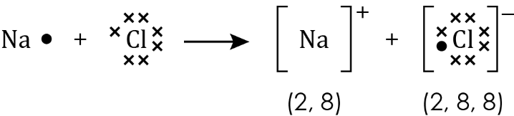

* 1. Which statement about a sodium ion is true?

Circle the correct answer.

(1 mark)

**A** A sodium ion has equal numbers of electrons and protons.

**B** A sodium ion has more electrons than protons.

**C** A sodium ion has fewer electrons than protons.

**D** A sodium ion has more electrons than a chlorine atom.

* 1. The atomic number of chlorine is 17. Which row in the table shows the correct number of sub-atomic particles for a chloride **ion** with a mass number of 35?   
     Circle the correct answer.

|  |  |  |  |
| --- | --- | --- | --- |
| **Row** | **Number of protons** | **Number of neutrons** | **Number of electrons** |
| **A** | 17 | 17 | 17 |
| **B** | 18 | 16 | 18 |
| **C** | 16 | 17 | 18 |
| **D** | 17 | 18 | 18 |

(1 mark)

1. The formula of magnesium oxide is MgO.
   1. Draw a diagram to show how a magnesium atom (2, 8, 2) and an oxygen atom (2, 6) form a magnesium ion and an oxide ion. Your diagram should look like that in **question 1**.

(3 marks)

* 1. The formula of magnesium chloride is . Describe what happens to magnesium atoms and chlorine atoms when the ionic compound magnesium chloride is formed.

____________________________________________________________________________

____________________________________________________________________________

____________________________________________________________________________

____________________________________________________________________________

(4 marks)

* 1. The symbol for an aluminium ion is Al3+. The symbol for an oxide ion is O2–. Write the formula for aluminium oxide?

_____________________________________________________________________________________ (1 mark)

1. This diagram represents the giant ionic structure of sodium chloride.

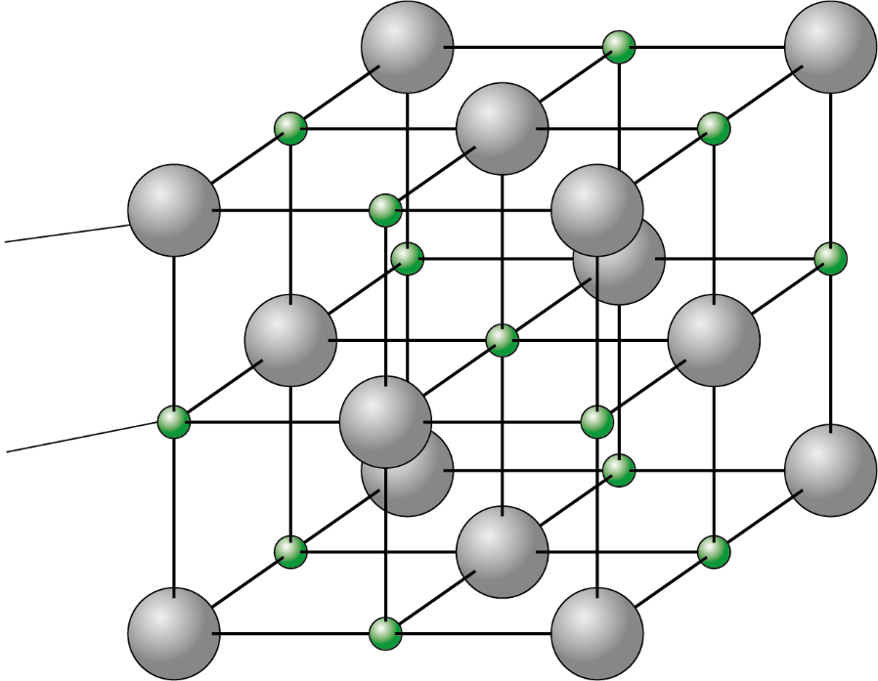

Cl-

Na+

* 1. What forces hold the giant structure together?

_____________________________________________________________________________________ (1 mark)

* 1. Give one limitation of this diagram.

____________________________________________________________________________

_____________________________________________________________________________________ (1 mark)

* 1. Explain why sodium chloride has a high melting point.

____________________________________________________________________________

____________________________________________________________________________

____________________________________________________________________________

____________________________________________________________________________

(4 marks)

* 1. The table shows the melting points of sodium chloride and magnesium oxide.

|  |  |  |
| --- | --- | --- |
| **Ionic compound** | **Which ions are present?**  **[give the formula]** | **Melting point/°C** |
| sodium chloride |  | 801 |
| magnesium oxide |  | 2852 |

1. Complete the table to show the ions present. **(2 marks)**
2. What type of bond is broken when sodium chloride melts?

________________________________________________________________________________ (1 mark)

1. Explain why the melting point of magnesium oxide is higher than the melting point of sodium chloride.

[2 marks]

1. Some students investigated the electrical conductivity of solid zinc chloride, zinc chloride solution and molten zinc chloride. The table describes their observations.

|  |  |
| --- | --- |
| **Substance** | **Did it conduct electricity?** |
| solid zinc chloride | no |
| zinc chloride solution | yes |
| molten zinc chloride | yes |

* 1. Explain the students’ results.

(3 marks)

* 1. The melting point of zinc chloride is 290°C. Draw a diagram of the apparatus you could use to show that molten zinc chloride conducts electricity.

(3 marks)

[Total: 27 marks]

Which question(s) did you get wrong? Why?

What will you do next time you’re asked a similar question?