**Amino acids: teacher guidance**

This resource forms part of the **Review my learning** series from the *Royal Society of Chemistry*. The worksheets assess learner’s understanding of content from common 11–14 and 14–16 curriculums. They can be used to identify knowledge gaps and misconceptions once that part of the curriculum has been taught.

The Amino acid worksheets cover the following topics:

* the general structure of amino acids
* the structure of glycine and alanine
* the polymerisation of amino acids to form polypeptides and proteins
* the peptide link
* equations to represent the polymerisation of amino acids.

If learners successfully answer questions on these topics, they can attempt the extension question. This requires learners to complete an equation that represents the polymerisation of alanine and to apply their knowledge to a diagrammatic representation of the polymerisation of amino acids.

**Scaffolding**

Level 1 (*) is a scaffolded worksheet which supports learners in a variety of ways, such as selecting words from a word bank, providing answer options to choose from or completed examples. Level 2 (**) is a partially scaffolded worksheet with a reduced level of support, such as partially completed sentences or a wider range of answer options to select from. Level 3 (***) is an unscaffolded worksheet in which most of the tasks involve answering questions with a minimum of prompts.

**Metacognition**

The ‘What do I understand?’ page is common to all levels of worksheet and can be used both to identify areas needing whole class attention and as an indicator for learners to help guide their revision.

Below you will find model answers for each level and guidance on learners’ misconceptions. Learners can use the model answers to self- or peer assess.

**When to use**

The worksheets can be used in a variety of ways:

* To assess learners’ knowledge at the beginning or end of a period of teaching. Match the level of the worksheet to the needs of the learners.
* To assess knowledge during a period of teaching once learners have completed the relevant topic.
* As part of revision.
* As a refresher exercise for teachers or non-subject specialists.

There is also scope to increase the level of worksheets used as learners progress through their curriculum.

**Further support**

For more resources to support teaching of this topic and address any misconceptions identified, go to [**rsc.li/3x2T9yT**](https://rsc.li/3x2T9yT). For more assessment questions on this topic use our Knowledge check and In context worksheets on *Natural polymers* from [rsc.li/3iF4Lvm](https://rsc.li/3iF4Lvm).

Answers

Amino acids: knowledge check

1. **Level 1, 2 and 3**

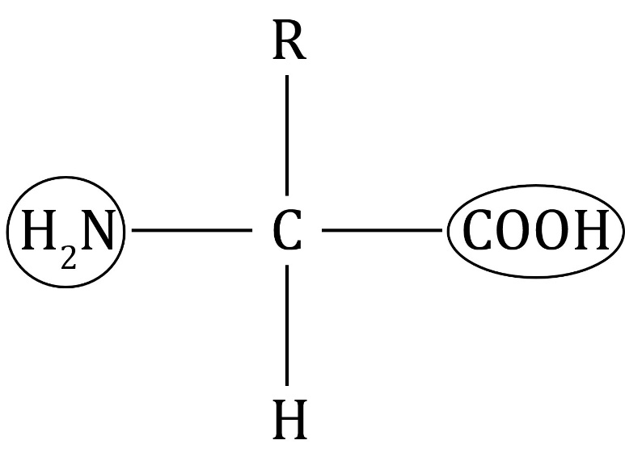

amine group

carboxylic acid group

**Guidance**:Learners should be familiar with the COOH functional group, but the group will be new to some. ‘R’ can be explained as a side group, or the rest of the molecule. The amine group is also called the amino group in some sources.

1. **Level 1, 2 and 3**
   1. side group
   2. different side groups
   3. COOH group
   4. basic
   5. H atom
   6. group

**Guidance**:Learners need to refer back to the general structure of amino acids in question 1.1 and deduce what ‘R’ represents.

1. **Level 1, 2 and 3**

polymers; monomers; condensation; water; proteins; peptide; carboxylic acid; nitrogen

**Guidance**: Learners may recall that the end product of protein digestion is amino acids and hence think that proteins are the building blocks of amino acids, rather than vice versa. They may need prompts to apply their knowledge of monomers and polymers to the polymerisation of amino acids.

Amino acids: test myself

1. **Level 1, 2 and 3**

The correct statement is **C**.

**Guidance**: Learners should be familiar with the acidic properties of the COOH group but may be less familiar with the basic properties of the group. Comparing this group to ammonia () may help.

1. **Level 1, 2 and 3**

The correct statement is **D**.

**Guidance**: Some learners confuse amino acids with proteins. They need to understand that the COOH group reacts with the group during polymerisation to form peptides links.

1. **Level 1, 2 and 3**

The correct answer is **A**: .

**Guidance**: Learners need to be able to translate between the structural formulas shown in diagrams and written structural formulas.

1. **Level 1, 2 and 3**

a polypeptide

**Guidance**: ‘A protein’ is also an acceptable answer. Many learners will be confused about the difference between polypeptides and proteins. Polypeptides are smaller than proteins. A polypeptide is usually quoted as consisting of between 2 and 50 amino acids. A protein consists of more than 50 amino acids and has a more complicated structure.

1. **Level 1, 2 and 3**

The polymerisation of amino acids is classed as a condensation reaction because water is a product.

**Guidance**: Learners often forget that water is also a product of amino acid polymerisation.

1. **Level 1, 2 and 3**

‘*n*’ represents a large number

**Guidance**: Learners may need prompts about notation used to describe polymerisation reactions. Remind learners about the importance of the use of the *n* to represent a large number and the square brackets around the structure of the repeating unit.

1. **Level 1, 2 and 3**

The repeating unit is

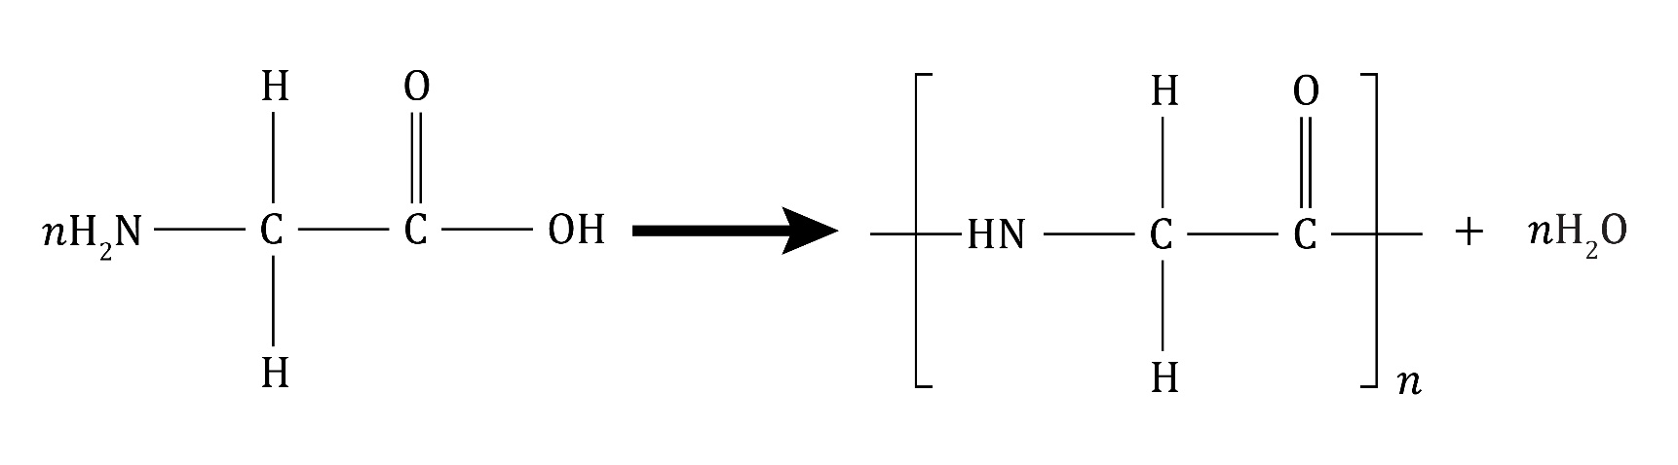

**Guidance**: See guidance for question2.6.

Amino acids: feeling confident?

1. **Level 1, 2 and 3**

(a) and (b)

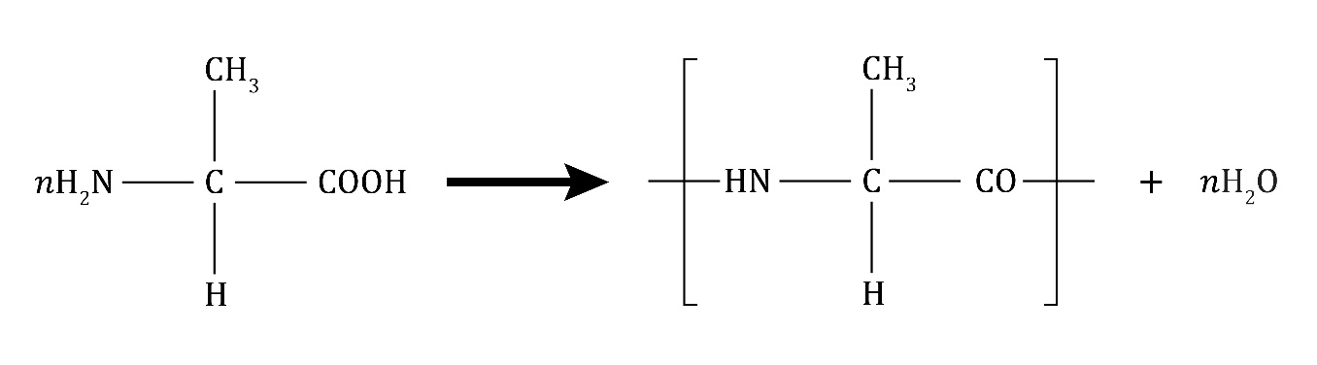

**monomer repeating unit**

**Guidance**: See guidance for question2.6.

1. **Level 1, 2 and 3**

|  |  |
| --- | --- |
| **Part of image** | **What does it represent?** |
| individual spheres | **amino acids** |
| different shaded spheres | **different amino acids** |
| the chain of six spheres | **a polypeptide** |
| the twisted chain of spheres | **a protein** |
| the lines connecting the spheres | **peptide links** |

**Guidance**: Learners need to apply their knowledge to this diagrammatic representation of amino acid polymerisation. Some learners will confuse polypeptides with proteins. Use the diagram to demonstrate the difference between them. Use the guidance from question2.4.

**Amino acids: what do I understand?**

|  |  |
| --- | --- |
| **Mini-topic** | **Assessed via:** |
| I can describe the general structure of amino acids. | 1.1, 2.1 |
| I can interpret the structure of glycine and alanine. | 1.2, 2.3 |
| I can describe the polymerisation of amino acids to form polypeptides and proteins. | 1.3, 2.2, 2.4, 2.5 |
| I can use equations to represent the polymerisation of amino acids. | 2.6, 2.7 |
| **Feeling confident? topics** | **Assessed via:** |
| I can complete equations to represent the polymerisation of amino acids. | 3.1 |
| I can understand diagrams that explain protein formation. | 3.2 |