Metallic deuterium formed at high pressures

Introduction

Scientists work to understand the world around us and what they find out often ends up in the news. The work of scientists impacts our lives all the time, so it is useful to be able to understand science writing. Read the science news story below and answer the questions.

Metallic deuterium formed at high pressures

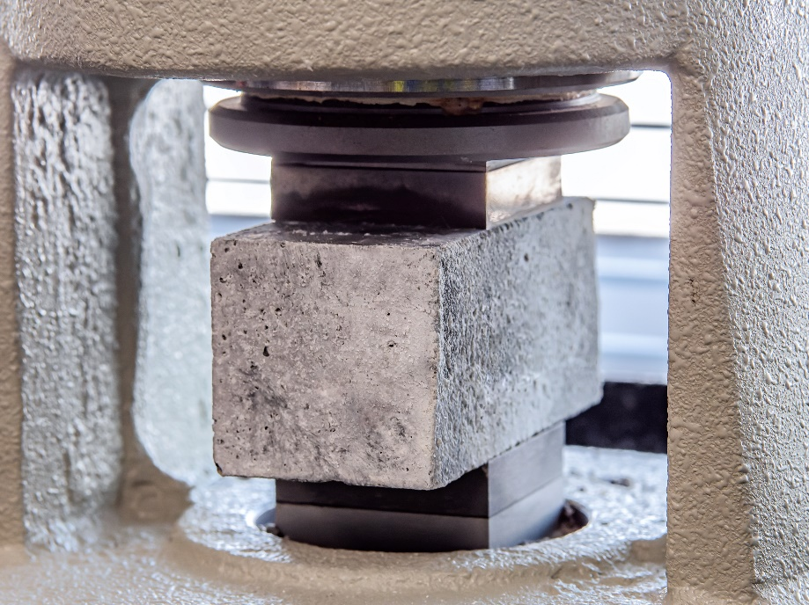

A concrete block under pressure, © Shutterstock

In theory, all **elements** become metallic at high pressures as the **atoms** are squeezed close enough that the **electrons** become **delocalised**.

Scientists have tried to observe the metallisation of hydrogen as it is the simplest element. In 2020, researchers claimed to have shown that hydrogen, 1H, formed a metallic state at a pressure of 425 gigapascals. They measured the absorption of infrared light, and it was consistent with a **metal**. Now scientists have found that an **isotope** of hydrogen called deuterium, 2H, has shown the same change in absorption of infrared light at the higher pressure of 460 gigapascals. The research could be used in the development of superconductors and new rocket fuels.

Questions

1. Describe how ions and electrons are arranged in a metal (you can include a diagram if it helps).
2. Explain what delocalised electrons are and how they help metals conduct electricity.
3. Write down the meaning of the following scientific words from the story – have you seen or heard these words before? Look them up in the glossary on page 4.
4. Element
5. Absorption
6. Isotope

Use the scale below to rate how much using the glossary is helping you understand the science in the story.

1 2 3 4 5 6 7 8 9 10

Not helping → Really helping

1. Get two different colour pencils. Circle any scientific words in colour one.
2. Using colour two, circle about five to ten words that communicate the key message in the story.

Use the scale below to rate how much circling words is helping you to understand the news story.

1 2 3 4 5 6 7 8 9 10

Not helping → Really helping

Use the scale in the box above to rate how confident you would feel explaining the story to the person next to you. Think of something else you can do when reading the text to help you understand the story and share it with the person next to you.

1. Write down one new thing you have learned from reading this science research news story.
2. Write your own summary of the story for the other learners in your class. Use the prompts below.

* What have the scientists discovered? Try to write this in just one sentence. (Findings)
* What was it that scientists were trying to investigate? (Context)
* Why does their discovery matter? (Relevance/application)
* Think about who it matters to and what impact it could have for them. (Impact)

Scientists publish their findings in research articles. These are then written about by writers and journalists for different audiences. Research articles and other types of science writing can be very technical but they will mostly always cover the four prompts in question 6.

1. Read the story called ‘High pressure forces heavy hydrogen to act like a metal’**.**This is based on the same research, but it is written for a different audience than the text at the top of this worksheet. With a pen or pencil, highlight bits of the article that link to each of the bullet points in question 6.

*Hint: You could number the bullet points 1–4 and use a different colour for each bullet point.*

1. How is this science writing different from the science writing at the top of this worksheet? Write down your answers.
2. Imagine you are a professional science writer. Explain how you would write about this research for:
3. a post on social media
4. a magazine article aimed at adults who work in the chemistry industry
5. a report for school that gets published on the school website for other learners to read, including learners who are younger than you.

*Hint: In each case, think about your audience (in other words, who will read it) and what they might want and need from the writing. This will help you answer the question.*

Glossary

Words in bold are chemistry key terms that you will find in our key terms support resources.

|  |  |
| --- | --- |
| **Unfamiliar word** | **What it means** |
| Absorption | the process of taking something into another substance |
| **Atom** | the smallest possible particle of an element; atoms are made up of protons, neutrons and electrons |
| Consistent | always happening or behaving in a similar way |
| **Delocalised electron** | an electron in a molecule or structure that is not associated with any particular atom, ion, or covalent bond and which is free to move |
| **Electron** | a negatively charged subatomic particle with very little mass found in the electron shells/energy levels of atoms |
| **Element** | a pure substance made of only one type of atom |
| **Isotope** | atoms with the same number of protons but different numbers of neutrons |
| **Metal** | an element that is shiny when cut, malleable and conducts electricity well; metals are found on the left and middle of the periodic table and tend to lose electrons to form positive ions |
| Metallic | made of, or similar to, metal or showing a quality of metal |
| Metallisation | when a material changes to act like a metal |
| Pressure | the force that a liquid or gas produces when it presses against an area |
| Superconductor | a substance, especially a metal, that allows an electrical current to move freely through it at a very low temperature |

Definitions of absorption, consistent, metallic, pressure and superconductor from Cambridge Dictionary, <https://www.dictionary.cambridge.org> © Cambridge University Press. Accessed January 2025. Used with permission.