Liquefying paint
Education in Chemistry
September 2020
rsc.li/3h1PjJa
Retrieval practice and quick-fire questions to revise your chemistry knowledge
Retrieval practice means recalling information you’ve learned from your memory with little or no support. The ‘Stopping the drip’ article is a perfect starting point for some retrieval practice. The science touches on lots of topics you will have come across in your post-16 studies.
1. Read through the article and highlight any keywords you recognise. Use these words to create 8 headings to focus your retrieval practice on. Each heading should represent a topic or subsection of your studies in which these keywords were introduced.
2. Copy the template below onto a large piece of paper and label each segment with one of the headings.
Using only your memory, fill each segment with as much information about the topic as you can.
When you are finished check your notes to add in the extra details that you had forgotten.

CHEMISTRY RETRIEVAL PRACTICE

If you struggled to come up with 8 headings, here are some possible headings you might wish to pick from.
polymerisation; esters; transition metal complexes; hydrolysis; alkenes; aromatic compounds; spectroscopy; electronegativity; free radicals; redox chemistry

3. Now test yourself by answering as many of these 10 quick questions as you can.
a. Draw a diagram to illustrate the formation of a π-orbital in ethene from the overlap of two p-orbitals on neighbouring carbon atoms.
b. ‘Infra-red spectroscopy confirmed that the dripping paint contained more acids and esters.’
State the wavenumber of the absorptions that could be used to identify acids and esters in the dripping paint.
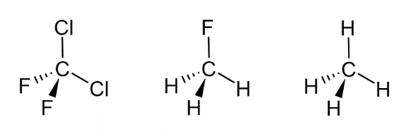
c. Identify the most polar molecule from the options below.
d. Outline a mechanism for the formation of dibromochloromethane from dibromomethane by free radical substitution.
e. When granulated zinc is added to an acidified solution of ${VO}_{2}^{+}$ ions and the solution is gently warmed, V²⁺ ions are formed. Zinc is oxidised to Zn²⁺ in the process.
Write two half equations for the oxidation and reduction processes occurring and combine them to form a full redox equation for the reaction.
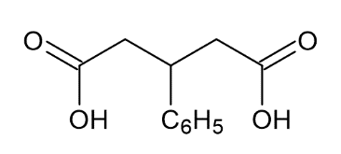
f. Give the IUPAC name for diacid 1.
Diacid 1:

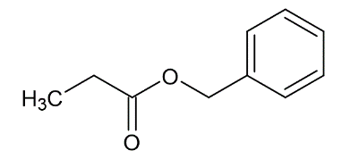
g. Give the IUPAC name for ester 2.
Ester 2:

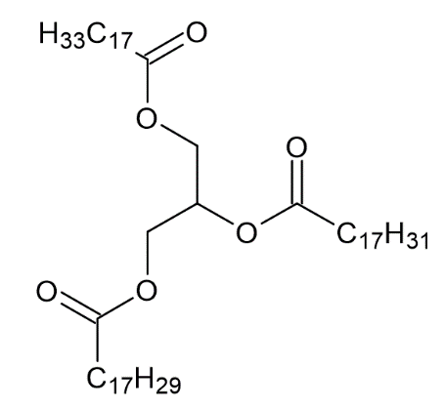
h. Complete the equation to show the products from the hydrolysis of the triglyceride under basic conditions.

+ 3NaOH

i. Draw the repeating unit formed from the condensation polymerisation of benzene-1,4-dicarboxylic acid and methylpropane-1,3-diol.
j. Describe the key features of a transition metal complex ion.

