**Collision theory and Maxwell–Boltzmann distribution curves**

**Learning objectives**

1. Understand reaction kinetics in terms of collision theory and energy profile diagrams.
2. Draw and interpret Maxwell–Boltzmann distribution curves.
3. Use Maxwell–Boltzmann distribution to explain how a change in temperature affects the rate of reaction.
4. Use Maxwell–Boltzmann distribution to help explain the action of a catalyst on reaction rate.

**Questions**

1. Oxygen and hydrogen react together to produce water. The reaction can be modelled using a particle diagram.
2. Look at the particle diagram below and explain why no products were formed.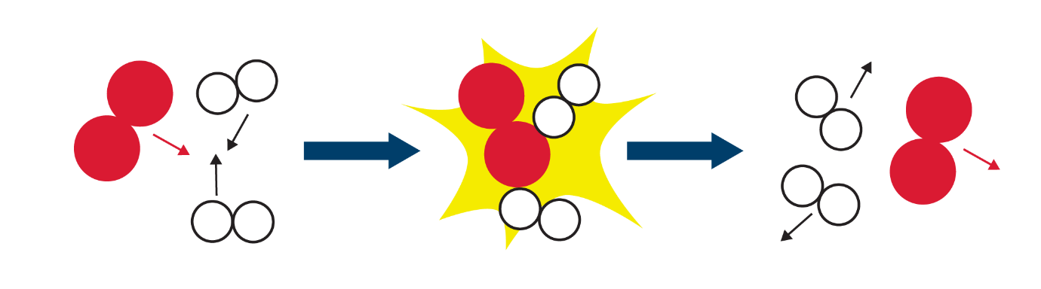
3. Draw another particle diagram which you think would lead to an effective collision.
4. Define the term activation energy.
5. Explain why most collisions do not result in a reaction.
6. The graph shows a Maxwell–Boltzmann distribution curve.

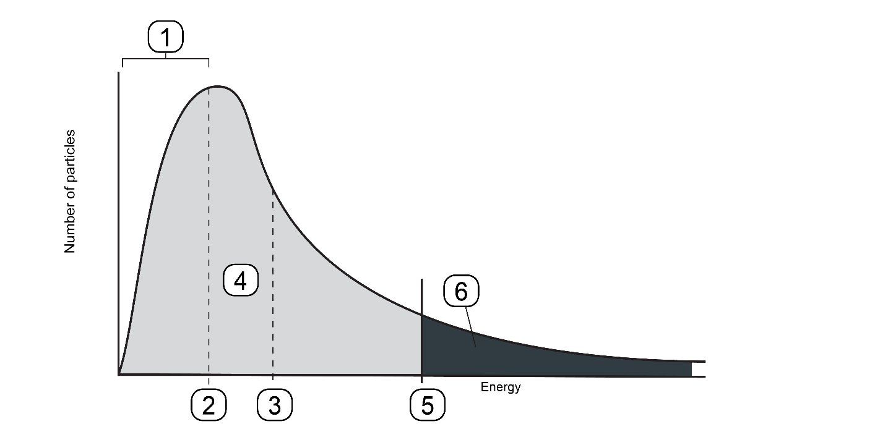

1. Match the statements to the correct part of the curve.

Write the number on the curve next to the correct statement:

* The most probable energy.
* The activation energy.
* The mean energy.
* The total number of particles present.
* Particles with low energy.
* Particles that will have enough energy to react.

1. Suggest a reason why a few particles have very low energy.
2. State whether the following statements are true or false. Give a reason for each answer.
3. The mean energy of the particles is the same as the peak of the curve.
4. The energy distribution should go through the origin.
5. The energy distribution should meet the *x* axis.
6. As *T* increases, the rate increases because the number of successful collisions increases.
7. The area under the curve increases as *T* increases.
8. The rate of a chemical reaction may be increased by increasing the temperature of a reaction.

Suggest why a small increase in temperature can lead to a large increase in the reaction rate between colliding particles. Include a diagram in your answer.

1. The rate of a chemical reaction may be increased by the addition of a catalyst.
2. What is a catalyst?
3. Describe how a catalyst works.
4. Sketch a graph to show how the energy distribution changes in a sample when the catalyst is added.
5. Refer to your graph in (c) to explain why the rate of reaction increases in the presence of a catalyst.
6. The question is about the rate of oxidation of carbon monoxide.

2CO(g) + O2(g) 🡪 2CO2(g)

The diagram shows the Maxwell–Boltzmann distribution forCOat *T1*, where *Ea* is the activation energy.

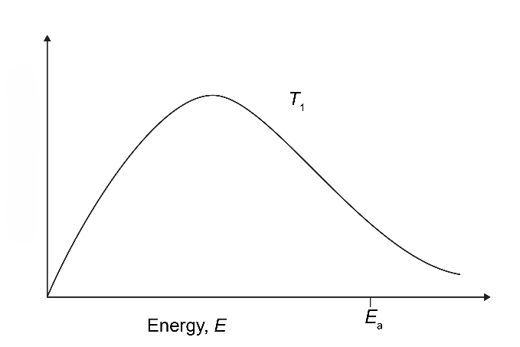

1. Label the *y* axis.
2. Draw a second curve on the same axis to show CO at a lower temperature, *T*2.
3. Explain, in terms of collision theory, why lowering the temperature will decrease the rate of reaction.
4. A catalyst is added to the reaction. Explain, in terms of collision theory, how you might expect the rate of reaction to change.