Microscale diffusion of a gas

These technician notes are part of a collection of microscale chemistry resources at: [rsc.li/4iiIjbl](https://rsc.li/4iiIjbl). Integrated instructions are available from [rsc.li/4fFHvLX](http://rsc.li/4fFHvLX).

Introduction

This experiment is ideally suited to demonstrate the principles of diffusion for learners aged 11–16.

Equipment (per group)

Chemicals to be supplied in 10 ml dropper bottles:

* Chlorine-based bleach solution (50% solution or ~0.25 mol dm-3) **or** sodium hypochlorite (2.5% w/v), 2 drops
* Starch solution (1% solution), 15 drops
* Hydrochloric acid (1 mol dm-3), 15 drops
* Potassium iodide (0.2 mol dm-3), 15 drops
* A4 print out of integrated instructions (laminated or within a plastic wallet)
* Pasteur pipettes x 3
* Paper towels
* Petri dish and lid

Safety equipment

* Eye protection: safety glasses to EN166 F

Equipment set-up

Ensure the bleach is a chlorine-based preparation rather than an oxygen-based solution and that it does not contain hydroxides, which can reduce the chlorine production. Remember to check the hazard warning labels of the specific bleach solution you use and risk assess accordingly.

Please note that sodium hypochlorite has a limited shelf-life and its concentration will decrease over time, especially if kept in a warm environment. Check the experiment generates enough chlorine gas to observe a colour change. If not, you can increase the number of drops of 2.5% (w/v) sodium hypochlorite as long as the solutions fit in the reaction vessel.

If insufficient chlorine is generated and the reaction vessel is full then use a 5% (w/v) solution of sodium hypochlorite **for the teacher to dispense**, as this is not suitable for learners under year 12. Conduct a revised risk assessment with adequate adjustments of the control measures, such as wearing safety goggles as eye protection or doing the experiment as a demonstration under a visualiser.

Learners can perform the experiment on a laminated copy of the integrated instructions, a copy placed inside a plastic wallet, or in a Petri dish placed over the sheet. An A4 printout inside a plastic wallet has better surface tension compared with a laminated template.

The reagents in the grey circle generate the chlorine gas.

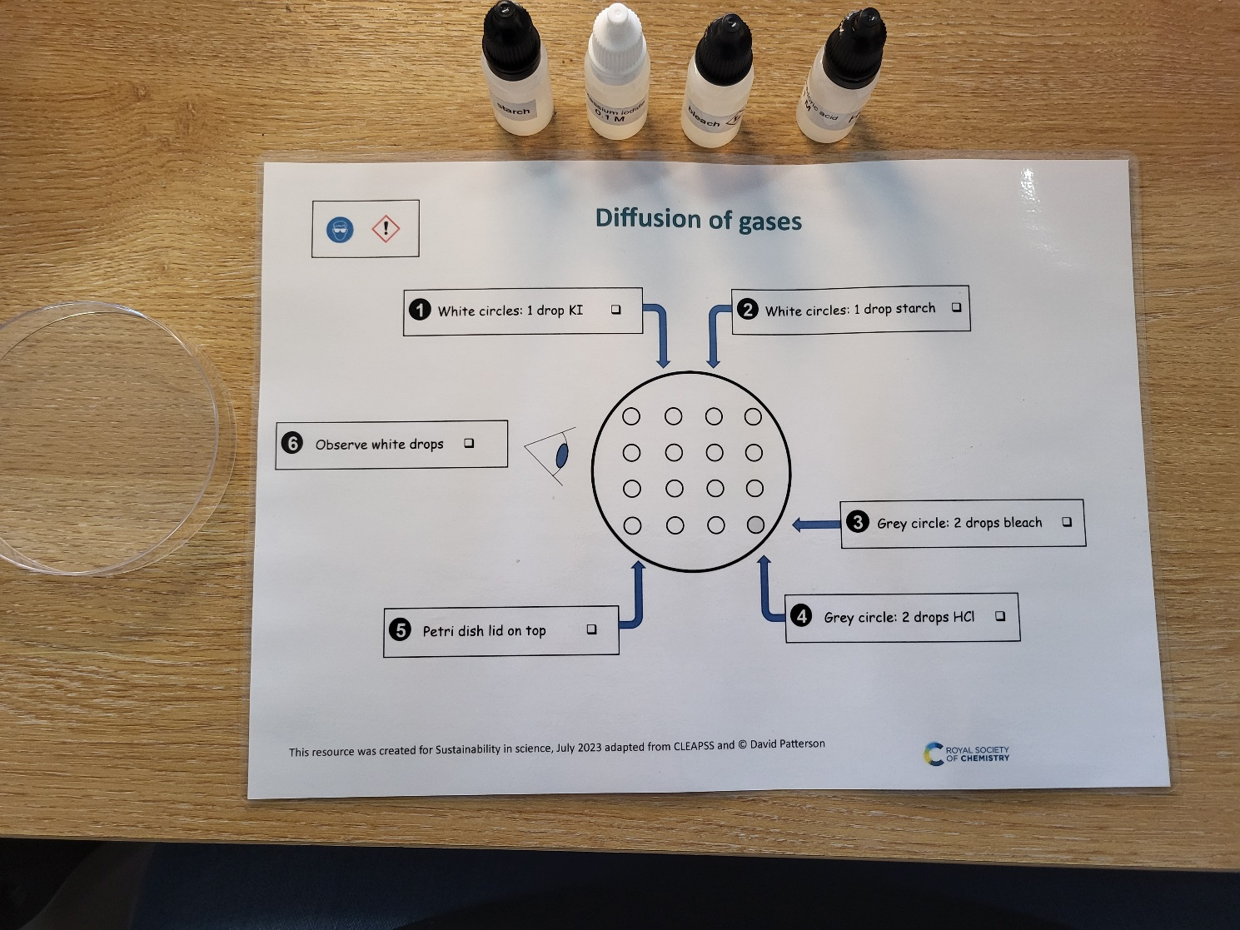

Method

1. Add one drop of potassium iodide to every white circle.
2. Then, add one drop of starch to every white circle. Starch is an indicator and will turn blue-black as it reacts with the iodine displaced by the chlorine gas.
3. Add two drops of bleach solution to the grey circle.
4. Add two drops of hydrochloric acid to the grey circle.
5. Carefully place an upturned Petri dish (or lid if using a Petri dish over the integrated instructions) over the grid and observe.

Expected results

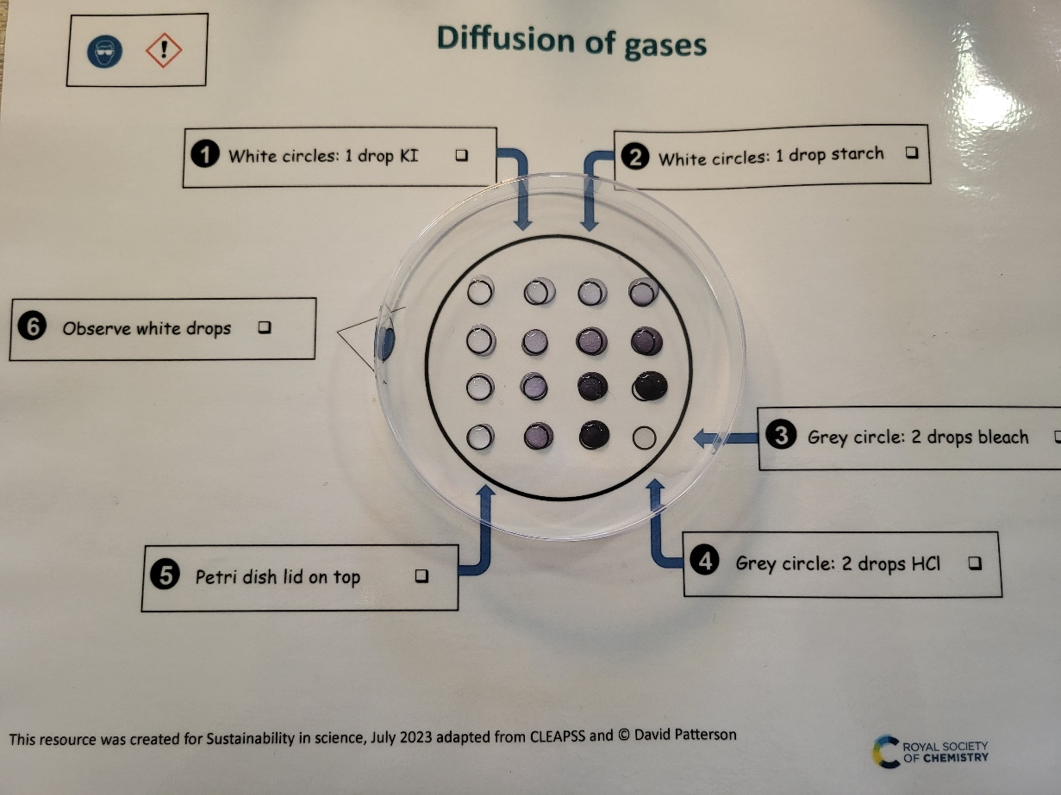

The image shows the expected results. Chlorine gas is evolved from the bleach/acid drop, and diffuses away from the grey circle. The chlorine dissolves into the iodide/starch drops. Chlorine displaces the iodine, forming the dark blue/black iodine/starch complex. Learners should observe the surrounding iodide/starch drops turning completely blue/black. The drops that are further away from the grey circle take longer to change colour and change less, showing the diffusion gradient.

Safety

* [Read our standard health and safety guidance](https://edu.rsc.org/resources/explaining-our-health-and-safety-guidance/1752.article) and carry out a risk assessment before running any live practical.
* If in doubt, contact your school health and safety advisor.
* Refer to SSERC/CLEAPSS hazcards and recipe sheets.
* Hazard classification may vary depending on the supplier.
* 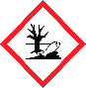Hazard symbol: flammableHazard symbol: toxicBy using very small volumes of the solutions and the Petri dish lid to contain the experiment, very little chlorine gas is released into the classroom, however some will still be present in the environment. To mitigate this risk, make sure you are working in a well-ventilated area. Chlorine gas is oxidising, toxic and dangerous to the environment, see CLEAPSS hazcard HC022A.

Corrosive (Symbol: corrosion)

|  |  |
| --- | --- |
| **Chemical supplied for the practical** | **Preparation** |
| Hydrochloric acid solution, 1.0 mol dm-3  HCl (aq).  Hazard symbol: harmful irritantNot currently classified as hazardous but is advisable to include on the label.  CLEAPSS Hazcard HC047A. | Hydrochloric acid concentrated  HCl (aq), 35–38% (w/w) solution, which is about 12 mol dm-3 depending on the supplier.  Hazard symbol: harmful irritant  DANGER  Causes severe skin burns and eye damage.  May cause respiratory irritation.  Wear splash-proof goggles when using concentrated hydrochloric acid and always add the concentrated acid to the water.  Protect the face when opening bottles of the concentrated acid (pressure may have built up) or when transferring or dispensing large volumes. Use a fume cupboard. Avoid contact with skin.  The exact concentration of a hydrochloric acid solution prepared can be determined by titrating against a standard solution of sodium carbonate.  To make 500 cm3 of 1 mol dm-3 HCl:  wear splash-proof goggles or a face shield and chemical-resistant gloves. Use a fume cupboard and avoid inhaling vapour. The acid has a sharp odour and can cause respiratory irritation. Take care when opening a bottle on a hot day. Measure out 42 cm3 of concentrated hydrochloric acid in a measuring cylinder. Add the liquid to about 350 cm3 of water in a beaker or laboratory jug. Stir well. If you use a beaker, pour the solution into an appropriately sized measuring cylinder or laboratory jug and add water to 500 cm3. Mix well. Pour the solution into a labelled bottle. Include hazard warning and/or control measure information on the label if appropriate.  CLEAPSS recipe sheet RB043. |
| 1 11% (w/v) starch solution  Not currently classified as hazardous.  CLEAPSS Hazcard 040C. | To prepare 100 cm3 of 1% (w/v) starch solution: mix 1 g of soluble starch with just enough cold water to form a thin paste. Stir in hot water from a just-boiled kettle up to a total volume of 100 cm3. The colourless solution should be clear, not cloudy. Cool the solution to room temperature then pour it into a labelled bottle.  CLEAPSS recipe sheet 123 starch solution. |
| 50% (v/v) bleach solution (~0.25 mol dm-3)    Hazard symbol: harmful irritant  WARNING  Irritant to skin and eyes.  Or  2.5% (w/v) sodium hypochlorite  Hazard symbol: harmful irritant  WARNING  Irritating to eyes and skin.  CLEAPSS Hazcard 089. | Bleach solution – check the specific container used for the risks associated with the formula. The concentration should be less than 0.25 mol dm-3 and can be classified as an irritant to skin and eyes. Hazard symbol: harmful irritant  Hazard symbol: corrosive(However, as a precaution the hazard warning can also be classified as corrosive, in which case safety goggles should be used instead of safety spectacles).  WARNING  Causes severe skin burns and eye damage  Sodium hypochlorite (sodium chlorate(I)).  The commercial solution sold described as ‘10–14% available chlorine’ contains 100,000–140,000 ppm of available chlorine; it has a concentration of 1.5 M in terms of sodium chlorate(I).  Hazard symbol: corrosive  Hazardous to the Environment - CLP Hazard Pictogram  WARNING Causes severe skin burns and eye damage.  Wear splash-proof goggles and work in a well-ventilated area.  Contact with acids liberates toxic gas. Very toxic to aquatic life with long lasting effects.  To prepare 100 cm3 5% (w/v) solution of sodium hypochlorite: wear splash-proof goggles, protect the face. Wear gloves. Work in a well-ventilated area or use a fume cupboard. Measure out 50 cm3 of sodium chlorate(I) solution into a 100 cm3 measuring cylinder. Add water to the 100 cm3 level.  To prepare 100 cm3 of 2.5% (w/v) solution of sodium hypochlorite: dilute the 5% (w/v) stock by measuring 50 cm3 of sodium hypochlorite into a 100 cm3 measuring cylinder. Add water to the 100 cm3 level.  Note: the concentration of sodium hypochlorite can be slightly higher but must be under 3% (w/v) so that students can still do the practical using safety glasses as eye protection as 3% (w/v) will require the use of safety goggles.  CLEAPSS recipe sheet 081. |
| Potassium iodide 0.2 mol dm-3  Not currently classified as hazardous but can be irritating to eyes.  CLEAPSS Hazcard 047b.  Technician tip: store in dark bottles or add a couple of sodium thiosulfate crystals to a solution that has become slightly yellow – although the colour will not affect the outcome of the practical. | To prepare 100 cm3 of 0.2 mol dm-3 solution of potassium iodide: wear goggles. Weigh out 3.3 g of potassium iodide and add to 75 cm3 of distilled water with stirring. Once dissolved make up to 100 cm3.  CLEAPSS recipe sheet 072. |

Disposal

* When the reaction is complete, wipe up the drops with a paper towel and dispose of the paper towel in laboratory waste.
* Technician tip: put the paper towels/cloths into a bucket of water before disposal. This dilutes the chlorine and prevents students or teachers accidentally inhaling a small amount of chlorine when opening the bin lid.