**The structure of benzene**

**Learning objectives**

1. Understand and use the concept of double bond equivalence.
2. Consider and discuss the evidence for the delocalised π-bond in benzene.
3. Discuss and understand the thermodynamic stability of benzene.

**Introduction**

The word benzene derives from ‘gum benzo’, an aromatic (sweet smelling) resin known since ancient times in Southeast Asia. Michael Faraday, a British scientist, first isolated benzene in 1825. It is found in crude oil, coal tar and was also detected in deep space in 1997. Chemists use the term **aromatic** to describe the whole family of substances chemically related to benzene.

Chemists first knew benzene’s empirical formula was CH but debated its possible structures. The German chemist, August Kekulé, proposed a structure for benzene and a molecular formula, . He suggested benzene was made of a ring of six carbons each bonded to one hydrogen, with alternating single and double bonds.

**Double bond equivalence**

Double bond equivalence (DBE) is a useful concept that chemists use to suggest possible structures for compounds. It is based on the number of hydrogens relative to the number of carbons in a compound. In this section, we will explore how it works.

1. Give the general formula for an alkane.
2. Give the general formula for an alkene.
3. Considering the examples cyclopropane () and cyclobutane (), give the general formula for cycloalkanes.
4. Dienes have two double bonds. Butadiene has the formula . Suggest the general formula for dienes.

You may have noticed that, for every double bond in the structure, the number of hydrogens is reduced by two, compared to the straight chain alkane. The same is true for rings, they reduce the number of hydrogens in the structure by two. Because both double bonds and rings have the same effect they are called double bond equivalents.

1. Give the number of double bond equivalents in the following:

*Hint: Recall that the number of DBE in a saturated molecule = 0*

1. Propane
2. Propene
3. Cyclopropane
4. Cyclopropene
5. Ethanol ()
6. Ethanal ()
7. Ethanoic acid ()
8. In this question, we will work through what Kekulé might have considered when looking for the structure of benzene.

Complete a copy of the table below, showing the number of DBE and possible structures for hydrocarbons with the empirical formula CH. You will only get feasible structures when the number of DBE is a whole number.

|  |  |  |
| --- | --- | --- |
| **Molecular formula** | **Number of DBE** | **Possible structures** |
| CH | 1.5 | No feasible structure |
|  | 2 | A structural diagram representing ethyne - from left to right, an H is joined by a single line to a C, joined by three lines to another C and then a single line to an H.This is ethyne |
|  |  | No feasible structure |
|  |  |  |
|  |  |  |
|  |  |  |

For more on DBE, try out stretch and challenge question 1 on page 5.

**Revisiting the structure of benzene**

Kekulé’s structure was adopted by the chemical community for many years. However, scientific models are constantly subject to challenge and evidence emerged that questioned Kekulé’s proposal. In 1929 Kathleen Lonsdale used x-ray crystallography to determine the bond lengths in the actual structure of benzene.

For clarity we will name Kekulé’s proposed structure as cylohexa-1,3,5-triene.

Working in a group, spread out the information cards so that everyone in your group can see them.

1. Select the cards relating to bond lengths and the structure of benzene. Discuss the answers to these questions:
2. What pattern of carbon–carbon bond lengths would be consistent with Kekulé’s structure cylohexa-1,3,5-triene?
3. Is your answer to (a) what was observed?
4. Are stronger bonds shorter or longer than weaker bonds?
5. A new bonding structure for benzene was proposed of an extended π-system that went around the whole six-membered ring. This is a 6-centre (atom), 6-electron delocalised π-bond, which would have the same strength bond between each pair of carbons. In what way do the observed bond lengths support this model?
6. Select the cards relating to enthalpies of hydrogenation and the structure of benzene. Use the information on the cards to each produce a completed version of the diagram below, you should include:
7. The names of the structures.
8. The correct number of hydrogen molecules so that the atoms balance.
9. The values of the enthalpies of hydrogenation, those measured and those predicted (shown with arrows).
10. The value of the enthalpy difference between the theoretical cyclohexa-1,3,5-triene and benzene (shown with the short, dashed arrow).

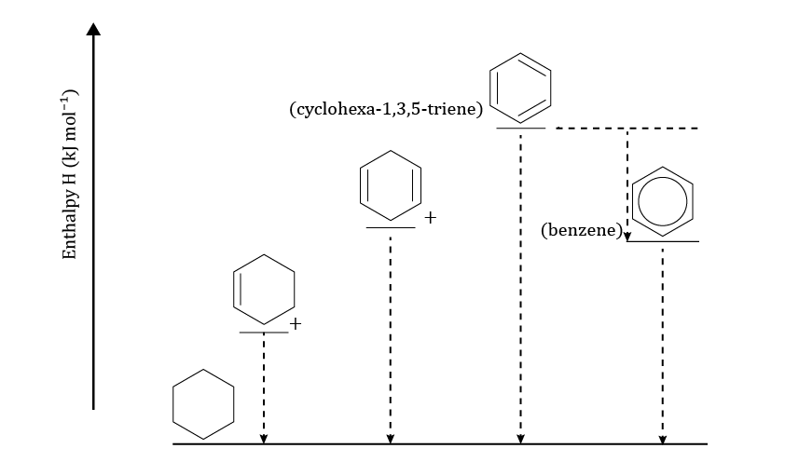

+

+

Use the information on the cards to help with questions 9–11.

1. Discuss in your group whether benzene or the theoretical cyclohexa-1,3,5-triene is more energetically (thermodynamically) stable.
2. Discuss in your group, considering the energy level diagram, whether you would expect benzene to be more or less reactive than alkenes.
3. Discuss why benzene is more/less stable than the theoretical cyclohexa-1,3,5-triene in terms of electron distribution.

**Reflection**

+

+

1. Based on your discussion and knowledge of structure and bonding, give two further descriptors which apply to benzene.
2. Based on your discussion and knowledge of hydrocarbon chemistry, give three pieces of evidence that confirm benzene is a continually delocalised structure and not cyclohexa-1,3,5-triene.
3. How did the discussion help you to explore your thinking on the structure of benzene?
4. What went well?
5. What would make it better next time?

**Stretch and challenge question**

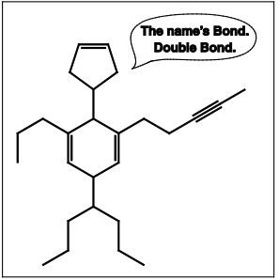*This question was included in the UK Chemistry Olympiad paper in 2016. Find out more about the Olympiad here and explore more questions at* [*edu.rsc.org/enrichment/uk-chemistry-olympiad*](https://edu.rsc.org/enrichment/uk-chemistry-olympiad)*.*

This question is about double bond equivalents (DBE).

The idea of DBE, the number of double bonds and/or rings that a compound contains, can be extremely useful when working out possible structures from formulas. Mr Bond, shown on the right, has 007 DBE.

1. The general formula for a non-cyclic alkane is . Give the general formulas for the following:
2. an alkene or cycloalkane,
3. an alkyne (a hydrocarbon containing a C≡C triple bond),
4. a cycloalkene,
5. a di-alkyne.

For each extra ring or -bond that a hydrocarbon has, an extra two hydrogens are lost compared with the alkane. The total number of rings and/or -bonds that a structure has is known as the number of double bond equivalents, DBE. For structures with multiple rings, the number of rings may be determined by counting the minimum number of cuts through bonds needed to be made in order to leave the structure ring-free.

1. The table below shows the possible combinations of rings, double bonds and triple bonds for DBE = 1 and DBE = 2. Extend the table to show the possible combinations for DBE = 3 and DBE = 4.

|  |  |  |  |
| --- | --- | --- | --- |
| **DBE** | **Ring** | **Double bond** | **Triple bond** |
| 1 | 1 | 0 | 0 |
|  | 0 | 1 | 0 |
| 2 | 2 | 0 | 0 |
| 0 | 2 | 0 |
| 1 | 1 | 0 |
| 0 | 0 | 1 |

The number of DBE in a hydrocarbon may be calculated by comparing the actual number of hydrogens (*X*) in a given hydrocarbon of formula with the number of hydrogens (*A*) in the non-cyclic alkane with the same number of carbon atoms ():

DBE

As an example, to work out the DBE for cyclohexene, , since the number of hydrogens in hexane (the alkane with six carbons) is 14,

DBE (cyclohexene) (14 – 10) = 2

1. Determine the number of double bond equivalents in:

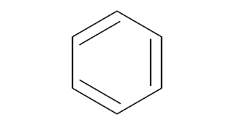

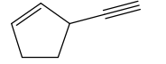

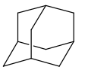

The types of DBE may be revealed using spectroscopic techniques, such as NMR. In 13C NMR, the number of signals in the spectrum depends on the number of different carbon environments in a structure. For example, in benzene, each carbon atom is equivalent and so the spectrum shows only one peak, whereas in 1,3-dimethylbenzene there are five different environments as shown below.

|  |  |
| --- | --- |
| A structural diagram of benzene - a hexagon with lines along three of the internal sides | A structural diagram of 1,3-dimethylbenzene with numbers representing five different environments reflected across a line of symmetry |
| In benzene, all the carbons are in equivalent environments, so the spectrum shows only one peak at 128 ppm. | In 1,3-dimethylbenzene, ignoring how the -bonds in the ring are drawn, a plane of symmetry (or rotation axis) runs through the molecule (shown by the dashed line). This means there are five different environments so five peaks appear in the spectrum as indicated. [Note: the unique carbons at 130 ppm and 128 ppm must lie on the axis.] |

Carbon atoms in the following environments typically give peaks in the regions indicated:

• Triple-bonded alkyne carbons: 70–100 ppm.

• Double-bonded alkene carbons: 100–160 ppm .

• Carbons with four single bonds to carbons or hydrogens: 0–50 ppm.

In the rather unusual allene group, C=C=C, the central carbon gives a peak over 200 ppm, and the carbons attached directly to the central allene carbon, flanking it either side, now fall in the same region as the triple-bonded carbons, i.e.

• Allene central carbon: >200 ppm.

• Allene flanking carbons: 70–100 ppm.

Using advanced NMR techniques, in addition to telling how many carbon atoms are in a particular environment, it is also possible to tell how many hydrogen atoms are attached to a particular carbon. We may denote this as (), (), (CH), or (C) for carbons with 3, 2, 1, or 0 hydrogens attached. The spectrum for 1,3-dimethylbenzene may be summarised as:

2 × 138 (C), 130 (CH), 128 (CH), 2 × 126 (CH), 2 × 21 ().

1. The following data is taken from the 13C NMR spectra of isomers with the formula which has five DBE. For each spectrum, first copy and complete the table to suggest how many triple bonds, double bonds, and rings each compound contains. Then suggest a skeletal structure consistent with the data. [You do not need to assign values to particular carbons.]

|  |  |
| --- | --- |
| **Spectrum** | **Signals / ppm** |
| A | 8 × 132 (CH) |
| B | 8 × 47 (CH) |
| C | 4 × 96 (C), 4 × 20 () |
| D | 2 × 210 (C), 134 (C), 113 (), 2 × 93 (CH), 2 × 79 () |
| E | 147 (C), 2 × 138 (CH), 2 × 131 (CH), 2 × 127 (CH), 112 () |
| F | 142 (CH), 136 (CH), 127 (), 120 (), 117 (CH), 112 (CH), 91 (C), 89 (C) |
| G | 2 × 146 (C), 2 × 127 (CH), 2 × 122 (CH), 2 × 30 () |
| H | 154 (C), 151 (C), 2 × 136 (CH), 2 × 128 (CH), 2 × 37 () |
| I | 157 (C), 101 (), 2 × 26 (CH), 4 × 19 (CH) |

|  |  |  |  |  |  |  |  |  |  |
| --- | --- | --- | --- | --- | --- | --- | --- | --- | --- |
|  | **Number of atoms in each region**  **(must add up to 8)** | | | | | **Structural information deduced** | | | |
| **Spectrum** | **Triple bond (alkyne)** | **Double bond (alkene)** | **Single bond** | **Allene central** | **Allene flanking** | | **Number of triple bonds** | **Number of double bonds** | **Number of rings** |
| **A** |  |  |  |  |  | |  |  |  |
| **B** |  |  |  |  |  | |  |  |  |
| **C** |  |  |  |  |  | |  |  |  |
| **D** |  |  |  |  |  | |  |  |  |
| **E** |  |  |  |  |  | |  |  |  |
| **F** |  |  |  |  |  | |  |  |  |
| **G** |  |  |  |  |  | |  |  |  |
| **H** |  |  |  |  |  | |  |  |  |
| **I** |  |  |  |  |  | |  |  |  |