Structure and bonding

This resource forms part of the structure and bonding topic package. It is supplied in a fully–editable format so you can adapt to best suit your learners.

Learning objectives
- Apply descriptions of covalent, ionic and metallic bonding to justify the different physical properties of covalent, ionic and metallic structures.
- Develop speaking and listening skills by using the structured talk foundations to help manage your group’s discussion.
- Build a shared understanding of the structure and bonding in the different forms of carbon, distinguishing between simple and giant structures from information about physical properties.
- Evaluate how successful your group’s word bridge is by comparing to the other examples.

Introduction

Encourage learners to think collaboratively by providing them with speaking and listening tasks. Effective discussions give learners the opportunity to build a shared understanding of chemistry concepts by articulating ideas that are developed and challenged constructively within the group.

Like any learning activity, effective discussion requires planning for purpose, content, action, time and reflection. Set learners a word bridge task to provide scaffolding that enables them to collaboratively reach a greater level of understanding than can be achieved alone and without the scaffold support. Put learners into groups of three, with defined roles and task them with laying a conceptual word bridge from start to finish, armed with a fact and some words to use as planks.

Word bridges were originally introduced in the article Constructive conversations with talk triplets, rsc.li/2wnzMRz.
Start    One concept or phrase | Fact  Useful information that will help learners to link the words below |  | Finish  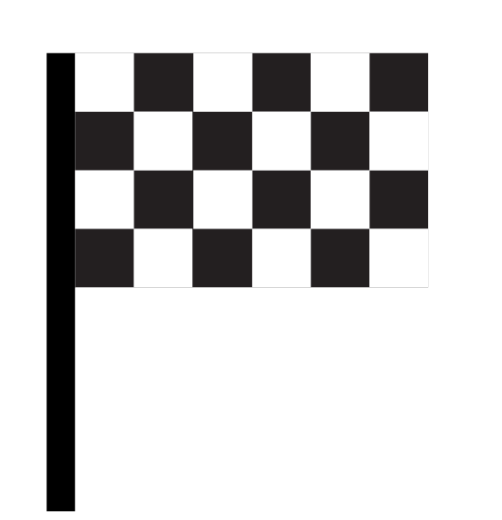  another concept  or phrase
 | Link these words
 | Words
 | several words or phrases | which learners need to put in order
 | during their | conversations
 | which will | help them cross

Supporting information  Learning objectives, a worked example, speaking and listening rules, roles and metacognitive questions. | Word bridges  Five word bridges for learners to build in groups, plus example answers. | Fix the bridge  Five misconceptions (related to the word bridges) for learners to discuss in groups, plus example answers.

Resource components

How to use word bridges

Set up the task
- Present the purpose of the task – to have structured conversations about chemistry, which help everyone to learn.
- Introduce the idea of ground rules in speaking and listening (slide 4).
- Invite comments and updates and keep the rules visible to learners throughout.
- Split the class up into groups of three in which one learner will take role A (architect), one will take role B (bridge builder) and one will take role C (civil engineer). Provide each group with a print out of slide 5, which introduces the roles.
- Talk through/display the ‘Building word bridges’ slide (slide 6). Provide each group with a printout of the sentence starters slide (slide 7).
- Project a word bridge onto the board. Provide each group with a printed copy of the word bridge if helpful.

Model structured talk
- Model a word bridge conversation first, before asking the learners to begin. You can use the worked example provided on slide 9.

Suggested sequence
- Give the learners 30 seconds to silently look at the word bridge fact and plan how they could use the words provided to get from the start to the finish.
- Give learners two minutes – in their different roles – to discuss the best way to use all the words provided to build the bridge. Remind them to use the fact provided to help link the start point to the finish point.
- Select a few groups to share their ‘bridge’ with the class (this is part of C’s role) and ask the class for feedback before providing the sample answer and correcting misconceptions. You can allow about five minutes for this. This step is essential to avoid misconceptions going unchallenged.
- Ask learners in each group to swap roles so A becomes B, B becomes C and C becomes A. Talk through the ‘Fix the bridge’ instructions slide (slide 12) and then display the relevant ‘Fix the bridge’ slide for the word bridge you are focusing on. Give the groups 30 seconds silent thinking time before asking them to assume their new roles.
- Give learners two minutes to discuss how to fix a wrong statement, or how to unpick and clarify a challenging statement. In some cases, there may also be questions posed which require debate and a consensus answer.
- Select a few groups to share their ‘Fix the bridge’ correction/clarification/answer with the class (again, this is part of learner C’s role) and ask the class for feedback before providing the sample answer (allow about five minutes).
- Ask learners in each group to swap roles again (they should be adopting the third role this time) before supplying the next word bridge and repeating the process.
- End the structured talk by inviting answers to the questions on the reflection slide. Prioritise contributions from any learners who have not yet presented to the class.

Tips for success
- Structured talk may be new to you and your learners. It takes time and regular practice for the groups to work effectively as a team, but it’s worth it.
- Encourage learners to give each other feedback during this activity. This is essential for them to develop their speaking and listening skills in this chemistry context. Following the suggested sequence above provides opportunities for peer and teacher feedback.
  - Prompt learners to provide feedback during discussions with questions like: ‘in what way do you agree or disagree with what X has just said?’
  - Provide additional support by listening in and feeding back in groups’ initial discussions.
- Project a stop clock to keep learners on task and to time.
- Throughout the activity, prompt learners to consider the metacognitive questions on slide 8 – provide printouts of this slide, if helpful. Revisit the slide as part of the reflection at the end of the lesson if necessary.

Adaptations

More support
- Use one word bridge at a time and emphasise establishing the speaking and listening rules. Following the timings above, each word bridge cycle should take about 15 minutes.
- Encourage learners who are uncomfortable with feeding back to the class to tell you so that you can make sure they are not the first one up.
- Instead of role C always presenting to the class, you could use a random name draw or wheel to select who presents their triplet’s word bridge. Prepare these in advance by copying in the list of learners’ names.
- For less confident learners who may struggle to engage with the structured talk, provide a copy of this topic’s accessible glossary (rsc.li/444TbFh) so they can refer to any unfamiliar words.

Less support
- Devote a larger portion of the lesson to discussion and supply multiple word bridges among the different groups.
- Set up stations for each word bridge and get the groups to move around the room until every group has completed a circus of word bridges and ‘Fix the bridge’ problems. Five are provided in this resource for this topic.
- Use any printed word bridges for revision, or to visualise links between different topics that share common concepts. Task learners to arrange them into a topic map.

Metacognition

This resource supports learners to develop their metacognitive skills in three key areas, shown in the table below.
Aspect | Ideas for prompts
Plan | Prompt learners to ask themselves the following questions during the 30 seconds of silent thinking time:  - Have I seen a task like this before? What will I need to complete this task? How am I going to do it? What is going to be challenging? What do I already know that will help me here?
Monitor | Discussion affords the opportunity to challenge personal knowledge and explore understanding by explaining and justifying ideas. Circulate round the triplets in their two-minute discussions and prompt learners to ask themselves:  - Are we using the fact to link all the words in order to move from the start to the end? Are we all staying in our roles of A, B or C? Do we need to change anything in order to complete the task?
Evaluate | Prompt learners to reflect with these questions:  - How do you feel about this task? Why? How well did you and others adhere to the ground rules? How did you get on with each of the roles in the triplet? What went well, what was challenging? What have you learnt doing this activity that you can put into action next time you talk about chemistry?

Other literacy support resources

This structured talk resource is part of a wider set of literacy resources available for the topic of structure and bonding. This set includes:
- Key terms support, available from: rsc.li/444TbFh
  - a key terms list – carefully selected vocabulary, with definitions, that learners will come across when studying this topic at this stage
  - an accessible glossary – uses diagrams, examples, pronunciation guides and more to bridge the gap between key terms and definitions
  - Frayer models – a way for learners to organise their understanding of a new piece of vocabulary by working through four conceptual quadrants with the key terms: explore, break down, explain, consolidate.
  - Unscrambling definitions – where learners piece together key terms definitions and use their understanding of the terms to complete sentences.
- Reading comprehension – worksheet to promote active reading of science research news, plus a presentation extension task. Visit rsc.li/44i3Yf3
- Structure strips – margin sized prompts to help learners write independently. Visit rsc.li/4aXYgzt

