Covalent structure and bonding: teacher guidance

**These Knowledge check worksheets**provide a series of questions to assess learners’ knowledge and understanding of this topic at the end of a period of teaching or as revision. They are available at Foundation and Higher level and as fully editable versions so you can adapt them to suit learners’ needs. Use for individual student work in class or at home. Find the full set of answers below.

Also available to assess this topic:

* **Review my learning** **worksheets**: available with three levels of scaffolded support to help build confidence in every learner. Use before, during or after teaching the relevant topic, to understand progress and identify misconceptions, **rsc.li/44igB7V**.
* **In context worksheets** ask learners to apply their knowledge to interesting contexts from everyday life, helping them develop their skills and prepare for examination, including calculation questions to practise mathematical skills within a genuine chemical context, **rsc.li/3VC8uR1**.

Answers

Foundation

1. (a) **B** compounds of non-metals only [1 mark]

**C** molecules of non-metals [1 mark]

(b) i. 2 [1 mark]

ii. 4 [1 mark]

iii. 6 [1 mark]

* 1. **D** an electron [1 mark]
  2. i. Two electrons shared [1], correct overall number of electrons [1]

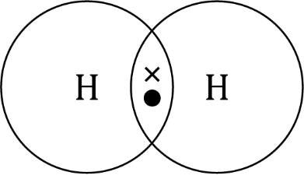

[2 marks]

* + 1. [1 mark]
  1. One pair/two electrons shared in two bonds [1], correct overall number of electrons [1]

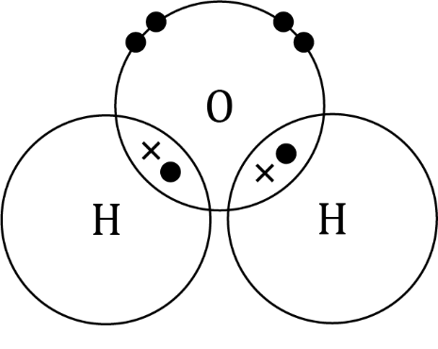

[2 marks]

1. (a)

|  |  |  |
| --- | --- | --- |
| **Substance** | **Diagram of structure** | **Type of structure** |
| poly(ethene) | A section of a poly(ethene) molecule showing several black spheres joined to each other and to two white spheres through single bonds. | polymer |
| ammonia | A computer image of a blue ball connected by three blue and white sticks to three white balls. | simple molecule |
| graphite | A section of graphite showing three layers of black spheres connected in interconnected hexagons through single bonds. | giant covalent structure |

[3 marks – 1 mark per correct row]

(b) strong[1]; weak[1]; intermolecular forces[1] [3 marks]

* 1. stronger[1]; higher[1]; more[1] [3 marks]

|  |  |  |  |  |
| --- | --- | --- | --- | --- |
| **Does the representation show:** | NH3 | Full displayed formula of ammonia showing a central nitrogen atom connected to three hydrogen atoms through single bonds. | Dot and cross diagram of an ammonia molecule showing a central nitrogen atom surrounded by three hydrogen atoms. The outer shell of each hydrogen atom overlaps with the nitrogen outer shell and there is a dot and a cross in each of the three areas of overlap. The outer shell of nitrogen also has two dots separately. | A computer image of a blue ball connected by three blue and white sticks to three white balls. |
| the types of atoms in the molecule? | ✓ | ✓ | ✓ | ✓ |
| the number of each type of atom? | ✓ | ✓ | ✓ | ✓ |
| how the electrons are shared? | 🗶 | 🗶 | ✓ | 🗶 |
| the 3-D structure? | 🗶 | 🗶 | 🗶 | ✓ |

[4 marks – 1 mark per correct row]

[Total: 24 marks]

Higher

1. **B** compounds of non-metals only [1 mark]

**C** molecules of non-metals [1 mark]

1. (a) One pair/two electrons shared [1], correct overall number of electrons [1]

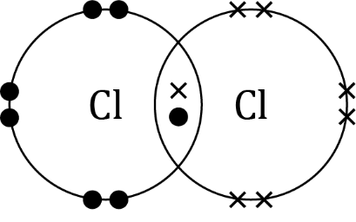

[2 marks]

(b) One pair/two electrons shared in two bonds [1], correct overall number of electrons [1]

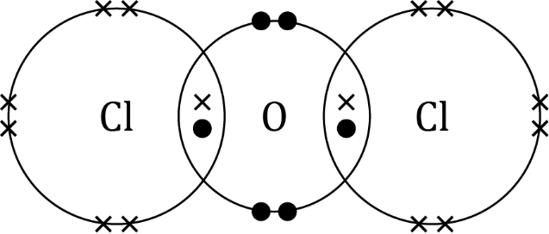

[3 marks]

(c) i. Allow liquid or gas. [Note that the boiling point of is 2.2 °C] [1 mark]

ii. has a simple molecular structure [1] with weak intermolecular forces between its molecules [1]. These are easily overcome/do not take much energy to overcome [1]. [3 marks]

1. Poly(chloroethene) is a polymer/has large molecules [1] with stronger intermolecular forces [1], which need more energy to overcome [1].

[3 marks]

1. (a) 4 electrons [1 mark]

(b) Two pairs/four electrons shared in two CO bonds [1], correct overall number of electrons [1]

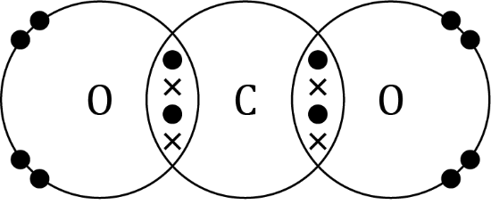

[2 marks]

1. (a) Correct number and type of atoms in correct order [1], double and single bonds shown correctly [1]

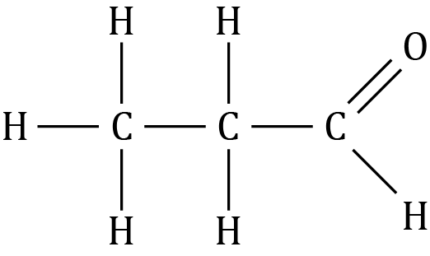

[2 marks]

* 1. [allow any combination of C, H and O to give ] [1 mark]

(c)

|  |  |  |  |  |
| --- | --- | --- | --- | --- |
| **Does the representation show:** | NH3 | Full displayed formula of ammonia showing a central nitrogen atom connected to three hydrogen atoms through single bonds. | Dot and cross diagram of an ammonia molecule showing a central nitrogen atom surrounded by three hydrogen atoms. The outer shell of each hydrogen atom overlaps with the nitrogen outer shell and there is a dot and a cross in each of the three areas of overlap. The outer shell of nitrogen also has two dots separately. | A computer image of a blue ball connected by three blue and white sticks to three white balls. |
| the types of atoms in the molecule? | ✓ | ✓ | ✓ | ✓ |
| the number of each type of atom? | ✓ | ✓ | ✓ | ✓ |
| how the electrons are shared? | 🗶 | 🗶 | ✓ | 🗶 |
| the 3D structure? | 🗶 | 🗶 | 🗶 | ✓ |

[4 marks – 1 mark for each correct row]

1. (a) X is giant covalent structure [1 mark]

Y is simple molecule [1 mark]

Z is polymer [1 mark]

* 1. intermolecular forces [1 mark]
  2. Simple molecular covalent substances have no charged   
     particles to carry the charge. [1 mark]

[Total: 29 marks]