Covalent structure and bonding

Introduction

These questions are designed to help you to develop your mental models (pictures in your head) of covalent structures so that you can visualise covalent molecules in different ways. Use the icon in the margin to find out which level of understanding the question is developing.

|  |  |
| --- | --- |
| An icon used to indicate the Macroscopic part of Johnstone's triangle. | **Macroscopic:** what we can see. Think about the properties that we can observe, measure and record. |
| An icon used to indicate the Sub-microscopic part of Johnstone's triangle. | **Sub-microscopic:** smaller than we can see. Think about the particle or atomic level. |
| An icon used to indicate the Symbolic part of Johnstone's triangle. | **Symbolic:** representations. Think about how we represent chemical ideas including symbols and diagrams. |

Questions

1. Covalent compounds exist in the solid, liquid and gas state at room temperature.

|  |  |  |  |
| --- | --- | --- | --- |
| A diagram containing six circles. Four white and two dark orange. None of the circles are touching. All the circles are randomly arranged. | A diagram made up of four shapes. Each shape contains three circles that are arranged in a straight line. The two outer circles are white and the middle circle is dark orange. The four shapes are not touching each other and are randomly arranged and oriented. | An image made up of 16 circles arranged in a regular pattern of four rows and four columns. The circles are touching their adjacent neighbour in the rows and columns. The colour of the circles alternates between white and dark orange. | An image made up of 16 circles arranged in a regular pattern of four rows and four columns. The circles are touching their adjacent neighbour in the rows and columns. The colour of the circles alternates between white and pale orange. |
| A | B | C | D |

1. Carbon dioxide is a colourless gas at room temperature.

Select the diagram, A, B C or D, that best represents the structure of carbon dioxide.

1. Silicon dioxide is a crystalline solid at room temperature.

Select the diagram, A, B C or D, that best represents the structure of silicon dioxide.

1. The formula for water is . Different diagrams can be used to represent a single water molecule.

|  |  |
| --- | --- |
| A diagram made up of three circles. Two white circles and a red circle. The two white circles are touching the red circle. The angle between where the white circles touch the red circle is approximately 90 degrees. | The structural formula for water consisting of a single O connected to two Hs. The bond angle between the two Hs is 104 degrees. |
| A | B |

1. Describe how a hydrogen atom is shown in each diagram.

__________________________________________________________________________________

__________________________________________________________________________________

__________________________________________________________________________________

__________________________________________________________________________________

1. Describe how covalent bonding is shown in each diagram.

__________________________________________________________________________________

__________________________________________________________________________________

__________________________________________________________________________________

__________________________________________________________________________________

1. The formula for methane is .

|  |  |  |
| --- | --- | --- |
| A skeletal formula consisting of a single C and four Hs arranged in a straight line: C-H-H-H-H | A skeletal formula consisting of a single C surrounded by four Hs in a cross shape. One H above, one below, one to the left and one to the right. Each H has a single line linking it to the C. The C therefore has four lines, one each from each H. | A skeletal formula consisting of a single four Cs and four Hs arranged in a straight line: C-H-C-H-C-H-C-H |
| A | B | C |

1. Select the diagram that represents the atoms and covalent bonds in a molecule of methane.
2. Draw a dot and cross diagram of a methane molecule.

Carbon atoms have 6 electrons and hydrogen atoms have 1 electron.

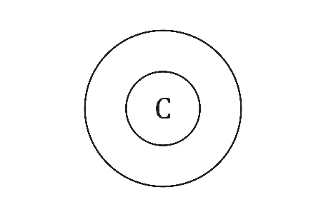

1. Another diagram of CH4 shows the carbon atom in the middle with two hydrogen atoms on each side.

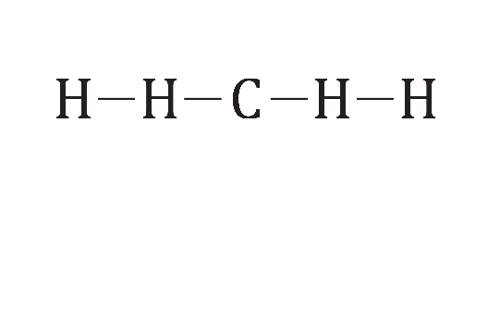

Explain why this diagram cannot be correct.

__________________________________________________________________________________

__________________________________________________________________________________

__________________________________________________________________________________

__________________________________________________________________________________

__________________________________________________________________________________

1. A Molymod™ kit uses balls and connecting sticks to represent how atoms in a molecule are joined by covalent bonds.

In the kit, a carbon atom is represented by a black ball.

1. Explain why the black balls in the kit are made with four holes.

__________________________________________________________________________________

__________________________________________________________________________________

1. These diagrams show two models of a methane molecule.

|  |  |
| --- | --- |
| A skeletal formula consisting of a single C surrounded by four Hs in a cross shape. One H above, one below, one to the left and one to the right. Each H has a single line linking it to the C. The C therefore has four lines, one each from each H. | A photograph of a Molymod kit model of methane consisting of one black ball connected to four grey sticks on the ends of which is a white ball (four white balls in total). The structure forms a tetrahedron in shape. |
| Displayed formula | Molymod™ kit model |

State one advantage of the Molymod kit model.

__________________________________________________________________________________

__________________________________________________________________________________

1. The formula of water is. Draw a dot and cross diagram of a water molecule.  
   An oxygen atom has 8 electrons and a hydrogen atom has 1 electron.
2. In a Molymod kit, a red ball represents an oxygen atom.  
   Suggest how many holes each red ball is made with. Give a reason for your answer.

__________________________________________________________________________________

__________________________________________________________________________________

__________________________________________________________________________________

1. The diagram below shows the shape of a water molecule.

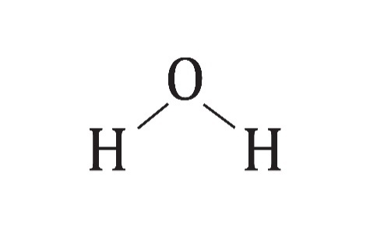

Suggest why the bonds in a water molecule are not in a straight line. Refer to the structure of a methane molecule in your answer.

__________________________________________________________________________________

__________________________________________________________________________________

__________________________________________________________________________________

__________________________________________________________________________________

__________________________________________________________________________________



1. The formula of carbon tetrafluoride is .
2. Draw the dot and cross diagram of carbon tetrafluoride.

In a Molymod kit, a green ball can be used to represent fluorine.

|  |  |  |
| --- | --- | --- |
| A diagram of a 3D model containing one black sphere and four green spheres. The black sphere is in the centre with the green spheres connected to it by grey rods at 90 degree angles. The overall shape of the model is a flat cross. | A diagram of a 3D model containing one black sphere and four green spheres. The black sphere is in the centre with the green spheres connected to it by grey rods, each equidistant from each other. The overall shape of the model is a tetrahedron with each of the green spheres at one of the corners of the triangular prism and the back sphere in the centre. | A diagram of a 3D model containing one black spere and four green spheres. The black sphere is in the centre with two green spheres connected to it by grey rods in a long straight line. Two green spheres either side of the black sphere. |
| A | B | C |

1. Select the Molymod model picture that shows the correct 3D structure of carbon tetrafluoride.
2.  The formula for silicon dioxide is . The formula for silicon dioxide does not tell us that it forms giant covalent structures.

The diagram below shows a ball and stick model of silicon dioxide.

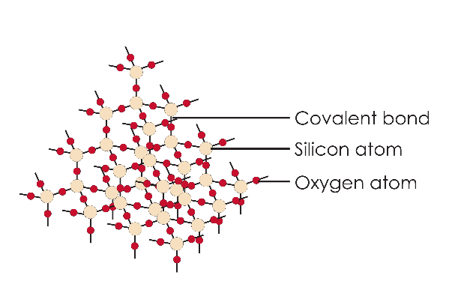

1. Complete the sentence to describe what the formula represents.

“For every atom of silicon there are ___________________________________________.”

The diagram below shows a dot and cross diagram for one silicon atom and four oxygen atoms. This diagram shows a section of the bonding in the giant silicon dioxide structure. It does not show a separate molecule.

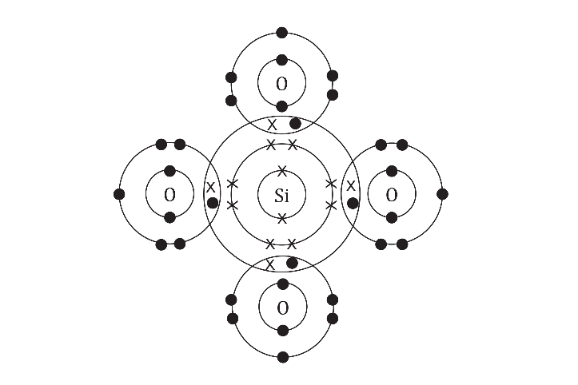

1. Give the number of electrons in the outer shell of each oxygen atom. __________
2. State how many more covalent bonds each oxygen can make. __________
3. Explain why silicon and oxygen are able to form a giant covalent structure.

__________________________________________________________________________________

__________________________________________________________________________________

__________________________________________________________________________________