The microscale synthesis of indigo dyes – student sheet

In this experiment you will be doing a microscale synthesis of the dye indigo. This dye has been known for a very long time (in Britain it was being used before the Romans first came to the country) and used to be obtained naturally from woad.

It was first produced synthetically by the German chemist Baeyer in 1879 and this work formed the foundation of much of the modern organic chemical industry. You will probably be very familiar with indigo – it is the colouring in blue jeans.

Students must wear suitable eye protection and gloves.

Procedure
- Weigh out approximately 0.1 g of 2-nitrobenzaldehyde into a test tube.
- Add 2 cm3 of propanone (from a measuring cylinder) and swirl gently to dissolve the solid.
- Add 25 drops of deionised water and swirl gently.
- Slowly add 20 drops of sodium hydroxide solution to the solution. The solution quickly darkens and a purple solid (indigo) should precipitate out.
- Leave for 5 min to complete the precipitation.
- Filter the solution washing with deionised water until the washings are colourless, and set aside to dry.
- Describe the appearance of your product.

The structure of indigo is shown below:
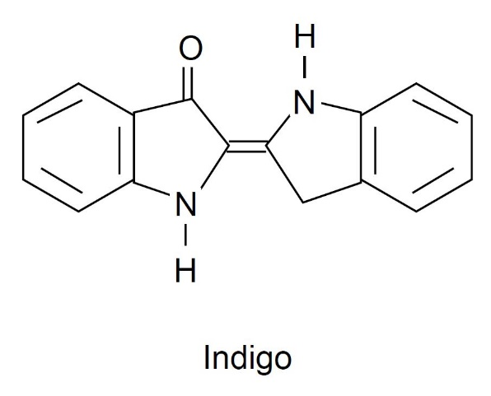

Health, safety and technical notes
- Read our standard health and safety guidance here https://rsc.li/3BXrM8v
- Students must wear suitable protection (Splash resistant goggles to BS EN166 3).
- Sodium hydroxide solution, 0.5 mol dm–3 NaOH (aq) is corrosive (see CLEAPSS Hazcard HC091a).
- Propanone is highly flammable, and an eye/respiratory irritant (see CLEAPSS Hazcard HC085a)
- 2-Nitrobenzaldehyde is Harmful if swallowed and a skin/eye and respiratory irritant (see ChemSpider10630).

