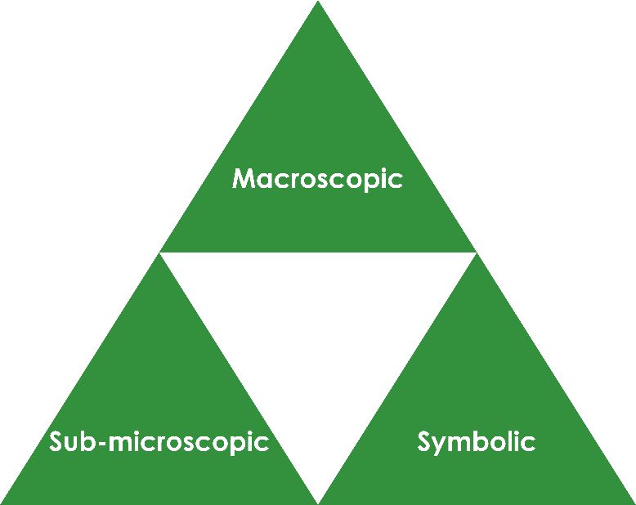Diffusion of colour in water: Johnstone’s triangle

Learning objectives

1. Describe the process of diffusion.
2. Explain diffusion using the particle model.

Introduction

Diffusion happens all around us all the time. We can use coloured compounds to visualise the movement of particles.

Johnstone’s triangle

In chemistry we make sense of the things that we can see by representing what we can’t see using formulas, equations, diagrams and models.

Johnstone’s triangle is a way of thinking about these different concepts as different corners of a triangle:

* Macroscopic – what we can see. Think about the properties we can observe, measure and record.
* Sub-microscopic – smaller than we can see. Think about the particle or atomic level.
* Symbolic – representations. Think about how we represent chemical ideas, including symbols and diagrams.

Being able to connect and move between these three different levels is important for scientific understanding.

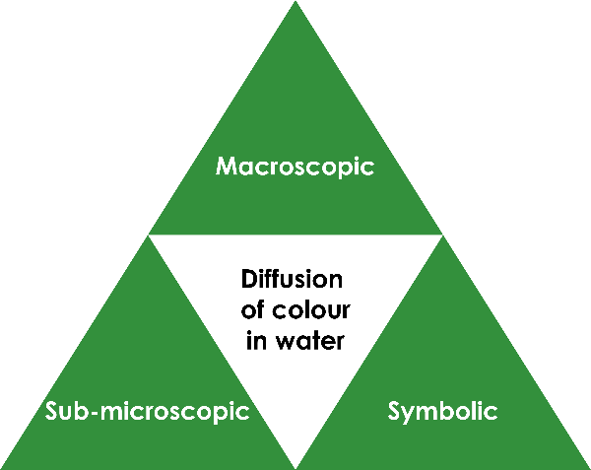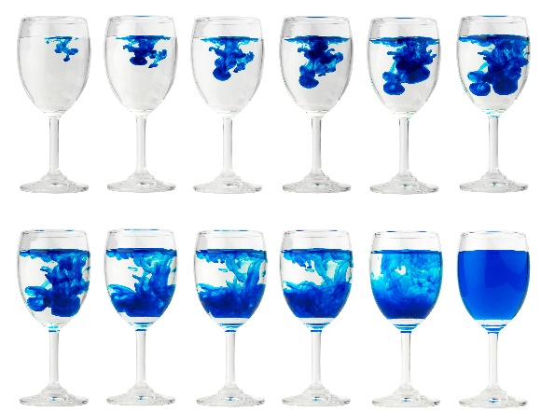

Symbolic – representations

The diffusion of particles can be presented by using diagrams as shown below:

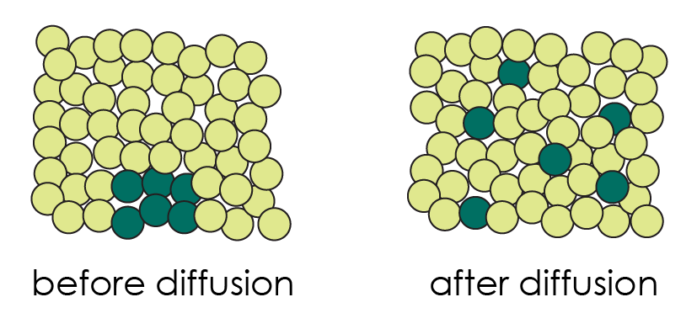

Describe what these diagrams show happening during diffusion.

Sub-microscopic – smaller than we can see

Complete the sentence:

Particles in a liquid ____________________ randomly. When they collide with each other they ____________________ direction. This means that, over time, they ____________________ until they are evenly distributed through the solvent.

Before particles in a solid can diffuse the solid has to dissolve. Describe the difference between **dissolving** and **diffusion**.

Macroscopic – what we can see

Watch the demonstration. Describe what you observe.

Image adapted from: © Shutterstock / NARUDON ATSAWALARPSAKUN