Melting ice and boiling water: Johnstone’s triangle

This resource is from the **Johnstone’s triangle** series which can be viewed at: [rsc.li/43jMfSn](https://rsc.li/43jMfSn). It will help learners to understand the different ways you need to think in chemistry, building their mental models and understanding.

Learning objectives

1. Describe what happens to a substance when it is heated or cooled in terms of state changes.
2. Use melting and boiling point information to work out the state of a substance at a given temperature.

How to use Johnstone’s triangle

Use Johnstone’s triangle to develop learners’ thinking about scientific concepts at three different conceptual levels:

* 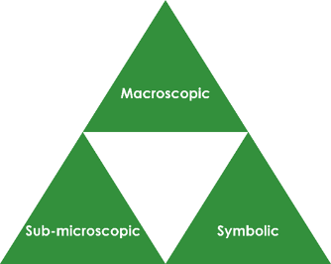Macroscopic – what we can see. Think about the properties you can observe, measure and record.
* Sub-microscopic – smaller than we can see. Think about the particle or atomic level.
* Symbolic – representations. Think about how we represent chemical ideas including symbols and diagrams.

For learners to gain a deeper awareness of a topic, they need to understand it at all three levels.

When introducing a topic, do not try to introduce the three levels of thinking at once. This will overload working memory. Instead complete the triangle over a series of lessons, beginning with the macroscopic level before introducing the sub-microscopic and then the symbolic levels, once understanding of the previous stages is secure.

The three levels are interrelated, for example, learners need visual representation of the sub-microscopic level to develop mental models of the particle or atomic level.

Find further reading about Johnstone’s triangle and how to use it in your teaching at [rsc.li/4laqj4k](https://rsc.li/4laqj4k)

Scaffolding

It is important to share the structure of the triangle with learners prior to use. Tell them why you want them to use the triangle and how it will help them to develop their understanding. Use an ‘I try, we try, you try’ approach when you are introducing Johnstone’s triangle for the first time.

More resources

To further develop learner’s thinking in all areas of Johnstone’s triangle, try our **Developing understanding of melting and boiling points** worksheets ([rsc.li/4kIRGkR](https://rsc.li/4kIRGkR)). This includes icons in the margin referring to the conceptual level of thinking needed to answer the questions.

Teacher demonstration

Use this demonstration of the melting and boiling of water to encourage learners to observe and describe the macroscopic changes of state that are occurring.

Equipment for teacher

* Melting ice cube on a watch glass
* Boiling kettle

Method

1. Place an ice cube on a watch glass and observe it melting. You may wish to make use of a visualiser to allow for whole class observation.
2. Add water to a kettle and switch it on to boil the water.
3. Learners write their observation in the ‘Macroscopic’ section of the Johnstone’s triangle worksheet.

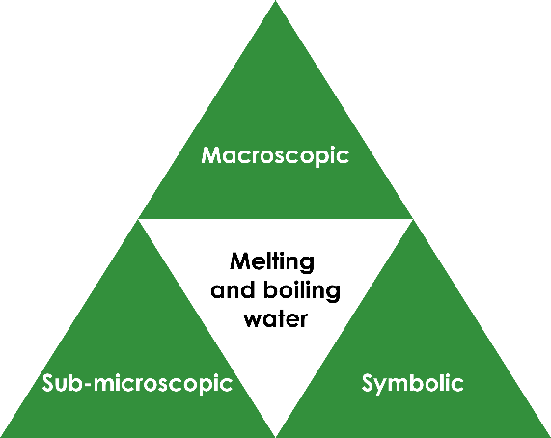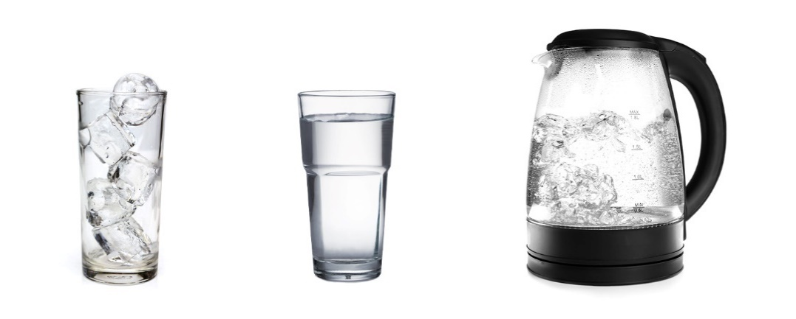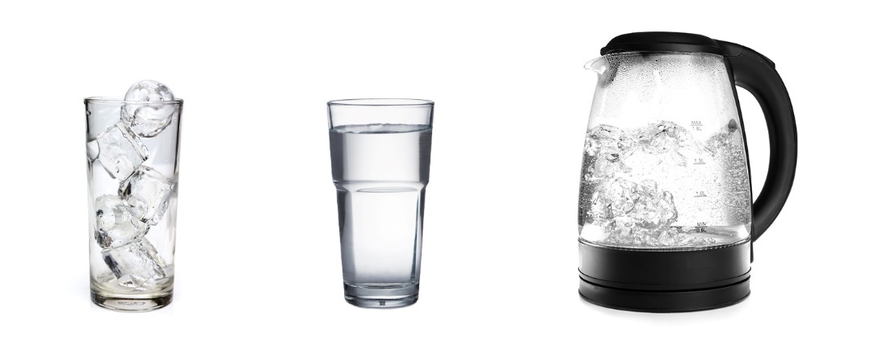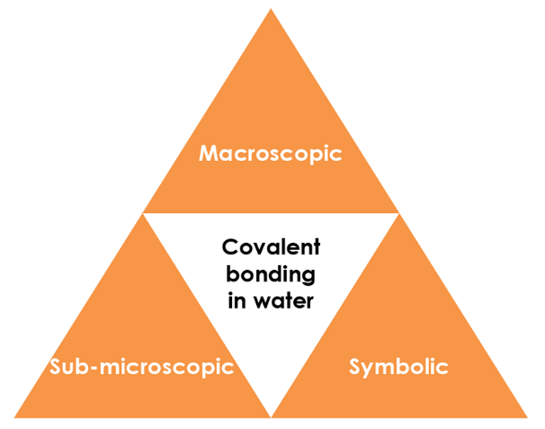

Macroscopic - what we can see

Name the changes of state that are happening:

1. To the ice cube **melting**
2. In the kettle **boiling**

Describe how the kettle turns water from the liquid to gas state.

**The kettle heats the water to its boiling point (100°C).**

Image adapted from © Shutterstock

**liquid**

**gas**

**solid**

**condensing**

**freezing**

**boiling**

**melting**

Symbolic - representations

The diagram shows the particle diagrams for the three states of matter with arrows to show the different changes of state.

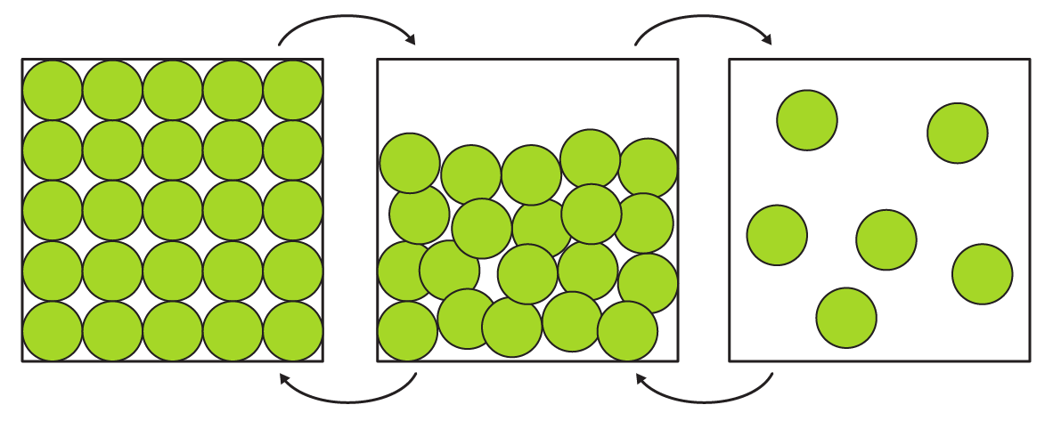

Add a label to each arrow to name the change of state.

**melting boiling freezing condensing**

Sub-microscopic - smaller than we can see

Water has a melting point of 0°C and a boiling point of 100°C.

Work out the state at the temperatures given below and complete the particle diagram for each. Write the state beneath your diagram.

-34°C 109°C 54°C

  

______________ ______________ ______________