Becoming Mendeleev

Learning objectives

1. Explore key periodic trends of group 1, group 7 and group 0.
2. Describe how Mendeleev used trends in chemical and physical properties to arrange elements in groups.
3. Predict properties of elements based on trends in groups.
4. Use graphs and numerical data to make predictions.

Introduction

Dmitri Mendeleev’s contributions towards the periodic table as we know it were monumental in furthering our understanding of chemical elements. In producing his periodic table, Mendeleev:

* Ordered elements mainly by **atomic mass.**
* **Swapped elements** that he felt were not placed in the correct group based on their chemical and physical properties.
* **Left gaps** for elements he felt had not yet been discovered.
* **Predicted** chemical and physical properties of these elements.

In this series of tasks, you will become Mendeleev by trying out his method! You will explore some key chemical and physical properties of three groups: the alkali metals (group 1), the halogens (group 7), and the noble gases (group 0). By using these trends, you will be able to predict the properties of four elements: **francium, astatine, tennessine and oganesson.**

Task 1: the alkali metals (group 1)

The elements of group 1 are known as the alkali metals due to the solutions formed when they react with water. You will have seen these reactions for the first three alkali metals: lithium, sodium and potassium.

We know that Mendeleev made predictions of elements he felt were yet to be discovered at the time. One of these elements was ‘dvi-caesium’, an element *like* caesium which he felt was waiting to be found.

After many failed attempts to isolate the element, it was finally discovered by Marguerite Perey and named francium in 1939. You will explore the chemical reactions of the alkali metals and then make predictions about the chemical behaviour of this element.

Making predictions

The table below shows observations for the reaction of group 1 metals with water.

|  |  |  |
| --- | --- | --- |
| **Element** | **Observations of reaction with water** | **Equation** |
| Lithium | Fizzes | lithium + water → lithium hydroxide + hydrogen |
| Sodium | Fizzes vigorously | sodium + water → sodium hydroxide + hydrogen |
| Potassium | Fizzes vigorously, a lilac flame is produced | potassium + water → potassium hydroxide + hydrogen |
| Rubidium | Fizzes violently | rubidium + water → rubidium hydroxide + hydrogen |
| Caesium | Explodes in contact with water | caesium + water → caesium hydroxide + hydrogen |

1. Explain how the group number relates to the electronic structure of the alkali metals.
2. Suggest the formula of the ion formed when francium reacts.
3. Describe the trend in reactivity as you descend group 1 using these observations.
4. Predict what you would observe if francium was added to water.
5. Identify the metal-containing product which would be formed in the reaction between francium and water.
6. Construct a balanced symbol equation for the reaction between caesium and water.
7. Use your answer to Q1.6 to suggest the balanced symbol equation for the reaction between francium and water.
8. A student adds five drops of universal indicator to each solution after the reaction. Suggest how the pH of the resultant solution might vary down the group.
9. Group 1 metals also react with chlorine.
10. State the formula of the product formed when sodium reacts with chlorine.
11. Predict the likely formula of the product formed when francium reacts with chlorine.
12. Predict the likely structure and bonding of the product formed when francium reacts with chlorine.

Task 2: the halogens (group 7)

The halogens are a highly reactive group of non-metal elements. The halogens form diatomic molecules with the general formula .

When studying mineral samples in 1939, a scientist named Walter Minder observed what appeared to be a new element in samples of radium. He undertook chemical tests and found this new element behaved like iodine. The element was eventually discovered in 1940 and named astatine. Astatine is radioactive and has a very short half-life. This means scientists have never isolated enough astatine to weigh it and we know little about its chemical and physical properties.

The element tennessine was officially confirmed in 2015 and added to group 7 of the periodic table. It was discovered in 2010 by a group of scientists from the Joint Institute for Nuclear Research, the Lawrence Livermore National Laboratory and the Oak Ridge National Laboratory. We know very little about tennessine, because only a few atoms have ever been made.

You will use some key trends down group 7 to predict likely physical properties for astatine and tennessine.

Modelling the halogens

Using materials found around your home, make models to show the structures of the halogens from fluorine to iodine. You should represent the following trends going down the group:

* What happens to the size of the molecules?
* What happens to the colour intensity?  
  *(Remember: this is not a property of individual molecules, it is a ‘bulk property’ of the material, which means it is a property when there are many of the molecules together.)*
* What happens to the state at room temperature?

Questions

1. Describe the structure and bonding of the fluorine molecule.
2. Draw a dot-and-cross diagram for a molecule of chlorine. Show the outer electrons only.
3. Predict the expected structure and bonding of astatine.
4. Predict the chemical formulas of astatine and tennessine molecules.
5. What happens to the number of occupied electron shells as we descend the group?
6. Explain how the size of the molecules affects the melting point.
7. Predict and explain the likely state of tennessine at room temperature.
8. Describe the trend in colour intensity of the halogen vapours as we descend group 7.
9. Predict the likely colour intensity of astatine.
10. The table below shows some data on the halogens.

|  |  |  |  |  |
| --- | --- | --- | --- | --- |
| **Element** | **Molecular formula** | ***M*r** | **Melting point (°C)** | **Boiling point (°C)** |
|  |  | 38 | -220 | -188 |
| Chlorine |  | 71 | -102 | -34 |
|  |  |  | -7 | 59 |
| Iodine |  | 254 | 114 | 184 |
| Astatine |  |  | 300 | 350 |
| Tennessine |  | 588 | ? | ? |

1. Complete the table.
2. Use these data to plot a graph of the molecular formula (*x*-axis) against the melting point (*y*-axis) on the axes over the page.
3. Repeat this for boiling point (*y*-axis), plotting the points **on the same graph.** You will need to add a key to label each line.
4. Draw a horizontal line at 20°C. This is room temperature.
5. Use your graph to estimate the melting and boiling point of tennessine.
6. Use your graph to predict the state of tennessine at room temperature (20°C). Does this match your earlier prediction?

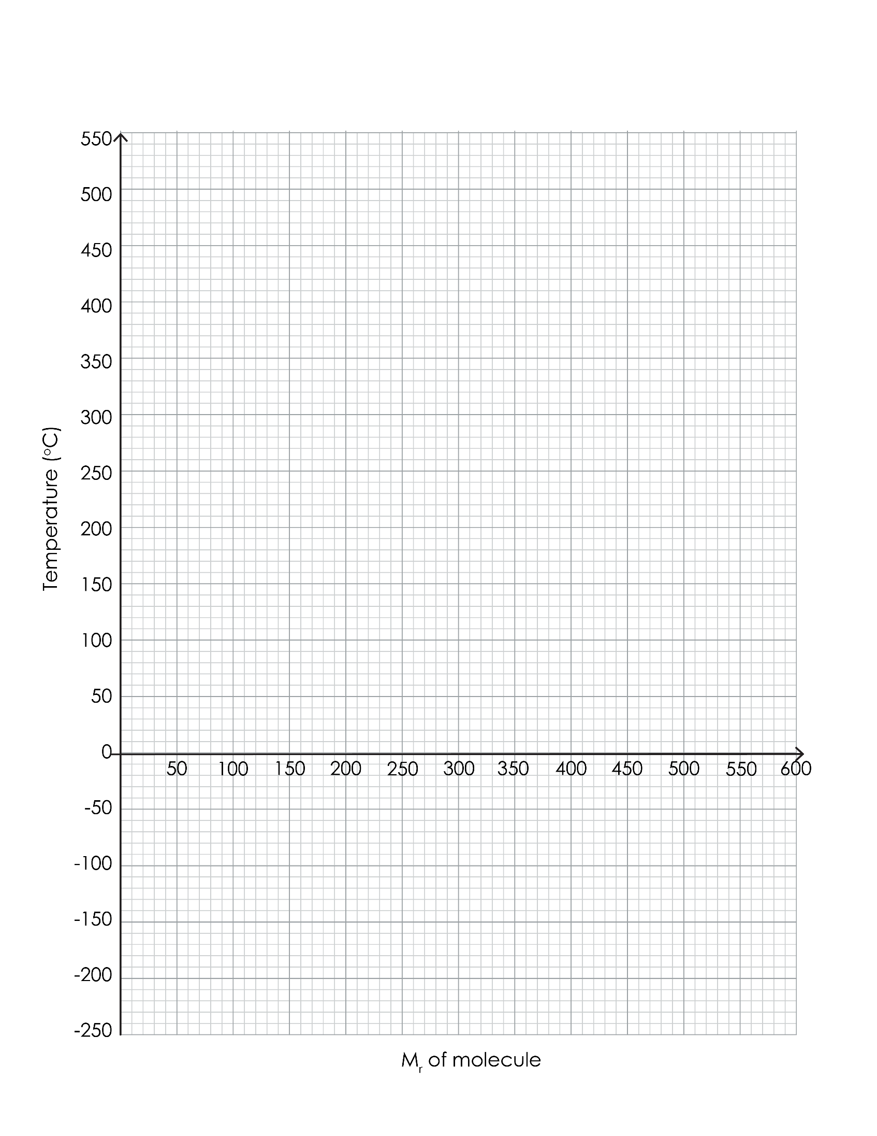

Task 3: the noble gases (group 0)

The noble gases were late discoveries in the world of chemical elements. This is because they are very unreactive. Scientists in the late 1800s had begun identifying gases in air samples using new spectroscopic techniques. Lord Rayleigh and William Ramsey began studying gas densities – a measure of how tightly packed the gases are within their volume. By carefully measuring the density of the gas which remained once all oxygen, carbon dioxide and water vapour had been removed from air, one gas remained which was denser than nitrogen. Rayleigh and Ramsey realised a new element, unknown at the time, was making up a small proportion of the sample. This gas was argon. Using Mendeleev’s prediction methods, Ramsey predicted other noble gases and their properties, establishing the existence of neon, krypton and radon.

Oganesson is the element with the highest atomic number and atomic mass of all the currently known elements. It is a synthetic element, first synthesised in 2002 by a group of scientists from the Joint Institute for Nuclear Research and formally named in 2016 after the nuclear physicist Yuri Oganessian – one of only two elements named after a scientist who was alive at the time of naming. Oganesson completes group 0 of the periodic table.

Using the key concept studied by Rayleigh and Ramsey – density**,** measured in kg/m3 – we can predict the likely density of oganesson. Only six atoms have ever been synthesised, so it has only ever been possible to estimate!

Making predictions

The table below gives some data about the elements in group 0.

|  |  |  |  |
| --- | --- | --- | --- |
| **Element** | **Atomic number** | **Density (kg/m3)** | **Atomic radius (pm)** |
| Helium |  | 0.18 | 31 |
| Neon |  | 0.90 | 38 |
| Argon |  | 1.78 | 71 |
| Krypton |  | 3.71 | 88 |
| Xenon |  | 5.85 | 108 |
| Radon |  | 9.97 | 120 |
| Oganesson |  | Unknown | 152 |

1. This question focuses on the density trend.
2. Complete the table.
3. On the axes below, plot a graph of the atomic number (*x*-axis) against the density (*y*-axis).

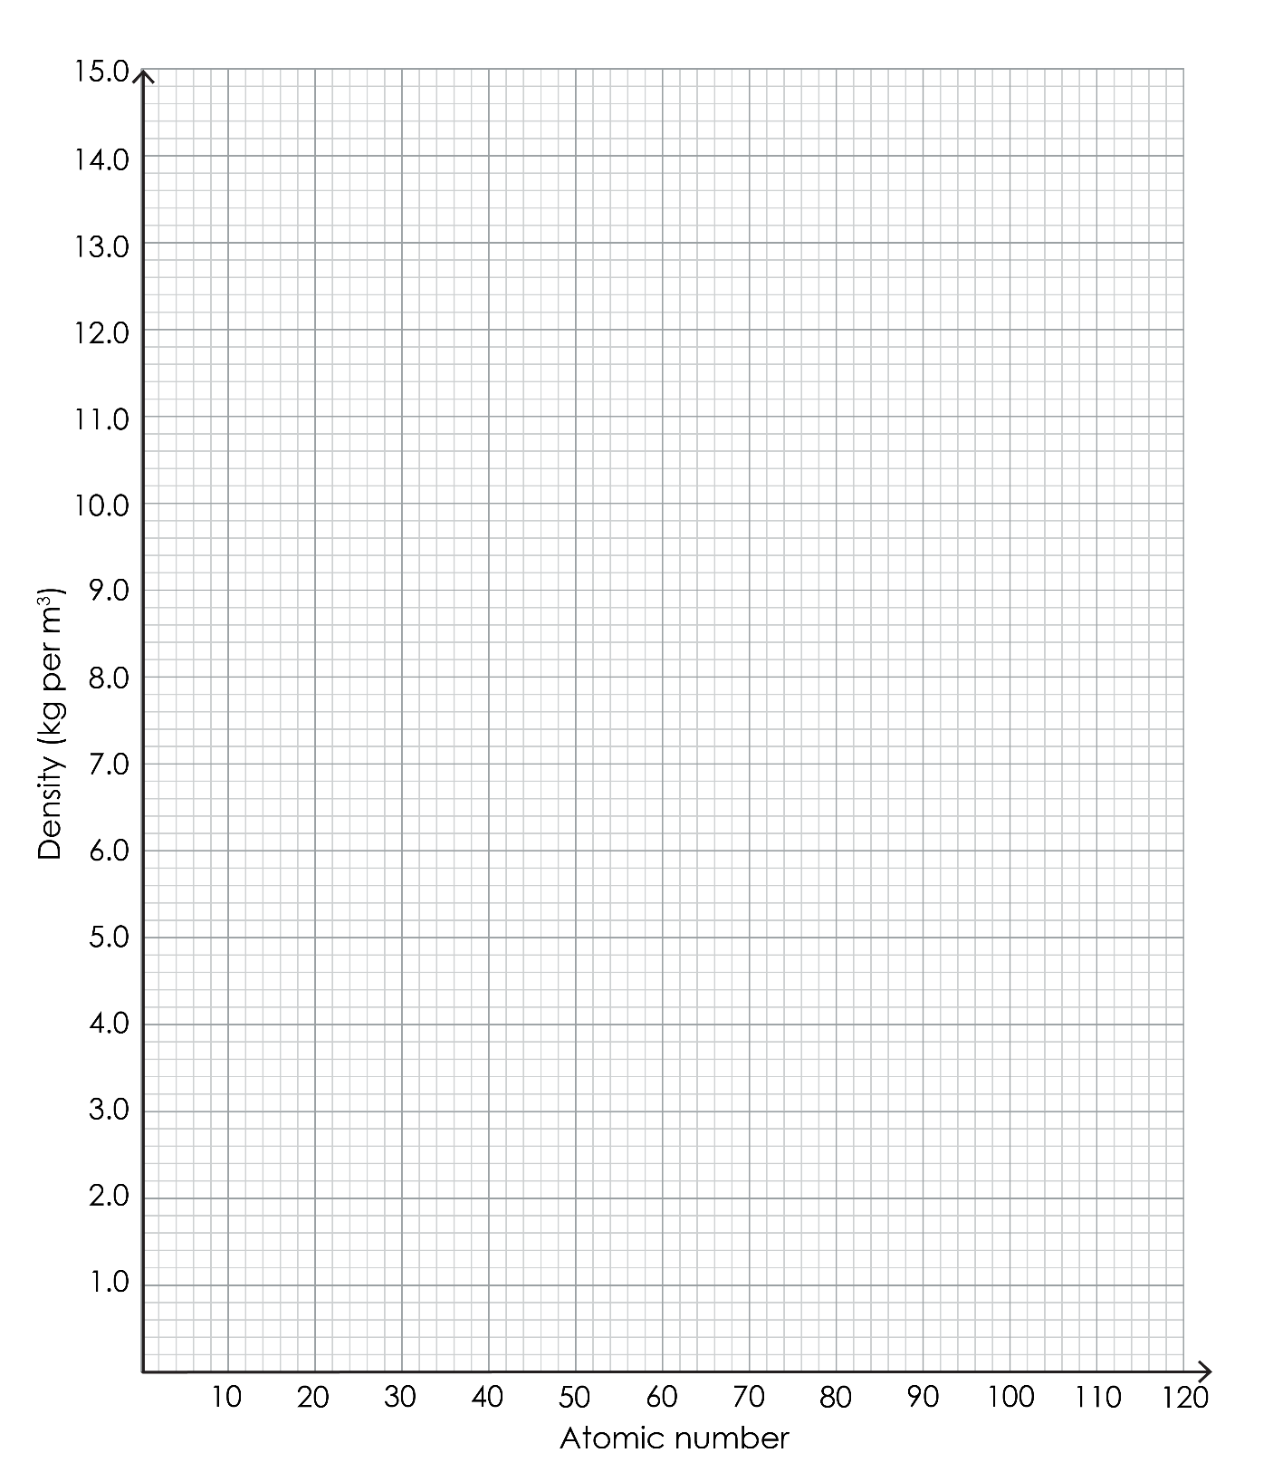

1. Describe the trend in density as you go down group 0.
2. Use your graph to predict the density of oganesson.
3. Only six atoms of oganesson have ever been made. We will estimate the volume of oganesson produced.
4. How many moles is 6 atoms of oganesson? (Avogadro’s constant = 6.022 x 1023).
5. One mole of any gas occupies approximately 24.0 dm3. Estimate the volume of 6 moles of oganesson.
6. This question focuses on the trend in atomic radius.
7. Look at the data in the table. Describe the trend in atomic radius as you go down group 0.
8. Predict the trend in melting and boiling point as you go down group 0. Explain your answer using the data in the table.