Particle diagrams

1. 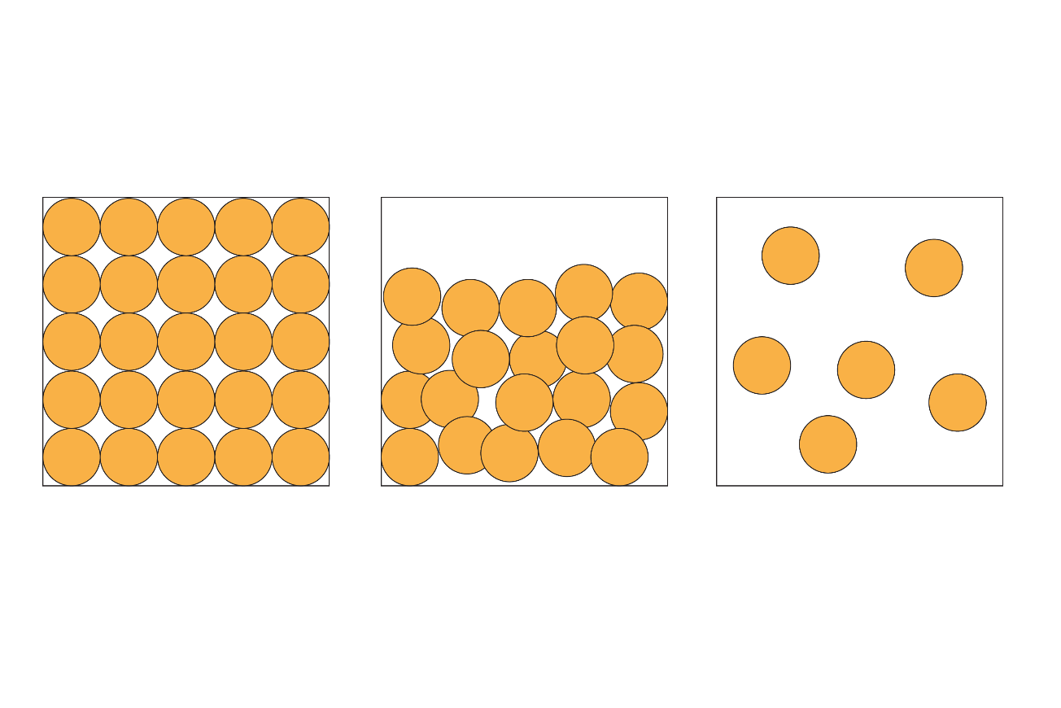These 2D diagrams represent the particles in a solid, a liquid and a gas.

**solid liquid gas**

* 1. The particles in the diagrams are represented by small circles. Depending on the type of substance, what could the particles in the diagrams be representing?   
     Circle the correct answers.

*Hint: There is more than one correct answer.*

**A** atoms

**B** electrons

**C** ions

**D** molecules

(3 marks)

* 1. Complete the table by ticking the boxes to show the position of the particles in a solid, liquid or gas. One has been done for you.

|  |  |  |  |
| --- | --- | --- | --- |
| **The particles are:** | **Solid** | **Liquid** | **Gas** |
| in a fixed position | **🗸** |  |  |
| free to move |  |  |  |
| in a regular pattern |  |  |  |
| in an irregular arrangement |  |  |  |

(4 marks)

1. (a) Name the changes of state using these words:

boiling melting freezing condensing

|  |  |  |
| --- | --- | --- |
| **Starting phase** | **Final phase** | **Name of change** |
| solid | liquid |  |
| liquid | gas |  |
| gas | liquid |  |
| liquid | solid |  |

(4 marks)

* 1. State how the **energy** of the particles change in each of the following state changes:

1. solid to liquid?

_____________________________________________________________________________________ **(1 mark)**

1. liquid to gas?

_____________________________________________________________________________________ **(1 mark)**

* 1. State how the **movement** of the particles change in each of the following state changes:

1. solid to liquid?

_____________________________________________________________________________________ **(1 mark)**

1. liquid to gas?

_____________________________________________________________________________________ **(1 mark)**

* 1. Which statement correctly explains why the changes in **question 2(a)** are physical changes?   
     Circle the correct answer.

**A** New substances are made.

**B** The electrons have been rearranged.

**C** The products have different chemical formulas to the reactants.

**D** No new substances are made.

(1 mark)

* 1. Which of the following factors stays the same during a change of state?   
     Circle the correct answer.

**A** the arrangement of particles

**B** the chemical formulae of the particles

**C** the movement of the particles

**D** the spaces between the particles

(1 mark)

1. The table shows the melting points of three metals.

|  |  |
| --- | --- |
| **Metal** | **Melting point/°C** |
| aluminium | 660 |
| copper | 1085 |
| lead | 328 |

* 1. Which metal has the strongest forces between the particles?

_____________________________________________________________________________________ **(1 mark)**

* 1. Explain your answer to **question 3(a)**.

_____________________________________________________________________________________ **(1 mark)**

* 1. Draw a particle diagram to represent the physical state of lead at 400°C.

(1 mark)

* 1. What is the difference between the forces of attraction between   
     particles in solids, liquids and gases?

(3 marks)

[Total: 23 marks]

Which question(s) did you get wrong? Why?

What will you do next time you’re asked a similar question?