Diffusion and dissolving

This resource is from the **Johnstone’s triangle** series which can be viewed at: [rsc.li/3T36kYu](https://rsc.li/3T36kYu). In this series you will also find our **Diffusion: Johnstone’s triangle** worksheet which introduces the triangle in the context of the diffusion of colour in water and can be viewed at: [rsc.li/3Y73h4j](https://rsc.li/3Y73h4j).

Learning objectives

|  |  |  |
| --- | --- | --- |
| **LO** | **Objective** | **Where assessed** |
| **1** | Predict the gradual diffusion of a coloured dye in water. | Q1(a) |
| **2** | Explain the diffusion of a coloured dye in water, in terms of the random movement of the dye and water particles. | Q1(b), 1(c) and 1 (d) |
| **3** | Connect understanding of diffusion and dissolving to predict and explain observations when a coloured crystal is placed in water. | Q2 |

How to use this resource

This resource aims to develop learners’ understanding of diffusion and dissolving. The questions encourage learners to think at the sub-microscopic level about how the observation of colour spreading through water can be explained in terms of the movement of particles. As a result, learners should develop more secure mental models to support their thinking about this topic.

|  |  |  |  |  |
| --- | --- | --- | --- | --- |
| **When to use?** | Enter with solid fill Introduce | Watering pot with solid fill **Develop** | Arrow circle with solid fill **Revise** | Clipboard Mixed with solid fill Assess |
| Use after initial teaching or discussion of this topic to develop ideas further. You can also use as a revision activity. | | | |
| **Group size?** | Head with gears with solid fill **Independent** | Group brainstorm with solid fill **Small group** | Classroom with solid fill **Whole class** | Work from home house with solid fill **Homework** |
| Suitable for independent work either in class or at home. Or use the questions for group or class discussions. | | | |
| **How long?** | Stopwatch 25% with solid fillArrow Right outlineStopwatch 50% with solid fill | | 15–30 mins | |

Johnstone’s triangle

Johnstone’s triangle is a model of the three different conceptual levels in chemistry: macroscopic, sub-microscopic and symbolic. You can use Johnstone’s triangle to build a secure understanding of chemical ideas for your learners.

Find further reading about Johnstone’s triangle and how to use it in your teaching at [rsc.li/4mL4RUf](https://rsc.li/4mL4RUf).

Johnstone’s triangle and this resource

The icons in the margin indicate which level of understanding each question is developing to help prompt learners in their thinking.

|  |  |
| --- | --- |
| An icon used to indicate the Macroscopic part of Johnstone's triangle. | **Macroscopic:** what we can see. Think about the properties that we can observe, measure and record. |
| An icon used to indicate the Sub-microscopic part of Johnstone's triangle. | **Sub-microscopic:** smaller than we can see. Think about the particle or atomic level. |
| An icon used to indicate the Symbolic part of Johnstone's triangle. | **Symbolic:** representations. Think about how we represent chemical ideas including symbols and diagrams. |

The levels are interrelated, for example, learners need visual representation of the sub-microscopic to develop mental models of the particle or atomic level. Our approach has been to apply icons to questions based on what the learners should be thinking about.

Questions may be marked with two or all three icons, indicating that learners will be thinking at more than one level. However, individual parts of the question may require learners to think about only one or two specific levels at a time.

Support

This worksheet is ramped so that the earlier questions are more accessible. The activity becomes more challenging in the later questions. You can give extra explanations for the more challenging questions. If completing as an in-class activity it is best to pause and check understanding at intervals, as often one question builds on the previous one.

It is useful for learners to observe macroscopic properties first-hand. You could circulate examples of substances in the classroom, run a class practical of a chemical reaction or show a teacher demonstration of properties.

Additional support may be needed for any learners still lacking in confidence in the required symbolic representation, for example by sharing and explaining a diagram or a simulation that can show movement of the particles.

Answers

1. *Guidance note:* This question develops learners’ understanding of what is observed when a drop of dye added to water diffuses (macroscopic understanding) and how this can be explained in terms of the random movement of particles (sub-microscopic understanding). This question assumes that students have observed something similar in real life.

(a)

1. A diagram showing a circle of dye with a radius significantly less than the diameter of the dish. For example:

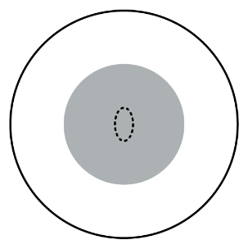

1. 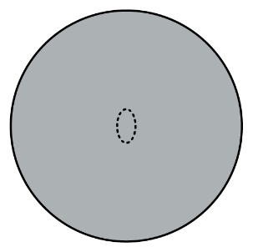A diagram showing that dye colour reaching to the edge of the dish. For example:
2. A diagram showing particles arranged as in the liquid state. The majority of the particles should be water particles with six dye particles spread out between them. For example:

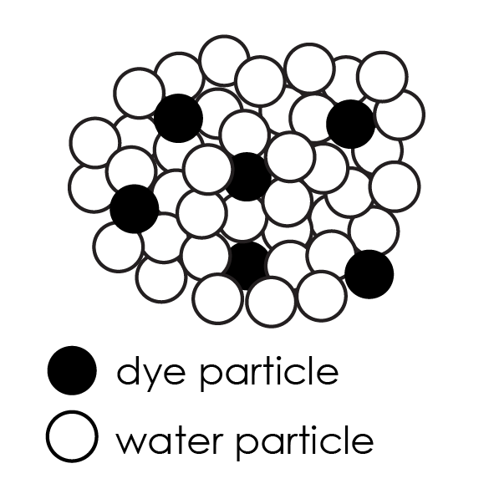

1. C
2. The dyes and water particles move randomly. Over time the dye particles move away from the centre of the dish. Eventually they reach the edge of the dish.  
   The random movement of the particles means that they spread out, even if there is no stirring.
3. *Guidance note:* This question develops learners’ understanding of observations of a coloured crystal dissolving in water and the gradual diffusion of the dissolved substance through the water (macroscopic understanding). The question also requires learners to connect the gradual spread of colour with the diffusion of particles of the coloured crystal (sub-microscopic understanding).
4. The crystal will get smaller.
5. The purple colour will gradually spread across the dish (and will become less intense).
6. The crystal gets smaller because the purple substance dissolves in the water. The particles of the purple crystal then gradually diffuse throughout the water in the dish.