Carbon allotropes

This resource is from the **Johnstone’s triangle** series, which can be viewed at: [rsc.li/4dBHbMJ](https://rsc.li/4dBHbMJ). In this series you will also find our **Carbon allotropes: Johnstone’s triangle** worksheet which introduces the triangle in the context of comparing graphite and diamond: [rsc.li/4daMHpQ](https://rsc.li/4daMHpQ)

Learning objectives

|  |  |  |
| --- | --- | --- |
| **LO** | **Objective** | **Where assessed** |
| **1** | Recall the structure of different allotropes of carbon. | Q1 |
| **2** | Explain why carbon can form giant structures. | Q2 |
| **3** | Explain why diamond does not conduct electricity but graphite does. | Q3 |

How to use this resource

This resource aims to develop learners’ understanding of the structure of carbon allotropes. The questions encourage learners to think about how the structures are represented and what this means at the sub-microscopic level. As a result, learners should develop more secure mental models to support their thinking about this topic.

|  |  |  |  |  |
| --- | --- | --- | --- | --- |
| **When to use?** | Enter with solid fill Introduce | Watering pot with solid fill **Develop** | Arrow circle with solid fill **Revise** | Clipboard Mixed with solid fill Assess |
| Use after initial teaching or discussion of this topic to develop ideas further. You can also use as a revision activity. | | | |
| **Group size?** | Head with gears with solid fill **Independent** | Group brainstorm with solid fill **Small group** | Classroom with solid fill **Whole class** | Work from home house with solid fill **Homework** |
| Suitable for independent work either in class or at home. Or use the questions for group or class discussions. | | | |
| **How long?** | Stopwatch 25% with solid fillArrow Right outlineStopwatch 50% with solid fill | | 15–30 mins | |

Johnstone’s triangle

Johnstone’s triangle is a model of the three different conceptual levels in chemistry: macroscopic, symbolic and sub-microscopic. You can use Johnstone’s triangle to build a secure understanding of chemical ideas for your learners.

Find further reading about Johnstone’s triangle and how to use it in your teaching at [rsc.li/4f9xaqV](https://rsc.li/4f9xaqV).

Johnstone’s triangle and this resource

The icons in the margin indicate which level of understanding each question is developing to help prompt learners in their thinking.

|  |  |
| --- | --- |
| An icon used to indicate the Macroscopic part of Johnstone's triangle. | **Macroscopic:** what we can see. Think about the properties that we can observe, measure and record. |
| An icon used to indicate the Sub-microscopic part of Johnstone's triangle. | **Sub-microscopic:** smaller than we can see. Think about the particle or atomic level. |
| An icon used to indicate the Symbolic part of Johnstone's triangle. | **Symbolic:** representations. Think about how we represent chemical ideas including symbols and diagrams. |

The levels are interrelated, for example, learners need visual representation of the sub-microscopic in order to develop mental models of the particle or atomic level. Our approach has been to apply icons to questions based on what the learners should be thinking about.

Questions may be marked with two or all three icons, indicating that learners will be thinking at more than one level. However, individual parts of the question may require learners to think about only one or two specific levels at a time.

Support

This worksheet is ramped so that the earlier questions are more accessible. The activity becomes more challenging in the later questions. You can give extra explanations for the more challenging questions. If completing as an in-class activity it is best to pause and check understanding at intervals, as often one question builds on the previous one.

It is useful for learners to observe macroscopic properties first-hand. You could circulate examples of substances in the classroom, run a class practical of a chemical reaction or show a teacher demonstration of properties.

Give learners physical models to use and manipulate, such as a Molymod™ kits or counters.

Additional support may be needed for any learners still lacking in confidence in the required symbolic representation, for example by sharing and explaining a diagram or a simulation that can show movement of the particles.

Answers

1. *Guidance note:* This question supports learners to recognise, interpret and evaluate typical diagrams representing the sub-microscopic structure of different allotropes of carbon.

* graphite: D
* graphene: B
* Buckminsterfullerene: C
* nanotube: A

1. A Buckminsterfullerene molecule is made of 60 carbon atoms but due to its shape is only a few (about 10) atoms across which makes it the size of a nanoparticle.
2. This way of representing diamond shows clearly how the carbon atoms are connected by covalent bonds.
3. A disadvantage of this particular diagram is that it does not show how the atoms are connected to form a giant structure. Some bonds are missing on the outside of the diagram.

Another disadvantage is that the ball-and-stick model suggests there are gaps between atoms when atoms are packed closely together.



1. *Guidance note:* This question guides learners to use dot-and-cross diagrams to explain why carbon can form giant structures.

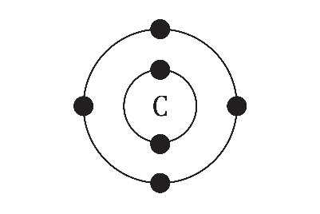

1. **C** 4
2. 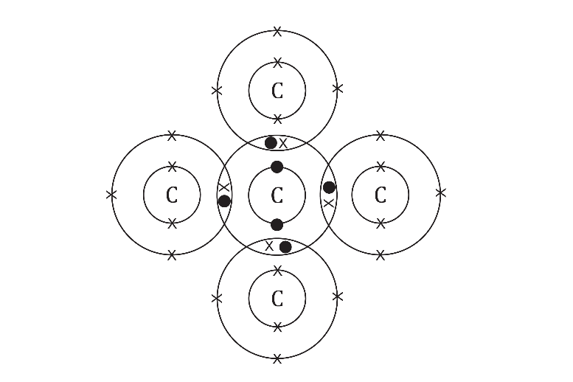
3. **C** 4
4. Carbon can form a giant structure because when a carbon atom covalently bonds to another carbon atom it has unpaired electrons remaining. This means that it can form more covalent bonds with other carbon atoms, forming a giant structure.



1. *Guidance note:* This question challenges learners’ thinking about a diagram of the structure of diamond by making links to atomic structure. Learners are then asked to use this thinking to explain macroscopic properties of diamond and graphite.
2. **B** shared pair of outer electrons
3. **C** nucleus and inner electrons
4. All the outer electrons of the carbon atoms in diamond are involved in the covalent bonding because each carbon atom forms four covalent bonds. There are no free electrons so diamond cannot conduct electricity.
5. 3
6. In graphite, three electrons per atom are involved in forming covalent bonds. The fourth outer electron from each carbon atom is not involved in covalent bonding. This fourth electron is delocalised, meaning that it is able to conduct electricity by moving between the layers of the graphite.