Carbon allotropes

Introduction

These questions are designed to help you to develop your mental models (pictures in your head) of the different structures of carbon. Use the icon in the margin to find out which level of understanding the question is developing.

|  |  |
| --- | --- |
| An icon used to indicate the Macroscopic part of Johnstone's triangle. | **Macroscopic:** what we can see. Think about the properties that we can observe, measure and record. |
| An icon used to indicate the Sub-microscopic part of Johnstone's triangle. | **Sub-microscopic:** smaller than we can see. Think about the particle or atomic level. |
| An icon used to indicate the Symbolic part of Johnstone's triangle. | **Symbolic:** representations. Think about how we represent chemical ideas including symbols and diagrams. |

Questions

1. Covalently bonded carbon atoms can form a variety of different structures.

Substances that are made of the same type of atom but with different structures are called allotropes.

The structures of some carbon allotropes are shown in the diagrams below.

|  |  |  |  |
| --- | --- | --- | --- |
| A ball-and-stick diagram showing a tube constructed from atoms bonded together in a pattern of hexagons with hanging bonds at the outer edges. | A ball-and-stick diagram showing a single flat sheet of atoms bonded together in a pattern of hexagons with hanging bonds at the outer edges. | A ball-and-stick diagram showing a spherical macromolecule made up of atoms bonded together in a pattern of alternating pentagons and hexagons. | A ball-and-stick diagram showing three flat sheets of atoms bonded together in a pattern of hexagons with hanging bonds at the outer edges. Between the sheets, which are arranged horizontally, there are vertical dotted lines. |
| A | B | C | D |

1. Write the letter for the diagram that represents the structure of each allotrope of carbon:

* graphite ____
* graphene ____
* Buckminsterfullerene ____
* nanotube ____

1. Nanoparticles have structures of about 1 to 100 nanometres, which is the size of a few hundred atoms. Use the diagram of the Buckminsterfullerene to explain why it is a type of nanoparticle.

__________________________________________________________________________________

__________________________________________________________________________________

__________________________________________________________________________________

__________________________________________________________________________________

The diagram below shows a representation of the structure of diamond.

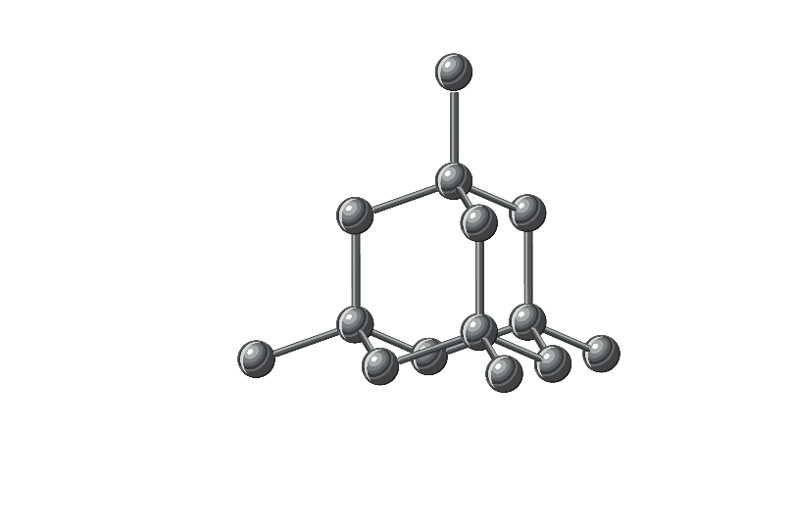

1. Give one advantage of this way of representing the diamond structure.

__________________________________________________________________________________

__________________________________________________________________________________

__________________________________________________________________________________

__________________________________________________________________________________

1. Give one disadvantage.

__________________________________________________________________________________

__________________________________________________________________________________

­­­­­­­­­­­­­­­__________________________________________________________________________________

__________________________________________________________________________________

1. A carbon atom has six electrons.
2. Complete the electronic structure diagram for a carbon atom.

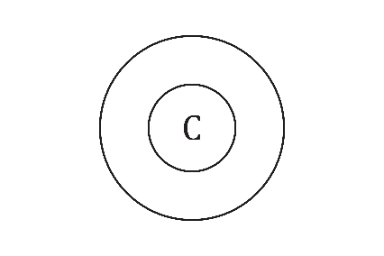

1. Circle the maximum number of covalent bonds that a carbon atom can form.

**A** 6 **B** 3 **C** 4 **D** 8

1. A carbon atom can form covalent bonds with more carbon atoms.  
   Add more carbon atoms to the diagram in part (a) to show the maximum number of carbon atoms the central carbon atom can bond with.
2. Circle the maximum number of carbon atoms that each carbon atom can bond with.

**A** 6 **B** 2 **C** 4 **D** 3

1. Explain why carbon can form giant covalent structures.

__________________________________________________________________________________

__________________________________________________________________________________

__________________________________________________________________________________

1. Diamond has a three-dimensional giant molecular structure.

The diagram below shows another representation of the structure of diamond.

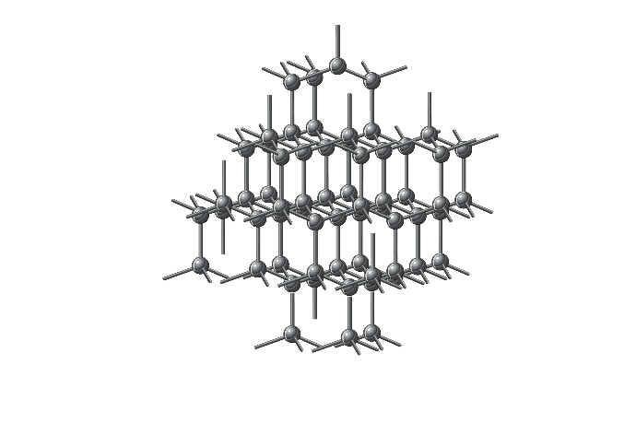

1. Which part of a carbon atom is represented by a line on the diagram?

|  |  |  |  |
| --- | --- | --- | --- |
| A | nucleus | B | shared pair of outer electrons |
| C | nucleus and inner electrons | D | inner electrons |

1. Which part of a carbon atom is represented by a circle?

|  |  |  |  |
| --- | --- | --- | --- |
| A | nucleus | B | shared pair of outer electrons |
| C | nucleus and inner electrons | D | inner electrons |

1. Explain why diamond **cannot** conduct electricity.

__________________________________________________________________________________

__________________________________________________________________________________

Graphite has a structure made up of layers of two-dimensional sheets.

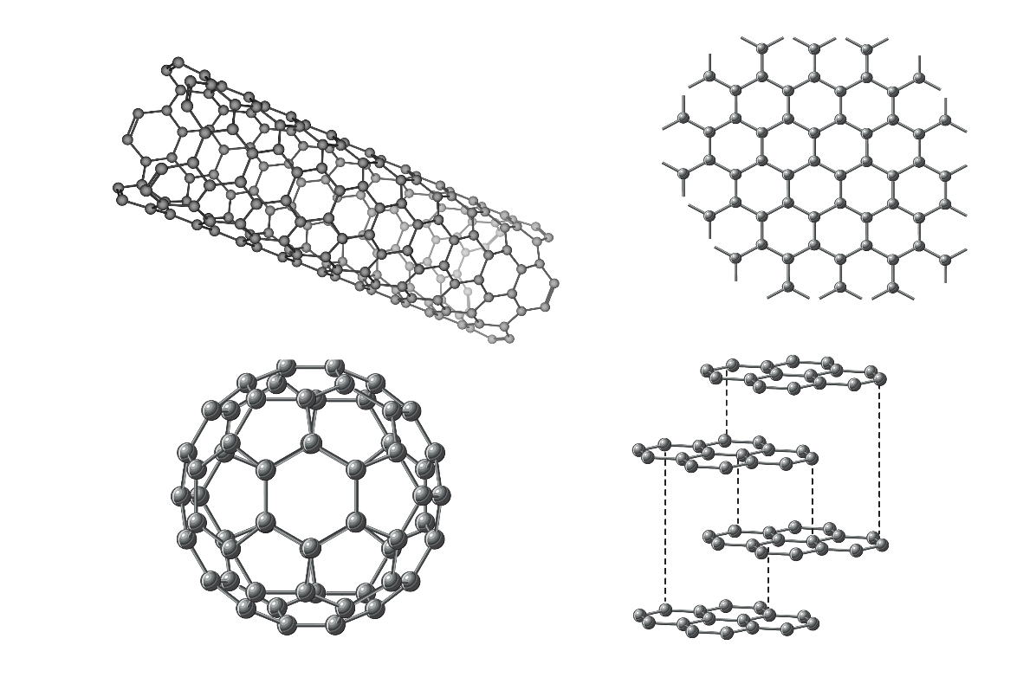

1. Give the number of electrons of each carbon atom that are involved in forming covalent bonds. _____
2. Explain why graphite **can** conduct electricity.

__________________________________________________________________________________

__________________________________________________________________________________

__________________________________________________________________________________