- This question is about the molecules in the table.
 | 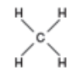 | 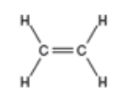 | 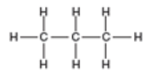
Alkane or alkene
Name of molecule
Molecular formula of molecule
- What do all of these molecules have in common?

Write your answers to parts b), c) and d) into the table.
- State which are alkanes and which are alkenes.

- Name each of the molecules.

- Write down the molecular formula of each molecule.

- Which of these molecules is the odd one out?
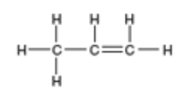
Give a reason.
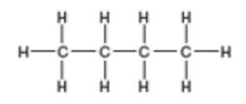

B
A

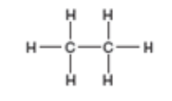
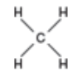

D
C

- This question is about ethane and ethene.
The structures of these molecules are shown below.

Ethene
Ethane

Which of these statements are true or false about these molecules?
Write your answers into the box – ‘T’ for true, and ‘F’ for false.
- The molecular formula for ethane is C₂H₆.

- Ethene is a saturated molecule.

- Bromine water can be used to distinguish between these two molecules.

- Alkenes are less reactive than alkanes.

- The carbon double bond in ethene makes it more reactive.

- Alkanes burn with more smoky flames than alkenes

- The general formula of an alkene is C_{n}H_{2n}.

This question is about the use of bromine water for testing for the presence of a carbon double bond.

Indicate the colour change seen when these molecules are added, separately, to bromine water.

Draw a straight line between the molecule and the correct colour change.
Colour change of bromine water
Ethene

Stays orange
Propane

Orange to colourless
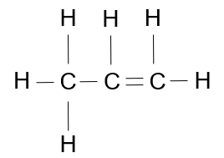

Colourless to orange

C₄H₁₀

