Ionic bonding and electron transfer

This resource is from the **Stretch and challenge** collection which can be viewed at: [rsc.li/4jOvTrl](https://rsc.li/4jOvTrl). Find extension resources designed to fit into curriculum topics for individual or whole class challenges.

Resource components

|  |  |
| --- | --- |
| A screenshot of a slide from the MS Powerpoint presentation, also available | A screenshot of the student worksheet which includes a table to evaluate and rewrite the four opinions. |
| **Presentation:** introduces the problem, the four opinions for groups to discuss and shares the answers. | **Student worksheet:** the student worksheet introduces the four competing ideas and gives space to discuss and rewrite the statements. |

Introduction

This activity helps learners to think through the importance of the electrostatic attraction between ions to the model of ionic bonding.

How to use this resource

|  |  |  |  |  |
| --- | --- | --- | --- | --- |
| **When to use?** | Enter with solid fill Introduce | Watering pot with solid fill **Develop** | Arrow circle with solid fill **Revise** | Clipboard Mixed with solid fill Assess |
| Use as an extension activity after a lesson on ionic bonding. Learners should already have prior knowledge of atomic structure, ionic bonding and the formation of ions. | | | |
| **Group size?** | Head with gears with solid fill **Independent** | Group brainstorm with solid fill **Small group** | Classroom with solid fill **Whole class** | Work from home house with solid fill **Homework** |
| Ask learners to work in groups of two or three. | | | |
| **Topics?** | Ionic bonding, electrostatic attraction, and energetic stability. | | | |
| **How long?** | Stopwatch 25% with solid fill | | 10–15 minutes | |

Discussion of answers

**Person A** is making a sensible point. The information given suggests that the process of electron transfer on its own is strongly endothermic. Since burning magnesium is exothermic, it must involve more than electron transfer.

**Person B** has abandoned the ionic model too readily. There is good evidence for the existence of ions – e.g. the conductivity of solutions and molten salts. Since magnesium is a metal and oxygen a non-metal, the bonding is ionic.

**Person D** is correct that the data are about isolated atoms, but the real reaction is between solid magnesium and oxygen molecules. However, this observation only gets us so far. You can form the isolated atoms of magnesium and oxygen from the solid and gas by investing the energy to break all the bonds. Breaking the bonds will be endothermic, so we have not explained why the process of burning is exothermic and indeed what drives the magnesium to react with the oxygen.

**Person C** has made a crucial point. The exothermic part of the whole process comes from the coming together of oppositely charged ions into a giant lattice. Opposite charges have potential energy when they are held apart which is converted to heat when they move closer. The mutual attraction of oppositely charged ions is the driving force behind ionic bonding.

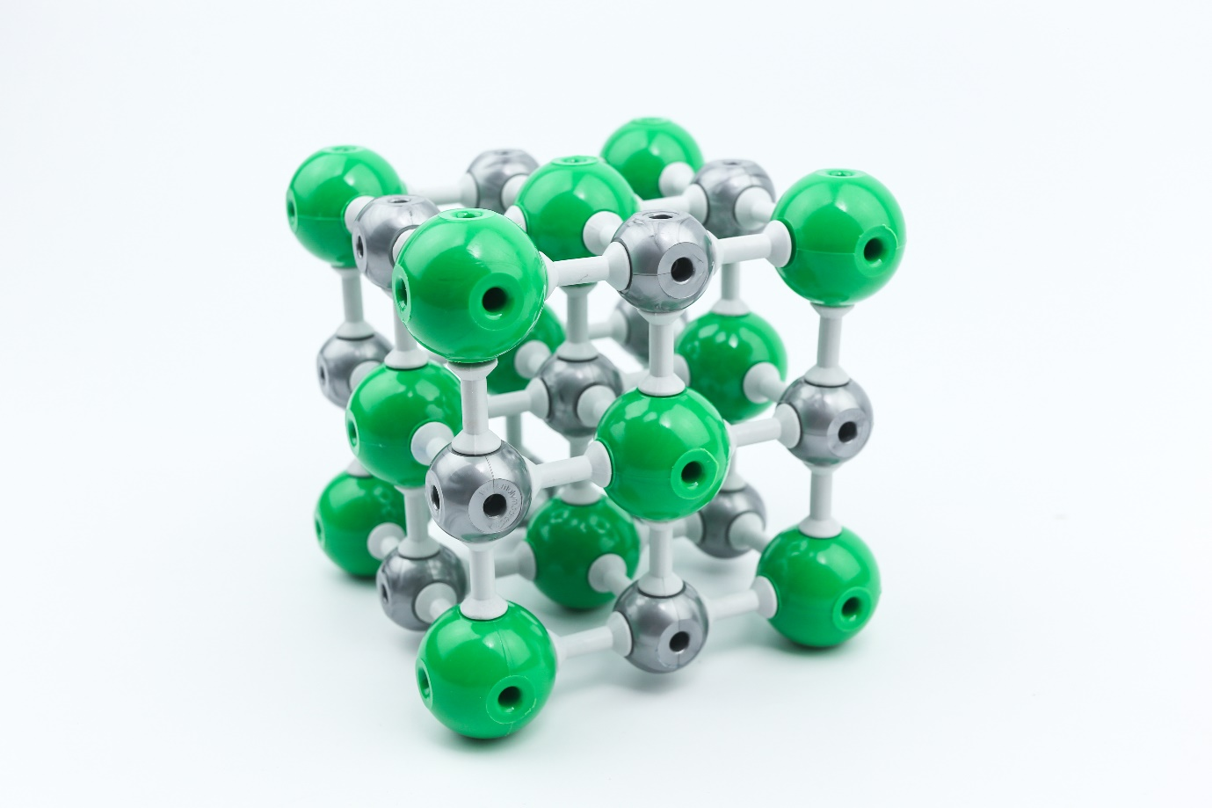

© Shutterstock / TOP-STOCKER

A model of an ionic lattice; the ions are held to each other by electrostatic attraction.