Metallic bonding: Johnstone’s triangle

This resource is from the **Johnstone’s triangle** series which can be viewed at: [rsc.li/3WViQfg](https://rsc.li/3WViQfg). It will help learners understand the different ways you need to think in chemistry, building their mental models and understanding.

Learning objectives

1. Describe a metal and its uses based on observations.
2. Use symbolic models to represent metallic bonding.
3. Explain how the type of bonding in a metallic compound relates to the properties you can observe.

How to use Johnstone’s triangle

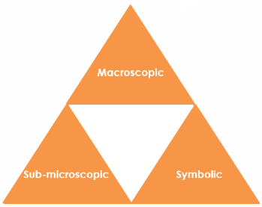Use Johnstone’s triangle to develop learners’ thinking about scientific concepts at three different conceptual levels:

* Macroscopic – what we can see. Think about the properties we can observe, measure and record.
* Symbolic – representations. Think about how we represent chemical ideas including symbols and diagrams.
* Sub-microscopic – smaller than we can see. Think about the particle or atomic level.

For learners to gain a deeper awareness of a topic, they need to understand it at all three levels.

When introducing a topic, do not try to introduce all of the levels of thinking at once. This will overload working memory. Instead complete the triangle over a series of lessons, beginning with the macroscopic level and introducing other levels, in turn, once secure.

All of the levels are interrelated, for example, learners need visual representation of the sub-microscopic in order to develop mental models of the particle or atomic level.

Find further reading about Johnstone’s triangle and how to use it in your teaching at [rsc.li/4fzqR0N](https://rsc.li/4fzqR0N).

Scaffolding

It is important to share the structure of the triangle with learners prior to use. Tell them why you want them to use the triangle and how it will help them to develop their understanding. Use an ‘I try, we try, you try’ approach when you are introducing Johnstone’s triangle for the first time.

More resources

To further develop learner’s thinking in all areas of Johnstone’s triangle, try our **Developing understanding** worksheets ([rsc.li/4eRv5A2](https://rsc.li/4eRv5A2)). These include icons in the margin referring to the conceptual level of thinking needed to answer the question.



Macroscopic – what we can see

Match the common uses of copper below with the properties that make it suitable.

Electrical wires Ductile

Saucepans Malleable

Water pipes Lustrous (shiny)

Jewellery Good conductor of heat

Good conductor of electricity

Symbolic – representations

Complete this metallic bonding diagram for copper by adding electrons.

Note: The electrons may be drawn anywhere and with any suitable symbol. There must be eight electrons.

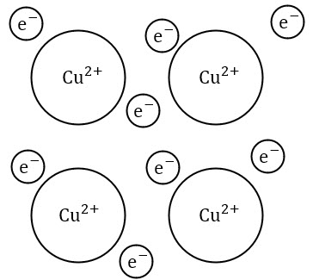

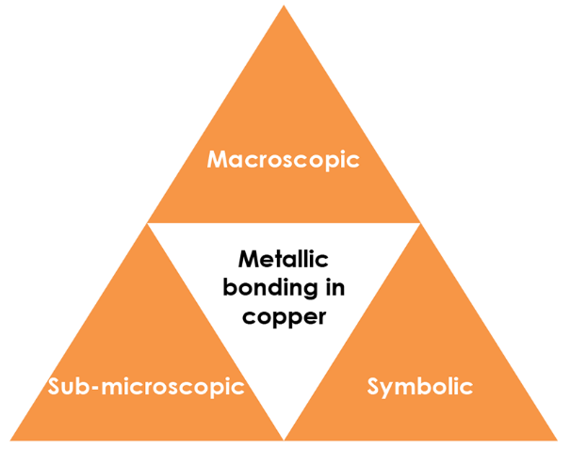

Sub-microscopic – smaller than we can see

With reference to the structure and bonding in metals explain why:

* Copper is malleable

**Metal ions are arranged in layers which can slide over each other. The delocalised electrons maintain the bonding within the metal even while the shape is changing.**

* Copper is a good conductor of electricity

**The delocalised electrons are free to move. They carry electrical charge and transfer energy quickly throughout the metal.**