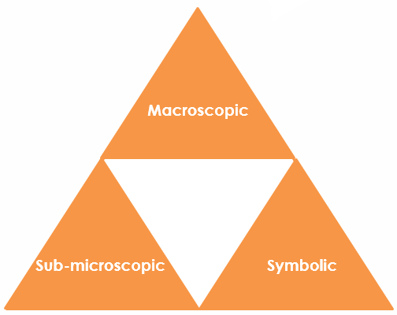Particle diagrams for water: Johnstone’s triangle

Learning objectives

1. Describe macroscopic properties of water as a solid, liquid and gas.
2. Draw particle diagrams to represent solids, liquids and gases.
3. Explain differences between solids, liquids and gases using particle diagrams.

Introduction

Particle diagrams are used to represent the arrangement of the particles within a substance in the solid, liquid and gaseous state.

Johnstone’s triangle

In chemistry we make sense of the things that we can see by representing what we can’t see using formulas, equations, diagrams and models.

Johnstone’s triangle is a way of thinking about these different concepts as different corners of a triangle:

* Macroscopic – what we can see. Think about the properties we can observe, measure and record.
* Sub-microscopic – smaller than we can see. Think about the particle or atomic level.
* Symbolic – representations. Think about how we represent chemical ideas, including symbols and diagrams.

Being able to connect and move between these three different levels is important for scientific understanding.

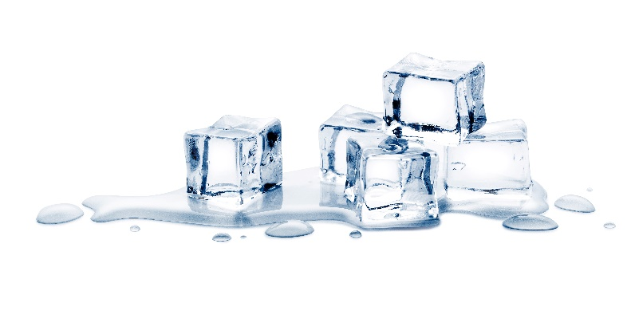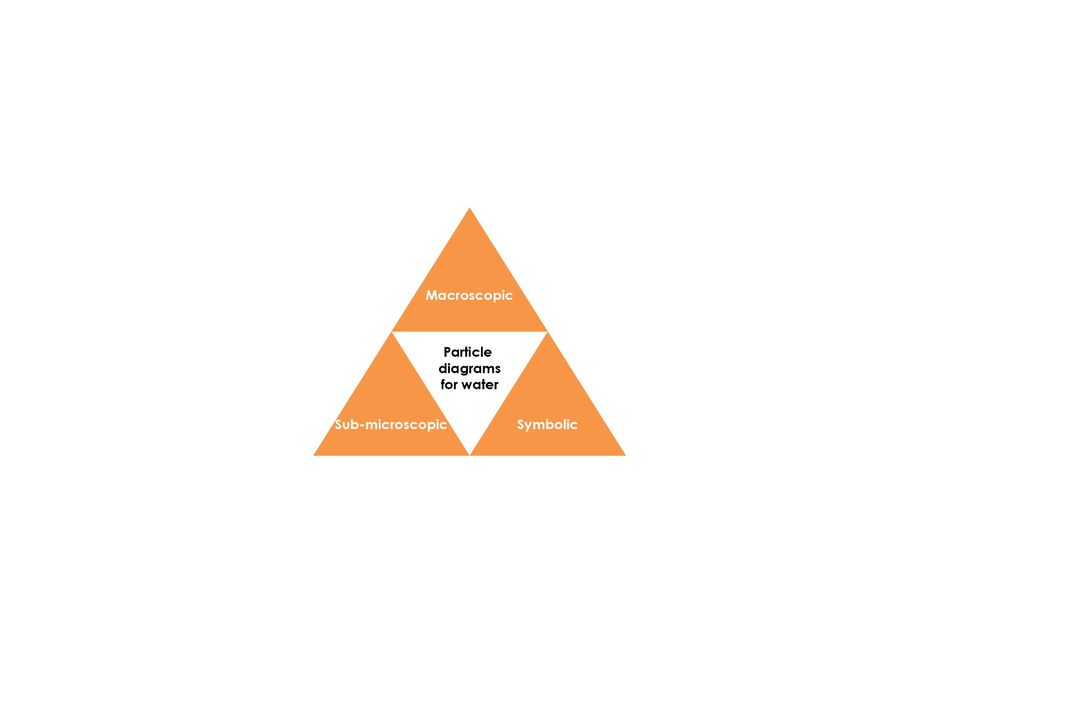

Sub-microscopic – smaller than we can see

Explain why liquid water flows but solid water does not. Use your understanding of the arrangement of particles and intermolecular forces.

Symbolic – representations

Complete the diagrams below to represent the arrangement of the particles in solid, liquid and gaseous water:

Three empty boxes above the labels 'solid', 'liquid' and 'gas'-  to be completed

**solid liquid gas**

In water, each particle represents an molecule. Draw a water molecule below:

Source: © Shutterstock / 19 STUDIO

Macroscopic – what we can see

Observe the demonstration of water in the solid, liquid and gaseous state. Use this to complete the table below:

|  |  |  |
| --- | --- | --- |
| **State** | **Has a fixed shape?** | **Can flow?** |
| Solid state |  |  |
| Liquid state |  |  |
| Gas state |  |  |