Particle diagrams: teacher guidance

These **In context** worksheets ask learners to use their knowledge of particle diagrams in an applied context, building their confidence and capability to face exam questions. Calculation questions are included to give opportunities to practise mathematical skills within this topic. The worksheets are available at Foundation and Higher level and as fully editable versions, giving you the flexibility to select the questions most relevant to a particular lesson.

Also available to assess this topic:

* **Review my learning** **worksheets**: available with three levels of scaffolded support to help build confidence in every learner. Use before, during or after teaching the relevant topic to understand progress and identify misconceptions, **rsc.li/44igB7V**.
* **Knowledge check worksheets: select from Foundation and Higher level** to assess learners’ knowledge and understanding of this topic at the end of a period of teaching or as revision, **rsc.li/4bZINkc**.

Answers

Foundation

1. (a) The coffee particles are gaseous.

(b)

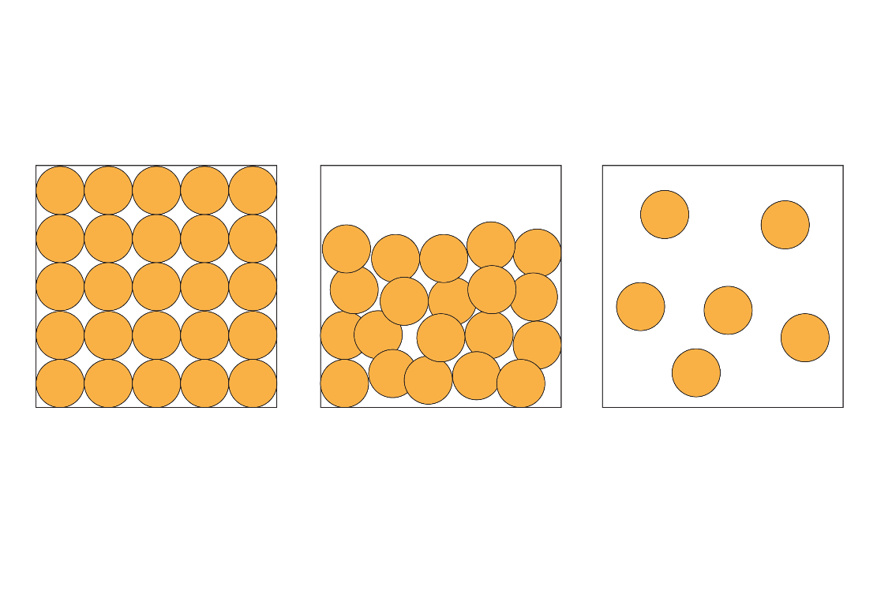

(c) **B** They are randomly arranged.

**C** They have high energy.

1. (a)



(b) The particles move round each other so the liquid can flow.

(c) The particles move around each other; therefore they move to take the shape of the container.

1. (a)



* 1. The particles in ice are in a fixed position, therefore they do not move freely.

(c)

|  |  |  |
| --- | --- | --- |
|  | **Particles in water** | **Particles in ice** |
| How close are the particles? | **about 60% of the particles are touching** | **the particles are close together/touching** |
| How do the particles move? | **the particles move around each other** | **the particles vibrate in fixed positions** |
| How are the particles arranged? | **the particles are arranged randomly** | **the particles are arranged regularly** |

1. (a) g/cm3 or g/dm3 or mol/dm3

(b) 10 g in 200 cm3 50 g in 1000 cm3 or 1 dm3

concentration 50 g/dm3

(c) mass of sucrose 200

5 g/dm3

1. No, because a cup of coffee is a mixture of many different chemical compounds.

Higher

1. (a)

i. The energy of the particles increases.

ii. The distances between particles increases.

iii. The speed of the particles increases.

(b)



1. (a) The particles in liquid water move around each other,   
   so liquid water flows.

(b)



(c) i. the diameter of a coffee ground = 300 000 nm

ii. the ratio of the diameter of a water molecule to the diameter of a coffee ground

0.3:300 000

1:1 000 000

(d) A cup of coffee is not a pure substance; it contains a mixture of compounds. The particle diagram represents one type of particle only.

1. (a) The particles in the diagram are spherical and a sucrose molecule is not spherical. The particles are solid; atoms are mostly empty space.

(b) Concentration × 0.00585