Addition polymers

This resource accompanies the infographic poster Addition polymers in Education in Chemistry which you can download and print to display in your classroom: rsc.li/3RBHTjX

Learning objectives
- Explain how alkenes react to form addition polymers.
- Understand how addition polymers are named and structured.

Introduction

This worksheet allows learners to demonstrate their understanding of how addition polymers are structured and named. The introduction to the student sheet reminds learners how unsaturated monomers are set out in the ‘H’ formation and how to transform the monomer units into a polymer. This section is useful for answering question 3.

Questions 1 and 2 look at how small alkenes undergo addition polymerisation via the reactivity of the double bond.

Question 3 explores how addition polymers are named and structured based on the unsaturated monomer. Question 4 looks at the reverse of this process. Note: both the IUPAC and common names are provided in the example for question 3.

Question 5 is an extension question which looks at a real-life polymer (Perspex). Learners deduce the monomer and repeating unit from the polymer structure, then describe the properties of Perspex and the benefits and drawbacks of its use.

Answers
- (a)

- This is an addition reaction. The bromine adds across the double bond. The unsaturated alkene forms a saturated product.

- A double bond/unsaturation.

Monomer | Polymer
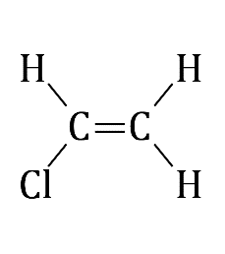  Chloroethene  or vinyl chloride | 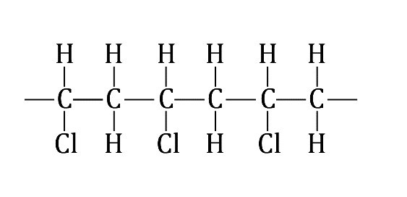  Name: poly(chloroethene) or poly(vinylchloride)
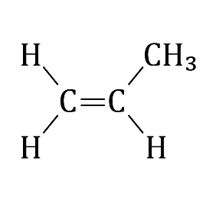  Propene | 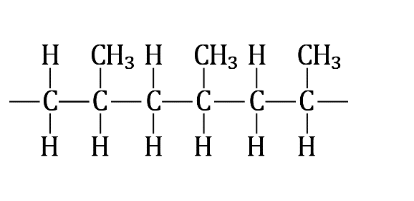  Name: poly(propene)
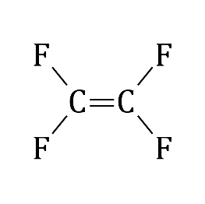  Tetrafluoroethene | 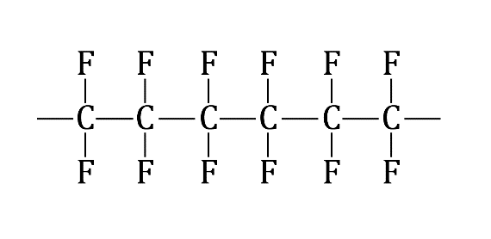  Name: poly(tetrafluoroethene)
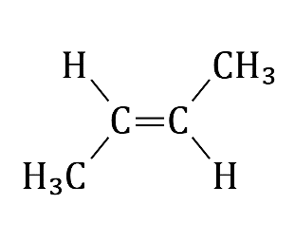  But-2-ene | 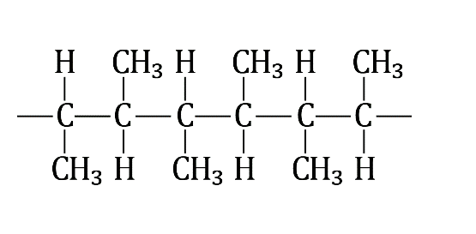  Name: poly(but-2-ene)
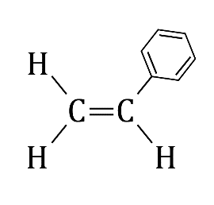  Styrene | 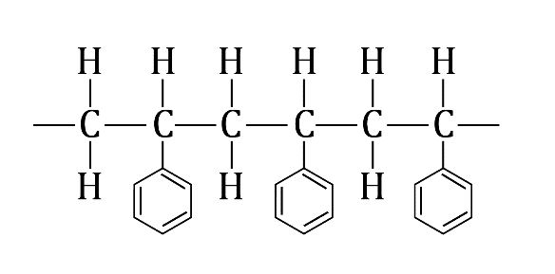  Name: poly(styrene)

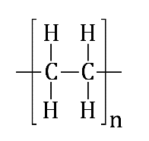 | 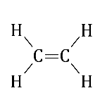
Repeating unit | Monomer

Extension question answer

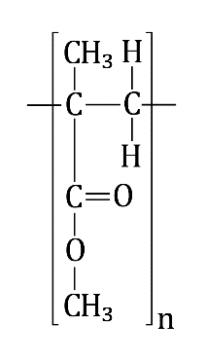 | 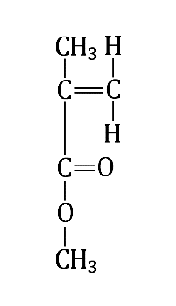
Repeating unit | Monomer
- Transparent, strong, waterproof.
- Shatterproof, lighter than glass, can be re-shaped on warming and cut without specialist equipment.
- Non-biodegradable. Will turn yellow after exposure to UV light. Doesn’t shatter – for example if you needed to escape from a vehicle/building, you might have trouble breaking the window.

