F3 Nuclear fusion

Revision: protons, neutrons and electrons

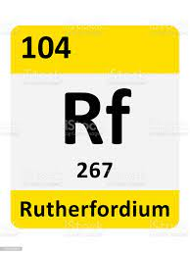Last lesson, you learned how to work out the number of protons, neutrons and electrons in an atom. You need to revise this knowledge before moving on to nuclear fusion.

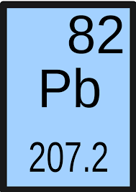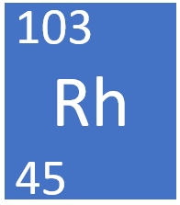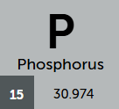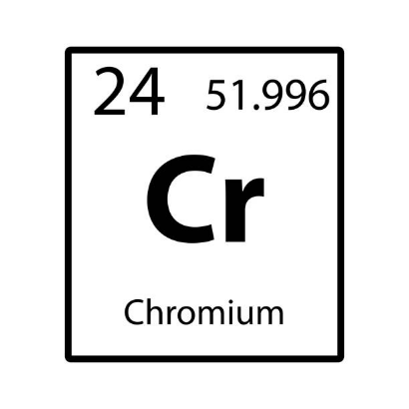

1. How can you tell which is the mass number and which is the atomic number for each element?

|  |  |  |  |  |
| --- | --- | --- | --- | --- |
| Element | Rh | Rf | Pb | Cr |
| Name |  |  |  |  |
| Protons |  |  |  |  |
| Neutrons | (of isotope with mass 103) | (of isotope with mass 103) | (of isotope with mass 103) | (of isotope with mass 103) |
| Electrons |  |  |  |  |

1. Fill in the table below to give the element names and numbers of protons, neutrons and electrons.
2. Why are the relative atomic masses of Pb and Cr **not** whole numbers?

New content: nuclear fusion

Nuclear fusion occurs in stars where there are very high temperatures and pressures. Nuclei of atoms can fuse together to create new elements. Nuclear reactions only involve the nucleus, whereas chemical reactions involve electrons.

For example, two helium nuclei can fuse together to form a beryllium nucleus.

1. In terms of nuclear particles, explain why fusion produces new chemical elements.
2. Draw two helium **nuclei**, showing the number of protons and neutrons.
3. Draw a beryllium **nucleus** of the isotope 8Be and explain how you know it can be formed from two helium nuclei.
4. Draw a carbon **nucleus**. How many helium **nuclei** would need to fuse to make it?
5. A nucleus has 17 protons and 21 neutrons. Write the nuclear symbol.
6. Using words, suggest a nuclear reaction that could produce magnesium-24 from neon-20.