- This question is about sports trainers.
When anybody jumps or runs, their legs and feet have to take pressure of up to seven times normal body weight. This can be very harmful to bones, joints and muscles.

Different polymers are used to make trainers, as they can easily be made to have the right properties.

One of the polymers that is used for making the fillings, heels and insoles in trainers is poly(ethene).
Source: Enavto Elements

- Give a property that poly(ethene) would need to have if used to make the heel of a pair of trainers.
Answer: Strong, good at absorbing shock, resistance to water, durable.
- What type of substance is poly(ethene)?
Answer: A polymer.

Ethene is used to make poly(ethene).
- What is the chemical formula for ethene?
Answer: C₂H₄.
- Draw the structure of an ethene molecule.
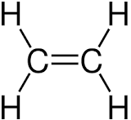

- i) What fraction of the atoms in an ethene molecule are carbon atoms?
Answer: $\frac{2}{6}$ _{or} $\frac{1}{3}$
ii) What is the ratio of carbon to hydrogen atoms?
Write your answer in its simplest whole number form.
Answer: 2 : 4 or 1 : 2.
- When ethene molecules polymerise, they form a very long chain polymer.
The molecule below shows two carbon and four hydrogen atoms in a chain of poly(ethene).

Complete the diagram by drawing 6 more carbon atoms, and 12 more hydrogen atoms.

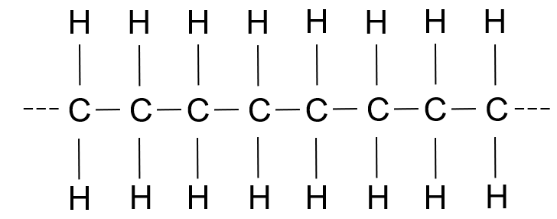

- The structure in part f) can be shown as a repeating unit.
The repeat unit is shown within a bracket, and the letter ‘n’ is written outside the bracket.

Draw the repeat unit for poly(ethene).

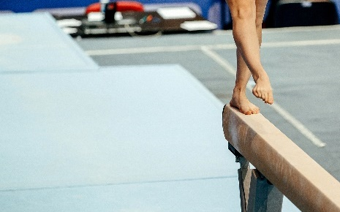
- Another polymer used in sport is poly(vinyl chloride), PVC.
This is used for making the mats used by gymnasts.

Vinyl chloride has the structure shown below.
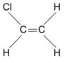
Source: Enavto Elements

- Name the elements present in a molecule of vinyl chloride.
Answer: Carbon, hydrogen and chlorine.
- Which bond in this molecule and a molecule of ethene (from the previous question) help it polymerise?
Answer: The carbon double bond.
- Draw a section of a polymer chain of poly(vinyl chloride) showing three repeat units.
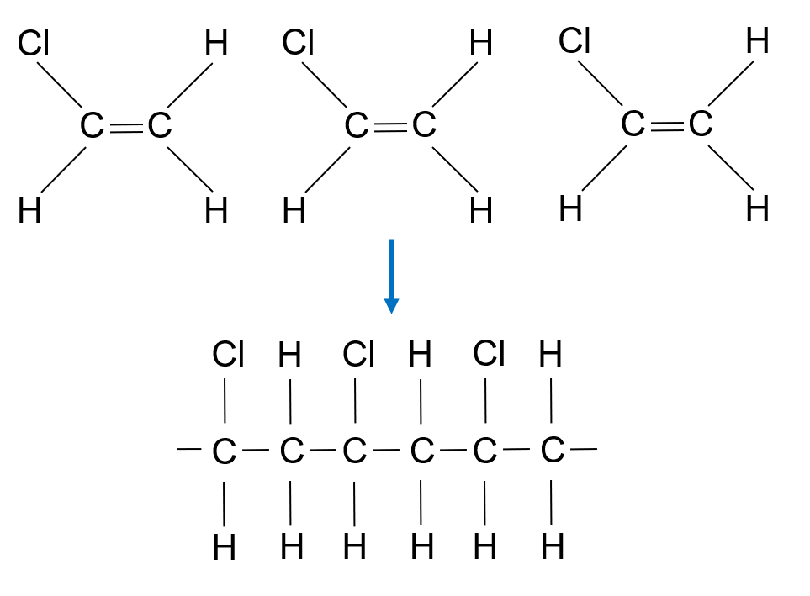

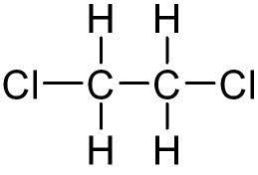
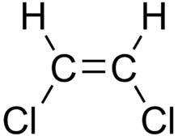
These two molecules may look similar, but they can behave very differently.

Molecule 1 Molecule 2
- One of these molecules is called dichloroethane and the other is called dichloroethene. Which one is which?

Write your answer into the table below.
Name of molecule | Molecule 1 or molecule 2
Dichloroethane | Answer: Molecule 2.
Dichloroethene | Answer: Molecule 1.

- One of the molecules may polymerise, and the other will not.
State which will polymerise. Give a reason.
Answer: Molecule 1 / dichloroethene.
It has a carbon double bond.

