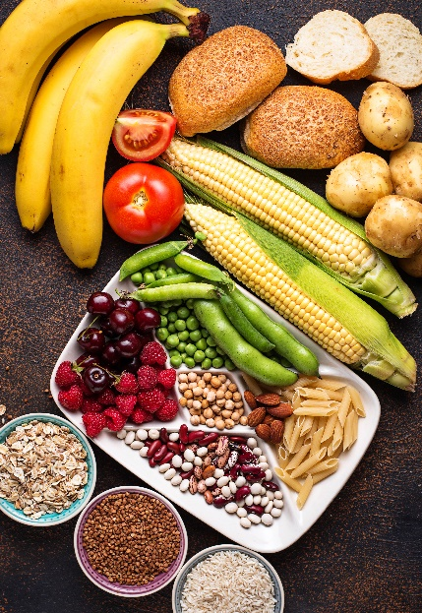
- All of these foods contain starch.
Starch is a polymer.

Below is the molecular structure of a molecule that can make starch.
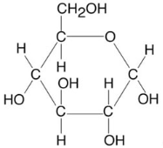

Molecule 1
Source: Envato Elements
- What is a polymer?
Answer: A very long chain molecule made of many smaller molecules (monomers) chemically bonded.
- Name molecule 1 above.
Answer: Glucose.
- What is the molecular formula of molecule 1?
Answer: C₆H₁₂O₆

Molecule 1 reacts with many other identical molecules to make starch.
Water is also formed in the process.
- What is the name given to molecules like molecule 1 that chemically bond together to form a polymer?
Answer: Monomers.

- In the equation below, n is a whole number.
Complete the equation:
Answer: nC₆H₁₂O₆ (C₆H₁₀O₅)_{n} + nH₂O
Starch
- What type of polymerisation in taking place when starch is formed?
Give a reason for this name.
Answer: Condensation polymerisation, as a small molecule like water is formed.

The diagram below shows how three molecule 1s react together:

- Explain what the rings show in the diagram.
Answer: The OH group from one glucose molecule combines with the H group from another, to form water.
- Draw a chemical bond between the three molecules to show how they chemically bond, after water has been removed.

- This question is about amino acids forming a polymer.

- What class of polymer is formed from amino acids?
Answer: Proteins.

The molecular structures of two different amino acids are shown below.
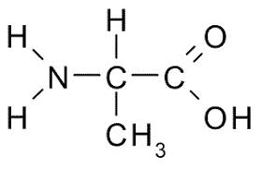
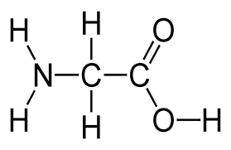

Glycine Alanine

- Name the functional groups present in each amino acid.
Answer: Amine group and carboxylic acid.
- Explain why these molecules are placed in the same homologous series.
Answer: They have the same functional groups, and differ by a CH₂ unit.

One functional group is acidic and the other is basic.
They react together to form water.

The diagram shows this taking place.

- Draw the structure of the molecule formed when glycine and alanine react according to the diagram.
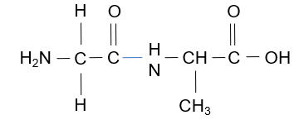

- What is the name of the link that bonds together amino acids in this way?
Answer: A peptide link.

