Covalent bonding tiles

Learning objectives
- Draw dot and cross diagrams for simple covalent molecules
- Identify single, double and triple covalent bonds

Instructions for teachers

This resource contains a sheet of printable covalent bonding tiles which can be printed and cut out into individual tiles to support learners when introducing covalent bonding. The electrons are identified using colour coded dots and crosses to help learners identify single, double and triple bonds. To avoid misconceptions learners will need to be reminded that, although different symbols are used, they all represent a single electron in the outer shell of the atom.

Task 1: Building bonds

In this task, learners familiarise themselves with the tiles in the resource and practice arranging them to make simple covalent molecules. This task is deliberately open ended and there are many possible arrangements for each of the steps in the task. Learners will get used to finding the correct tiles to complete each bond and the arrangements of the tiles which they may sometimes need to place at an angle.

Task 2: Simple covalent molecules

In this task, learners build named molecules based on their chemical formula. In the case of molecules containing oxygen, carbon and nitrogen, learners will need to choose the correct tile to show single, double or triple bonds as required.

Task 3: Hydrocarbons

In this task, learners use the tiles to explore patterns in the homologous series of alkanes and alkenes. Learners should already be familiar with using the resource (the different stages in task 1 help to explore this) before applying the tiles to chemistry concepts. The tiles can be used to demonstrate the general formulas for the alkanes and alkenes.

Task 4: Polymerisation

In this final task, learners are asked to create a stop motion animation or GIF to illustrate the process of polymerisation. They will need to use creativity and secure knowledge of structure and bonding to produce their animation.

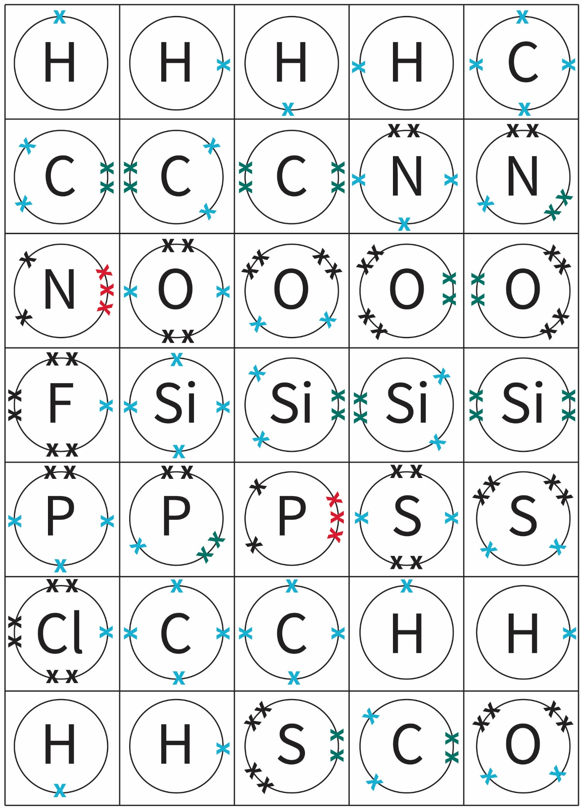
Covalent bonding cross tiles

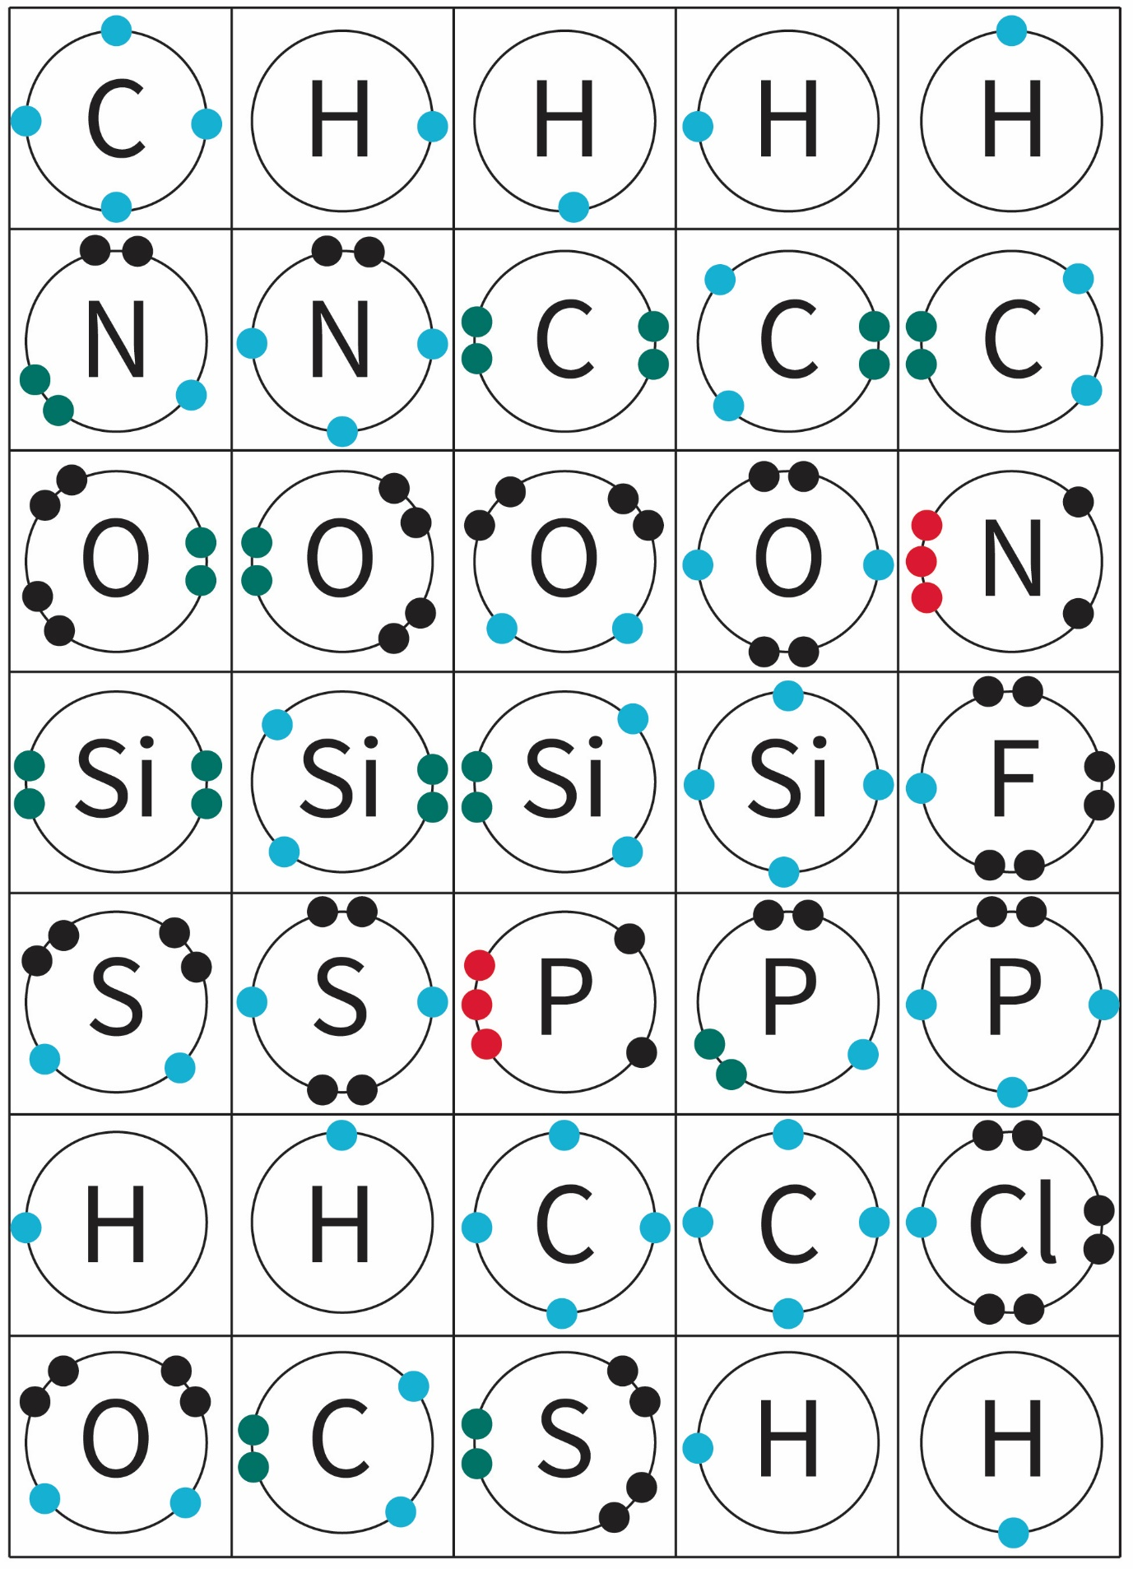
Covalent bonding dot tiles

Answers

Task 1: Building bonds
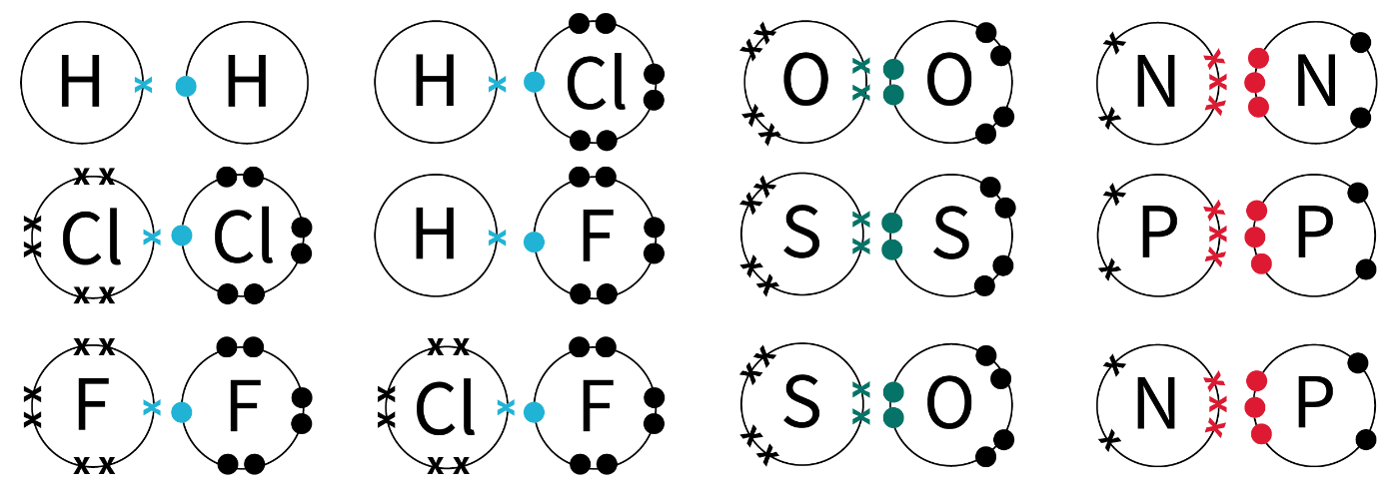
- Learners may have some or all of the following combinations of tiles:
- Learners may have assembled some or all of the following simple covalent molecules:

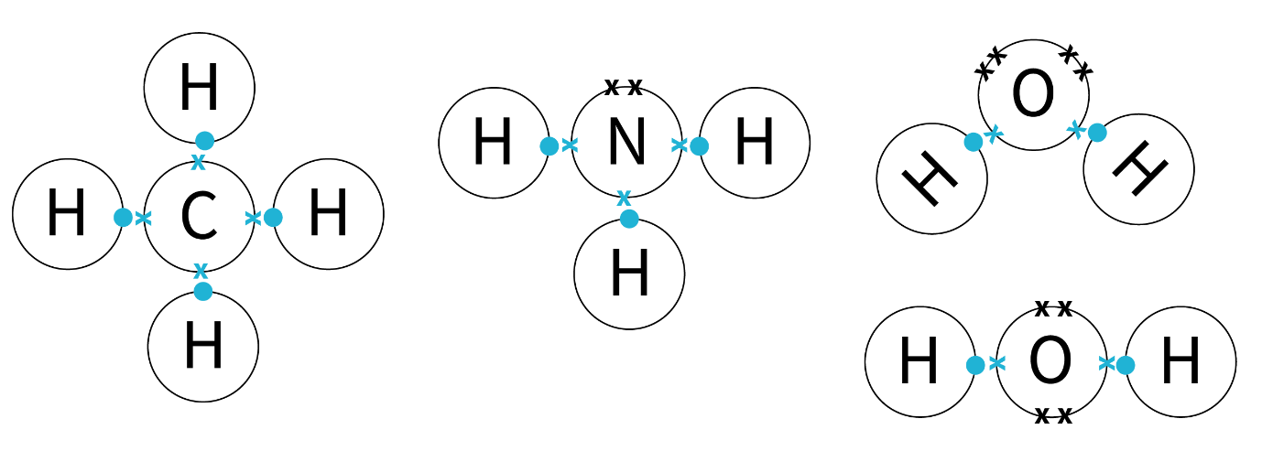
- Differences:
- These molecules are all larger
- They only contain single covalent bonds
- They all have a different shape
- The two oxygen tiles are to allow different structures and shapes to be arranged. Both the oxygen tiles have 2 single covalent bonds but in one the bonds are adjacent to each other and in the other the bonds are opposite each other.
- CH₄, NH₃, H₂O

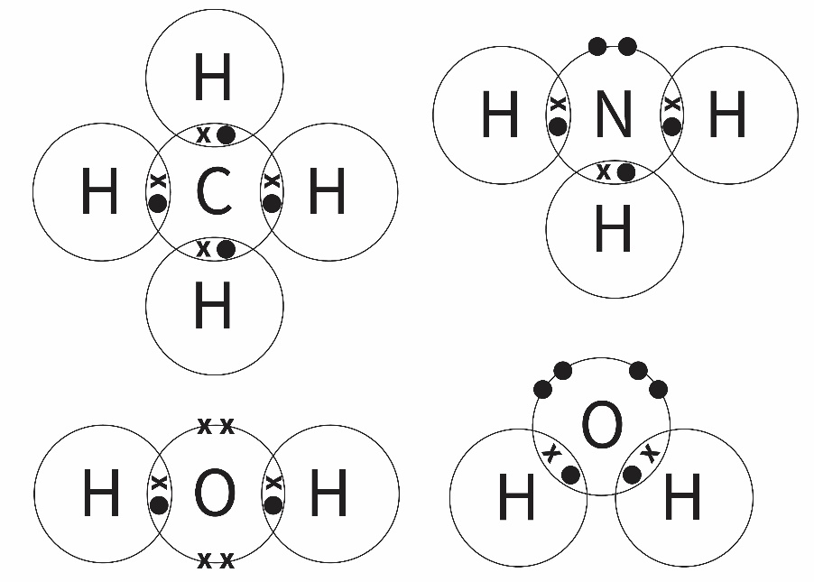

- The smallest molecule you can make is O₂ as it contains only two atoms.
- There are lots of possible combinations of three tiles. All learners should be able to arrange 5–8 different molecules, many will be able to arrange 8–10 molecules and some will arrange 10–16 molecules. Examples include: CO₂, SiO₂, CS₂, SiS₂, NOH, POH, HNS, HPS, PSCl, PSF, POCl, POF, NOCl, NOF, NSCl and NSF.
- There are a great many molecules that can be arranged with four tiles. Challenge learners to arrange 10 or more combinations of tiles.
Some examples are: H₂CO, COF₂, Cl₂CO, CSCl₂, CF₂S, CH₂S, C₂O₂, O₂Si₂, H₂SiO, SiOF₂, Cl₂SiO, SiSCl₂, SiF₂S and SiH₂S.

Challenge

This is open ended and you could end up with any number of combinations of weird and wonderful molecules. Depending on the interest and ability of your group you could steer learners towards building large hydrocarbons, especially if you want them to be able to name their molecule in part (c).
- This will depend on the structure they have arranged with their tiles.
Tip: Get learners to take a photo of the tiles before they try to draw their dot and cross diagram. This will prevent any problems with the tiles moving while they are drawing and give them something to compare to once the tiles have been tidied away.
- The simplest way to write a formula is to count the number of atoms of each element. To challenge learners even further ask them how they decided which element to write down first.
Extension: You could tell learners about the ‘Hill system’ of ordering the elements within chemical formulas. To take it even further you could introduce condensed formulas which give even more information about the structure of the molecule.
- If learners have built a ‘real’ molecule they should be able to search online using the formula to find out if it has a chemical name.

Task 2: Simple covalent molecules
Name of molecule | Formula | Draw the dot and cross diagram
Water | H₂O | 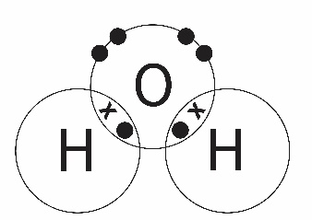
Hydrochloric acid | HCl | 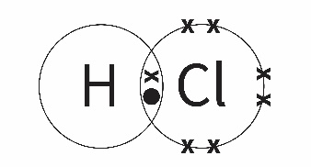
Carbon dioxide | CO₂ | 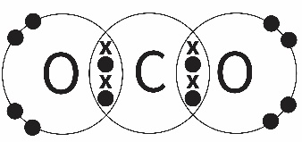
Methane | CH₄ | 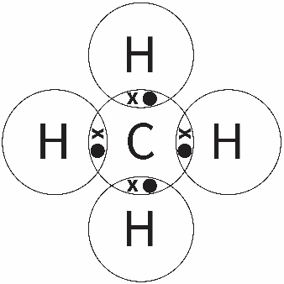
Nitrogen | N₂ | 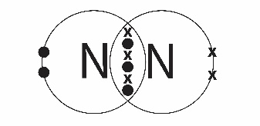
Ammonia | NH₃ | 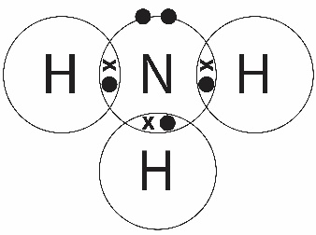
Extension:  Name of molecule | Formula of molecule | Any simple covalent compound made using the tiles eg. O₂, C₂H₄, NOH etc

Task 3: Hydrocarbons

Alkanes
- n/a
- See table
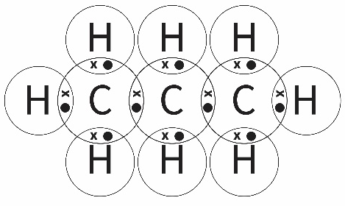

Alkenes
- The alkene homologous series contains a carbon-carbon double bond. You cannot have a carbon-carbon double bond in a molecule with just one carbon atom.
- See table
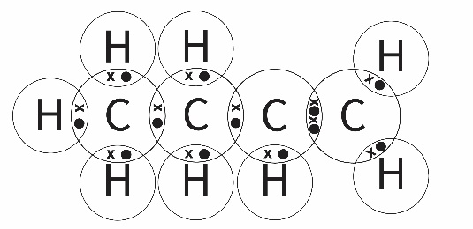

Alkane series | Formula | Alkene series | Formula
Methane | CH₄
Ethane | C₂H₆ | Ethene | C₂H₄
Propane | C₃H₈ | Propene | C₃H₆
Butane | C₄H₁₀ | Butene | C₄H₈
Pentane | C₅H₁₂ | Pentene | C₅H₁₀
Hexane | C₆H₁₄ | Hexene | C₆H₁₂
Heptane | C₇H₁₆ | Heptene | C₇H₁₄
Octane | C₈H₁₈ | Octene | C₈H₁₆
Nonane | C₉H₂₀ | Nonene | C₉H₁₈
Decane | C₁₀H₂₂ | Decene | C₁₀H₂₀
- Learners should notice the patterns which lead to the general formula for the alkanes (C_{n}H_{2n+2}) and the alkenes (C_{n}H_{2n}).

Task 4: Polymerisation
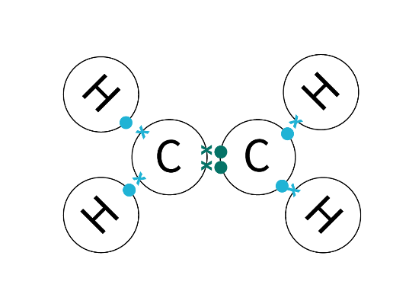

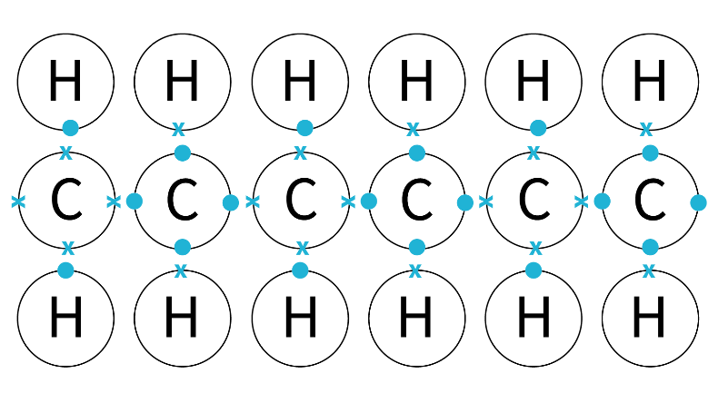

- See an example of a stop motion video using the covalent bonding tiles from this resource at https://rsc.li/3eiWEVv

