- The diagram shows the process called polymerisation.
Which of the following statements are true or false about this process?
Write a ‘T’ if true, and an ‘F’ for false in the box.
- The particles on the left are called monomers.  - In this process, many molecules bond together to form a very long chain molecule.  - The number of molecules on each side is the same.  - Different monomers can be used to make new substances having different properties and uses.  - Ethane is an example of a monomer.  - Many polymers break down in the environment and are biodegradable.  - Propene forms a polymer called poly(propane).  - Unsaturated molecules can form addition polymers. | F  T  F  F  T  F  T  T

- This question is about making poly(ethene) from ethene.

- Draw the structure of an ethene molecule showing all of the chemical bonds.
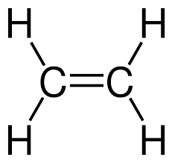

- Draw the missing bonds on this section of a poly(ethene).
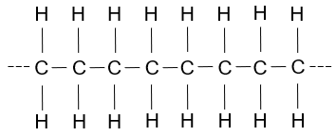

- How many ethene molecules are needed to make the part of the chain shown in part b)?
Answer: Four.
- Complete the table below that describes the differences between ethene and poly(ethene):
 | Ethene | Poly(ethene)
Carbon double bonds present? | Answer: Yes. | Answer: No.
Unsaturated or saturated | Answer: Unsaturated. | Answer: Saturated.
Observation on adding bromine water | Answer: Orange to colourless. | Answer: Stays orange.

- This question is about the molecule below.

- Name this molecule.
Answer: Propene.

The structure below shows part of a polymer made from the molecule in part a).
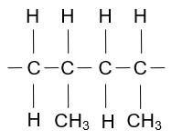

- What is the name of this polymer?
Answer: Poly(propene).
- Describe what happens to the carbon double bond in the molecule in part a) when it makes a polymer.
Answer: It turns into a carbon single bond.
Each carbon atom then forms two more carbon single bonds to other monomer units.

