Using thin-layer chromatography to investigate the reaction – student sheet

Introduction
You have probably used a simple chromatography experiment as part of your earlier studies to separate the dyes in a coloured ink. The same technique can be used to separate substances which are not dyes but in such experiments the chromatogram must be developed to show up the various different substances that have been separated.

Chromatography techniques are used a great deal in industry because they can be controlled very precisely and use very small amounts of substance. In this activity you investigate the purity and identity of your laboratory prepared aspirin samples using thin-layer chromatography (tlc). In this activity all the substances are white or colourless so you will need to develop the plate before you can see what has happened.

Thin-layer chromatography is a powerful tool for determining if two compounds are identical. A spot of the compound being investigated is placed on a chromatography plate, and a spot of a pure manufactured sample of the same substance is placed next to it. The plate is then allowed to stand in a suitable solvent, which travels up the plate. If the compound to be identified leaves exactly the same pattern on the chromatography plate as the known pure compound it is reasonable to conclude that they are the same. However, if extra spots are observed as well as the characteristic pattern of the known compound, then impurities are likely to be present in the sample.

In this experiment both crude and recrystallised samples of aspirin are compared with a known sample of aspirin.

Method
- Make sure that you do not touch the surface of the tlc plate with your fingers during this activity. Handle the plate only by the edges and use tweezers if possible.
- Take a tlc plate and using a pencil (not a biro or felt tip pen) lightly draw a line across the plate about 1 cm from the bottom. Mark three equally spaced points on this line.
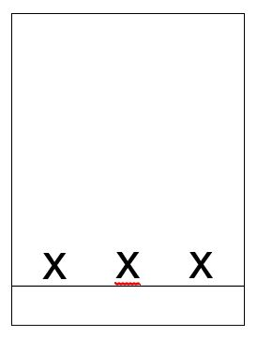
- Place small amounts (about 1/3 of a spatula measure) of your crude aspirin, your recrystallised aspirin and the commercial sample of aspirin in three separate test- tubes. Label the test-tubes so that you know which is which.
- Make up 5 cm3 of solvent by mixing equal volumes of ethanol and dichloromethane in a test-tube. Add 1 cm3 of the solvent to each of the test-tubes to dissolve the samples. If possible do this in a fume cupboard.
- Use capillary tubes to spot each of your three samples onto the tlc plate. Allow the spots to dry and then repeat three more times. The spots should be about 1–2 mm in diameter.
- After all the spots are dry, place the tlc plate in the developing tank making sure that the original pencil line is above the level of the developing solvent – ethyl ethanoate. Put a lid on the tank and allow to stand in a fume cupboard until the solvent front has risen to within a few millimetres of the top of the plate.
- Remove the plate from the tank and quickly mark the position of the solvent front. Allow the plate to dry.
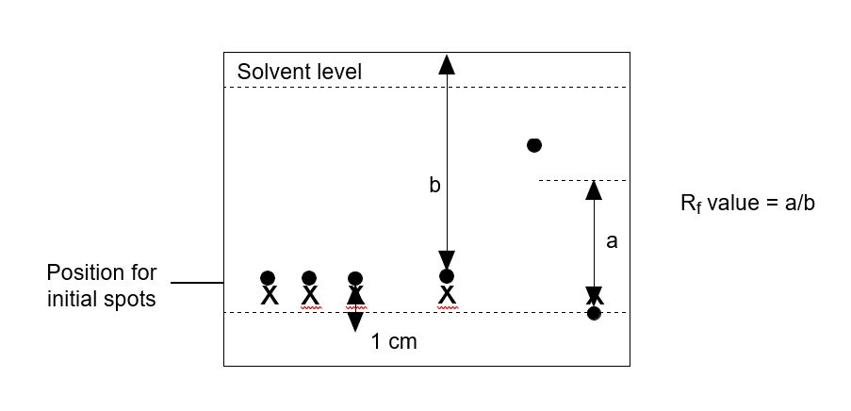
- Observe the plate under a short wavelength UV lamp and lightly mark with a pencil any spots observed.
- Carefully place the plate in a jar or beaker containing a few iodine crystals. Put a cover on the jar and warm gently on a steam bath until spots begin to appear. Do this in a fume cupboard if possible.

Results
- Draw a diagram to show which spots appeared under UV light and which appear with iodine.
- Determine the R_{f} value of the samples using the expression R_{f} = distance moved by sample/distance moved by solvent

Questions
- Write a short paragraph explaining why some substances move further up the tlc plate than others and how the results are made visible.
- What conclusions can you draw about the nature of the three samples tested?

