Making ice

Learning objectives
- Plan a method to investigate how quickly ice forms.
- Make careful observations and accurately record them in a table.
- Use experimental data to draw conclusions.
- Write an investigation report.

Introduction

The Mpemba effect is a phenomenon named after a Tanzanian teenager called Erasto Mpemba.

Mpemba was a student at Magamba Secondary School in Tanzania where one day, he and his classmates were making ice cream. The recipe for the ice cream said the mixture should be allowed to cool down before putting in the refrigerator. However, to ensure he could get a free space in the refrigerator, Erasto put his ice cream mixture into the fridge without letting it cool first. At the same time, one of his friends, who had let his mixture cool, also put his mixture into the fridge.

Whose ice cream do you think froze quicker?

Method

Working in small groups, plan an investigation to answer the question: ‘Which makes ice faster, hot or cold water?’. Use your method writing, planning and problem-solving skills to answer the question using the equipment listed below.

You may need to ask your teacher for some additional equipment.

Before you begin your planning, make a prediction and write it down. A good place to start your group discussions is to identify all the different variables.

Equipment

Materials (per group)
- Deionised water

Apparatus (per group)
- Beakers, 100 and 250 cm³
- Thermometers, –5 to +100°C
- Access to a refrigerator and freezer
- Safety glasses (one pair per learner)

Safety and hazards

Wear safety glasses and take care when dealing with hot or boiling water.

Investigation planning and report

When you have completed your investigation, you will need to write a report.

Your plan will need to have:
- Problem or investigation question
- Prediction
- Method

Your report will need to have:
- Results
- Evaluation
- Conclusion

Results

Draw a suitable table to record your results when planning your investigation to compare the speed hot and cold water make ice. Remember to include units for all measurements.

Questions

These follow-up questions are adapted from Review my learning: the particle model.
- Add the following labels to the diagram below.

boiling condensing freezing gas

liquid melting solid

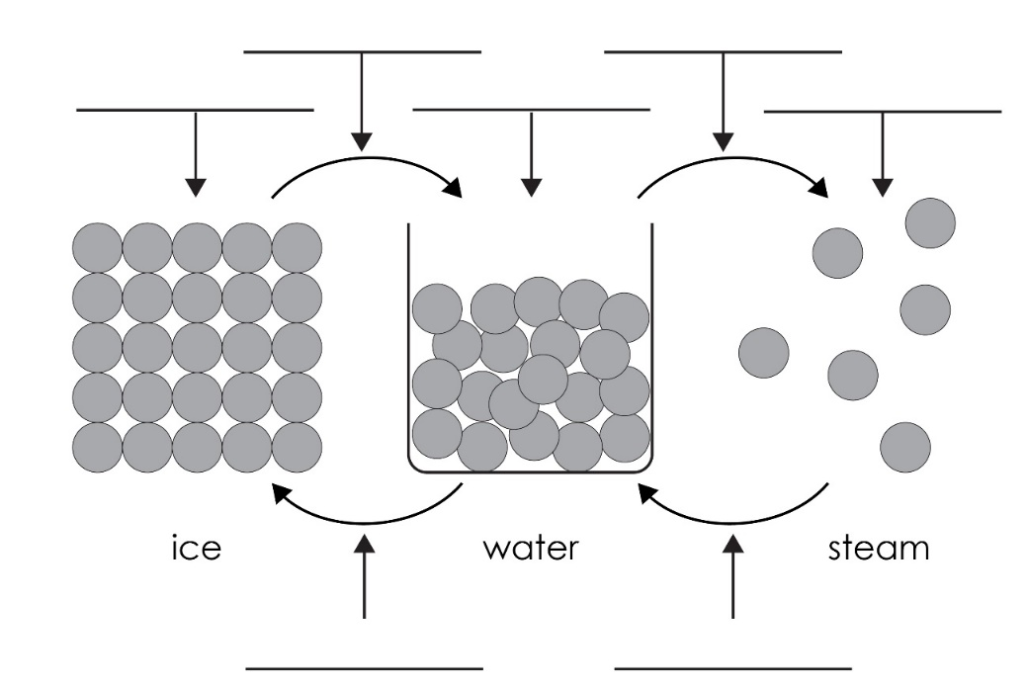
- Describe how the particles are arranged in water.

__________________________________________________________________________________

__________________________________________________________________________________
- Explain how the particles in water move.

__________________________________________________________________________________

__________________________________________________________________________________
- Describe how the particles are arranged in ice.

__________________________________________________________________________________

__________________________________________________________________________________
- Explain how the particles in ice move.

__________________________________________________________________________________

__________________________________________________________________________________
- Complete the sentence:

When water changes into ice, the change of state is __________________________.
- Describe what happens to the kinetic energy of the particles when a liquid changes to a solid. What type of change has occurred?

__________________________________________________________________________________

Challenge questions
- If you drop a piece of solid iron into liquid iron, it sinks. If you drop a piece of ice into water, it floats. Suggest a reason why.

__________________________________________________________________________________

__________________________________________________________________________________

__________________________________________________________________________________

__________________________________________________________________________________

- Suggest a reason why hot water might freeze faster than cold water.

__________________________________________________________________________________

__________________________________________________________________________________

__________________________________________________________________________________

__________________________________________________________________________________

__________________________________________________________________________________

__________________________________________________________________________________

__________________________________________________________________________________

__________________________________________________________________________________

