Fractional distillation and hydrocarbons: knowledge check
- The diagram shows crude oil being separated into fractions in a fractionating column.

Use the words listed to label each of the fractions produced.
liquified petroleum gas diesel kerosene
petrol heavy fuel oil bitumen

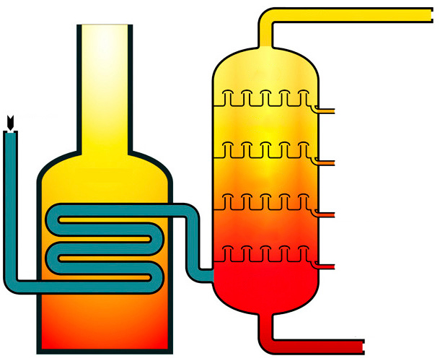
hot
cool
gas
furnace
crude oil

- Add the correct letter into the box provided to match the correct ending (A to E) for each of the sentence starters in the table. The first one has been done for you.
Crude oil contains … | D |  | A … evaporate and then condense.
Fractional distillation is used to … |  |  | B … hotter at the bottom.
During fractional distillation, the hydrocarbon fractions … |  |  | C … separate crude oil into hydrocarbon fractions.
The hydrocarbons are separated according to … |  |  | D … a mixture of hydrocarbons.
The fractionating column is … |  |  | E … their different boiling points.
- Choose the correct word from the brackets to complete each of the following sentences.
- The mixtures of hydrocarbons collected from the fractionating column are called [multiples/fractions].
- Hydrocarbons are compounds containing [hydrogen/water] and [oxygen/carbon] only.
- The hydrocarbons in crude oil are mostly alkanes, which have the general formula [C_{n}H_{2n+2}/C_{n}H_{2n}].
- A molecule of ethane, which contains [two/three] carbon atoms, has the formula [C₂H₆/C₂H₄].

- Use the words listed to complete the gaps in the following sentences.
stronger condense intermolecular forces
liquified petroleum gas higher

Small alkane molecules have weak __________________ __________________ and low boiling points. They do not __________________ in the fractionating column and leave as __________________ __________________ __________________.

Larger alkane molecules have __________________ intermolecular forces. Energy is needed to break the intermolecular forces, so alkanes with larger molecules have __________________ boiling points.

Fractional distillation and hydrocarbons: test myself
Answer questions 2.1 to 2.4 by circling the correct answer.
- Which of the following formulas represents a hydrocarbon? Circle the correct answer.

C₅H₁₂
CO₂
CH₃COOH
- Which of the following alkanes has the highest boiling point?

Circle the correct answer.
CH₄
C₇H₁₆
C₂₀H₄₂
C₇₀H₁₄₂
- The hydrocarbons in the liquified petroleum gas fraction contain between one and four carbon atoms.

Which of the following is a correct property of these hydrocarbons? Circle the correct answer.
high boiling points
easy to ignite
have high viscosity
strong intermolecular forces
- Which two products are produced in the incomplete combustion of methane?

Circle the correct answer.
oxygen
hydrogen
water
carbon
carbon dioxide
methanol

- Complete the missing reactant in the general equation representing the complete combustion of a hydrocarbon.
hydrocarbon + __________________ → carbon dioxide + water
- Complete the balanced symbol equation representing the complete combustion of propane by adding the correct numbers.
C₃H₈(g) + _________O₂(g) $→$_________CO₂(g) + _________H₂O(l)

Fractional distillation and hydrocarbons:
feeling confident?
- The diagram shows the apparatus used by learners during the fractional distillation of a crude oil alternative. During the experiment, the learners collected four different fractions.
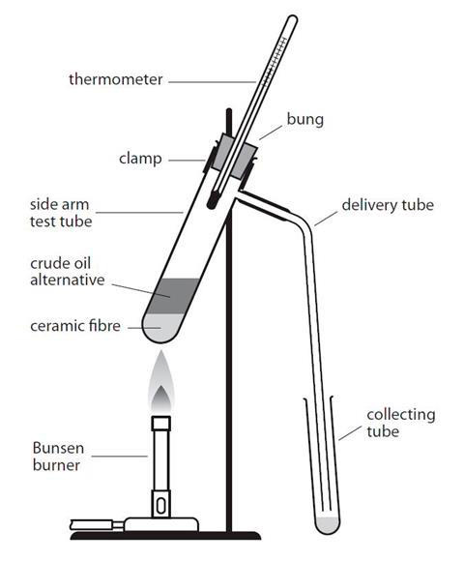

The table shows some of the observations recorded by the learners when they tested the properties of each fraction.
Fraction | Temperature range over which the fraction was obtained/°C | Colour | Viscosity | Ease of ignition
1 | 20–100 | very pale yellow | low viscosity
2 | 100–150 |  | flows quite easily
3 | 150–200 |  | doesn’t flow very easily | difficult to ignite
4 | 200–250 | brown

Make predictions about the missing observations and complete the gaps in the table using the words and phrases listed.
very difficult to ignite yellow high viscosity
easy to ignite very easy to ignite light brown

- The table includes the names, molecular formulas and displayed formulas for the first four alkanes. Complete the table by selecting the correct molecular formulas and displayed formulas from those listed.
C₃H₈ C₂H₆
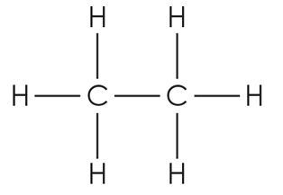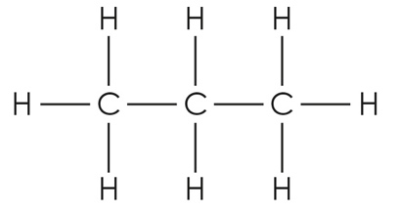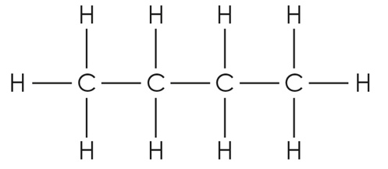
Alkane | Molecular formula | Displayed formula
methane | CH₄ | 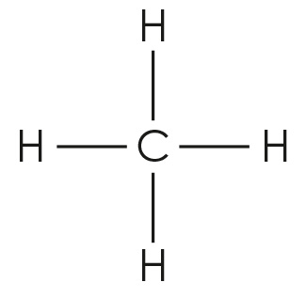
ethane
propane
butane | C₄H₁₀

Fractional distillation and hydrocarbons:
what do I understand?
Think about your answers and confidence level for each mini-topic. Decide whether you understand it well, are unsure or need more help. Tick the appropriate column.
Mini-topic | I understand  this well | I think I understand this | I need more  help
I can describe the process of fractional distillation.
I can explain why crude oil can be separated into fractions.
I can identify a hydrocarbon from its molecular formula.
I can write the general and molecular formulas for alkanes.
I can describe how the length of the hydrocarbon chain affects its boiling point.
I can compare the physical properties of the fractions.
I can compare complete and incomplete combustion.
Feeling confident? topics | I understand  this well | I think I understand this | I need more  help
I can predict the results of an experiment in which a crude oil alternative undergoes fractional distillation.
I can give the molecular and displayed formulas of the first four alkanes.

