Melting chocolate: graph activity
Education in Chemistry
March 2021
rsc.li/3udcF5V

Teacher notes
The graph drawing activity develops skills in drawing and interpreting graphs in the context of cooling melted chocolate. It is designed to be used alongside the melting chocolate infographic poster: rsc.li/3udcF5V
Stearic acid is a constituent ingredient of cocoa beans. Learners should have already completed the stearic acid experiment as a class practical. This resource offers an alternative context to that practical and an opportunity to apply the learning to a new set of data. Chocolate is a mixture rather than a pure substance, so will not have a single melting/freezing point. Learners will use the data in the table to draw their graph, allowing comparisons to be made between dark, milk and white chocolate.
The activity includes a student worksheet with a table of results, a set of pre-drawn axes to provide extra support to those who need it and a set of challenge questions.

Melting chocolate
Chocolate is a mixture of compounds, including stearic acid. Mixtures behave differently to pure substances during cooling.
Use these results to draw cooling curves for different types of chocolate, and then answer the questions to interpret the results.

Part 1: Prior knowledge
- a. What do you think happens to the temperature of a liquid as it is cooled beyond its freezing point?

b. Complete a sketch on the graph below to show what you predict will happen:
Time (min)
Temperature (ºC)

c. Will the temperature carry on falling when the liquid is changing into a solid? Why?

Part 2: Data table
Time (mins) | Temperature of chocolate (°C)
 | Dark | Milk | White
0 | 45.0 | 45.0 | 45.0
1 | 44.0 | 43.0 | 42.5
2 | 41.0 | 40.0 | 38.0
3 | 39.0 | 36.0 | 35.0
4 | 36.0 | 32.0 | 31.0
5 | 35.0 | 31.0 | 29.0
6 | 34.0 | 30.0 | 26.0
7 | 34.0 | 30.0 | 23.0
8 | 33.0 | 29.0 | 22.0
9 | 31.0 | 28.0 | 21.0
10 | 29.0 | 27.0 | 20.0
11 | 26.0 | 26.0 | 20.0
12 | 24.0 | 25.0 | 19.0
13 | 21.0 | 24.0 | 18.0
14 | 19.0 | 21.0 | 16.0
15 | 16.0 | 19.0 | 14.0
16 | 14.0 | 16.0 | 12.0
17 | 12.0 | 14.0 | 11.0
18 | 10.0 | 11.0 | 8.0
19 | 8.0 | 9.0 | 7.0
20 | 5.0 | 6.0 | 4.0
Juliet heated equal amounts of dark, milk and white chocolate in a boiling tube placed in a water bath until completely melted. She transferred the melted chocolate to an ice-bath to cool and measured the temperature every minute for 20 minutes. She recorded the temperature in the table below:

Part 3: Drawing a graph
- a. Plot a graph of Juliet’s results, choosing appropriate scales for the axes. Your x-axis should be time and the y-axis should be temperature. Make sure you use a different colour or symbol for each type of chocolate.
b. Draw a smooth curve of best fit for each chocolate. Use the same colour as you did when plotting the data. Think carefully about any changes in gradient that occur.
c. Label the region of each curve when the chocolates were freezing. What do you notice about the shape of the graph at this point?
d. Label the region of each curve where the chocolates were liquid.
e. Label the region of each curve where the chocolates were solid.

Part 4: Interpreting your graph
- Describe the shape of the graph you have drawn.

- Using your graph, can you determine the freezing point of the chocolates? Why/Why not?
- Explain the shape of the graph you have drawn. (Remember: chocolate is a mixture).

- Complete these sentences:
  - Mixtures melt over a __________________ of temperatures.

  - A mixture does not have a ______________ melting point whereas a pure substance has a
_______________ melting point.

Part 5: Comparing the results
Dark, milk and white chocolate contain different amounts of cocoa solids and cocoa butter. This affects the way they behave as they melt and freeze. You need to use data from the graph to compare the behaviour of the three chocolate types as they changed back into solids.
- State the freezing range for each type of chocolate. Indicate the range on your graph.

- Which chocolate started to freeze at the highest temperature? Use evidence from the graph to support your answer.
- Which chocolate took the longest to change from a solid to a liquid? Use at least two sets of data from the graph to support your answer.

- Describe what is happening to both the dark and milk chocolate at 11 minutes.
- Juliet says: ‘White chocolate took the longest to set.’ Do you agree? Use data from the graph to support your answer.

Pre-drawn axes
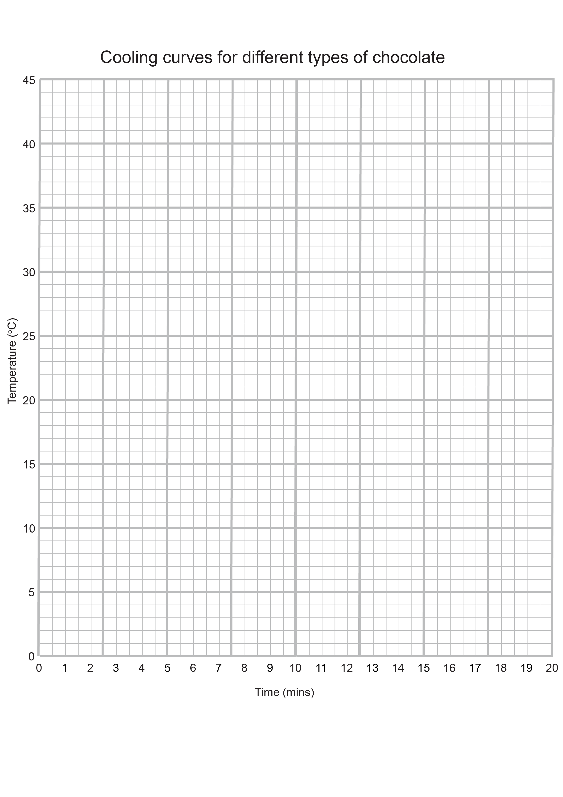

Challenge
- Below is a cooling curve of stearic acid:
Time (min)
Temperature (ºC)

Add the labels a, b and c to the graph to show:
  - the freezing point.
  - the substance in solid state and cooling down.
  - the substance in liquid state and cooling down.
- Describe the shape of the graph.

- Explain the shape of the graph.
- Compare and contrast the stearic acid graph with the melting chocolate graph.
- The table shows some melting points and boiling points.
Substance | Melting point (°C) | Boiling point (°C)
A | -115 | 80
B | -73 | -37
C | -221 | -189
D | -50 | 340

Complete the table to show the state of each substance at the temperature shown.
Temperature (°C) | A | B | C | D
215
0
-215
- On the axes below, draw a sketch to show the cooling curve of any pure substance and a sketch to show the cooling curve of any mixture.
Time (mins)
Temperature (ºC)
Time (mins)
Temperature (ºC)

