Using a microscale conductivity meter – student sheet

In this experiment you will be using a conductivity meter to test which solids and solutions/liquids conduct electricity.

Procedure

- Cover the worksheet with a clear plastic sheet.
- Add three drops of each of the solutions to the circles indicated below.
- Place a small amount of each of the solids in the circle indicated below.
- Test for conductivity by carefully placing just the tip of the electrodes in each of the substances in turn.
- Make a table of your results.
- Give explanations for your results trying to link the conductivity of a substance with its structure.
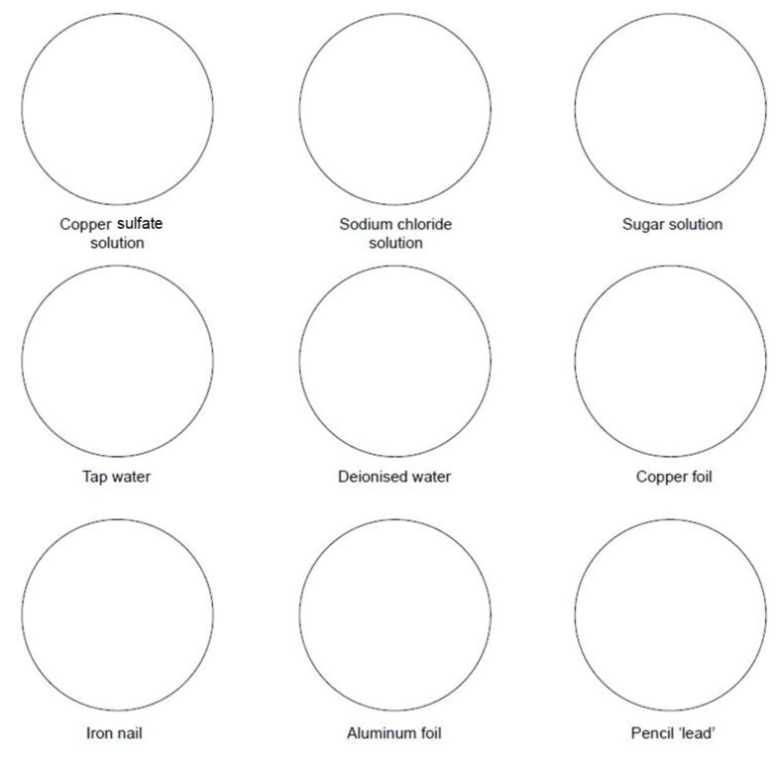

Health, safety and technical notes
- Read our standard health and safety guidance here https://rsc.li/3LNbkfo
- Students must wear suitable eye protection (Splash resistant goggles to BS EN166 3).
- Copper(II) sulphate solution, CuSO₄ (aq) causes eye damage (above 0.12 mol dm-1), is harmful if swallowed and HAZARDOUS to the aquatic environment.

