Graphs in chemistry: Cooling curves
Education in Chemistry
September 2020
rsc.li/2ZzBziL
Complete the practical, sketch a graph of your results and answer the questions.

Part 1: Practical
Kit:
- Beaker  - Water  - Stearic acid  - Bunsen burner | - Thermometer  - Clamp  - Boiling tube  - Timer
Instructions:
- Set up the apparatus as shown, filling the beaker with approximately 150 cm³ of water.
- Heat the water using a Bunsen burner until the thermometer reads approximately 80°C.
- Raise the level of the clamp so the boiling tube lifts out of the boiling water.
- Record the temperature and start the timer.
- Record the temperature every 30 seconds until the thermometer reads approximately 40°C, noting down the temperature when the stearic acid starts to freeze.
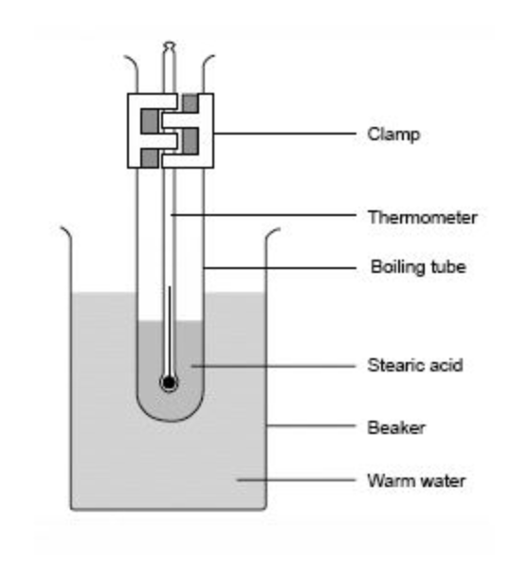

Part 2: Your results
- Plot a graph of your results, choosing appropriate scales for the axes.
- Label the temperature when the stearic acid was freezing. What do you notice about the shape of the graph at this point?
- Draw a smooth curve of best fit.
- The temperature should stay constant at 69.3°C while the stearic acid is melting, but often the temperature continues to go down slowly. Why might your experimental results not show a perfect horizontal line at 69.3°C?

Part 3: Other graphs
- On the axes below, draw a sketch of what you think the graph would have looked like if you had cooled the stearic acid gas down from 400°C to 30°C. The boiling point of stearic acid is 361°C.
400
0
Temperature, degrees C
Time
- How does your sketch differ from the graph of your experimental results? What have you assumed? Have you changed or ignored anything?
- When would the graph above be more useful than your graph from Part 2? When would it be less useful?
- Draw a sketch to represent the cooling curve for any substance.
Temperature
Time
- Why might a graph showing the general trend for cooling curves be useful for chemists?

