Lab-grown diamonds get a boost

Original article by Tim Wogan. Adapted by Nina Notman.

A new method for growing diamonds in the lab has sparkling potential

Scientists in South Korea have developed a new method for producing synthetic diamonds. The team is now working to optimise the method to grow larger diamonds and diamond films with a range of industrial applications.

Most of the diamonds grown in laboratories are not large gemstones. Instead, they are tiny diamonds, called diamond power or grit, or patchworks of minute crystals that have grown densely packed together, called polycrystalline diamond films or wafers. Among other things, synthetic diamonds are used to produce extremely hard drill bits and saw blades and as heat spreaders for advanced computer chips.

There are two long-established methods for growing synthetic diamonds. The first uses conditions similar to those in the mantle, where diamonds grow naturally. In a giant press, diamond seeds, graphite (the source of carbon atoms) and a metal catalyst are subjected to extremely high temperatures and pressures. The second method, chemical vapour deposition, uses microwaves to convert methane gas into the carbon atom source for growing diamonds.

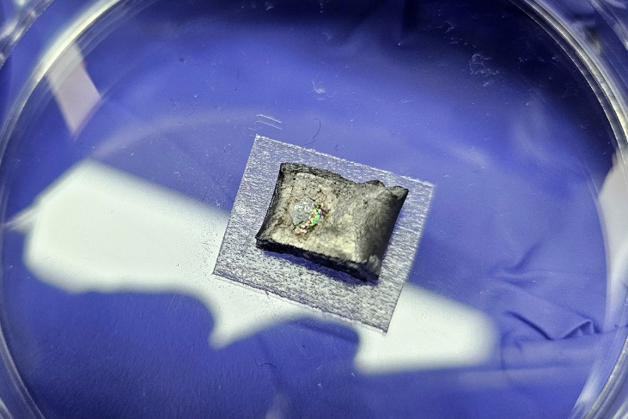
Going 3D

Source: © Dushlik/Getty Images

A more sustainable and potentially cheaper alternative to mined diamonds

The new approach was inspired by previous experiments where the carbon atoms in methane gas were rearranged into solid graphene sheets by exposing it to molten metal catalysts. The scientists tweaked these experimental conditions to create a different carbon structure: diamond. The carbon atoms in diamonds are in a tetrahedral arrangement with each carbon joined to four others by covalent bonds.

To make diamond, the team exposed a mixture of methane and hydrogen gases to a molten alloy of gallium, silicon, iron and nickel at temperatures of around 1000°C and ambient pressure. The role of the silicon isn’t yet determined, but without it the carbon atoms do not come together into a diamond structure.

Using this method, the scientists grew polycrystalline diamond films to tens of micrometres across in less than three hours. To make diamond films of useful sizes, further tweaks to the experimental design are being made.

This is adapted from the article ‘Liquid metal synthesis of diamonds achieved at atmospheric pressure’ Chemistry World. Read the full article: rsc.li/4auq1Pm.

