Compounds with amine groups

Classification of amines and amides

Amines are compounds containing a basic nitrogen atom with a lone pair. They are derivatives of ammonia where bonds are formed with one or more organic ‘R’ groups. When the lone pair is also used in co-ordinate bonding with say a H+ ion then the compound formed is called a quaternary ammonium salt. When an amino group is next immediately adjacent to a carbonyl C=O group, the compounds are called amides. Both types of compound can be classified as primary (1°), secondary (2°), tertiary (3°) or quaternary (4°), according to the number of organic R groups on the nitrogen.
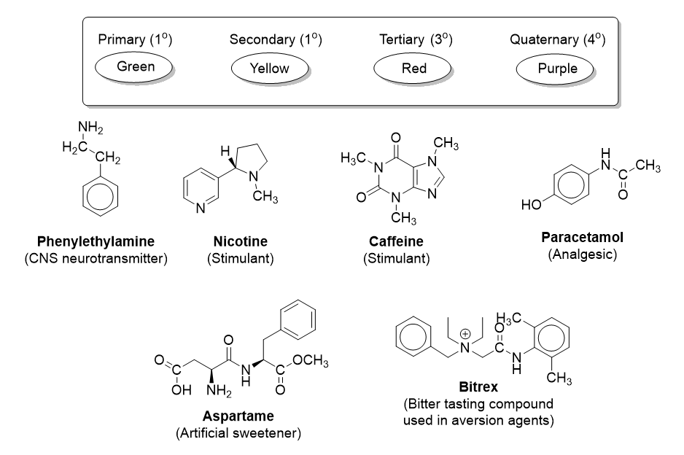
- Look at the following chemicals containing amine and amide groups. Colour code the groups according to their class.

Properties of amines
Oliver took some ammonia solution (Beaker A) and added some dilute HCl. Before the addition the ammonia had a distinctive ‘fishy’ odour. Following the addition this went away (Beaker B). When dilute NaOH was added to beaker B the fishy odour returned.
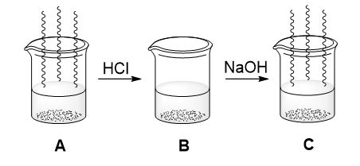

- Using your knowledge of amine chemistry, explain the observations Oliver made.

- George took some ammonia and added it to water. He added universal indicator to the solution which turned purple. Explain these observations.

- The table below shows the pKa values for some amines. The smaller the pKa value, the stronger the base. Discuss these values.

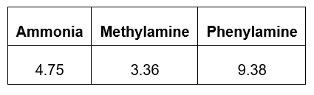

Amine mechanisms
- Outline the mechanism leading to the formation of X from bromoethane in the presence of an equimolar quantity of ammonia.

(8 marks)
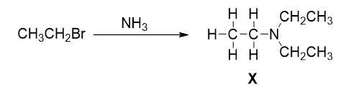

- Explain why this reaction does not stop at the first amine product
(1 mark)
3. Suggest a way that the formation of X can be supressed, leading to a high yield of aminoethane
(1 mark)

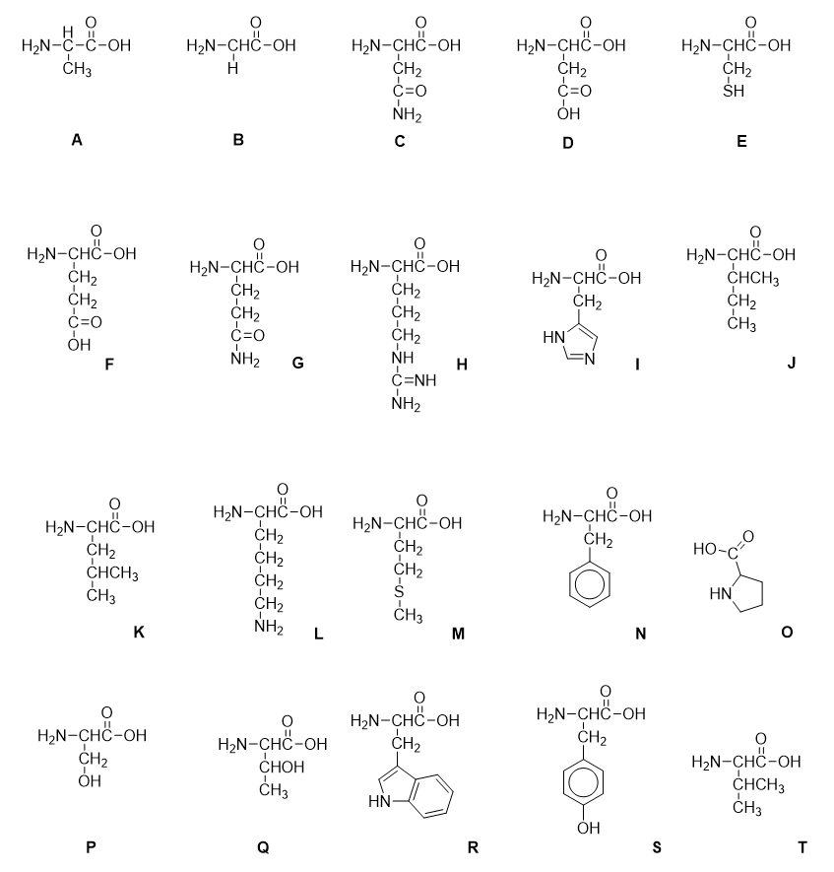
Amino acids

Above are diagrams of the 20 naturally occurring amino acids. The clues describe 10 of them. Give the letter of the alphabet for the structure being described.

Alanine is a major source of energy for muscles. It has a molecular mass of 89.
Arginine is an amino acid necessary for wound healing and has an imine in its R group.
Aspartic acid is an amino acid that can be transformed into aspartame, an artificial sweetener. It has 2 acid groups in its structure.
Cysteine is an amino acid which is abundant in the keratin proteins that make up curly hair through the formation of disufide bridges. It has a thiol in its structure.
Glutamic acid is an amino acid which is used to build GABA neurotransmitters. It has the same structure as aspartic acid but with the addition of an extra CH₂ in the R side chain.
Glycine is the simplest amino acid and forms part of the haemoglobin structure.
Histidine is an amino acid that is associated with allergic responses. It has 3 nitrogen atoms in its structure.
Phenylalanine plays an important role in the production of collagen and has a benzyl R side chain.
Proline is a critical component of cartilage tissue. It is a relatively simple amino acid with no R side chain and its amine group is part of a 5 membered ring.
Tryptophan is used by the body to produce the key calming neurotransmitter serotonin. Its R side chain contains a bicyclic aromatic heterocycle (2 rings, joined together and one or more containing an atom other than carbon.

Amino acids and pH

- Complete the diagram to show the structure of the amino acid A at the pHs indicated.
(3 marks)
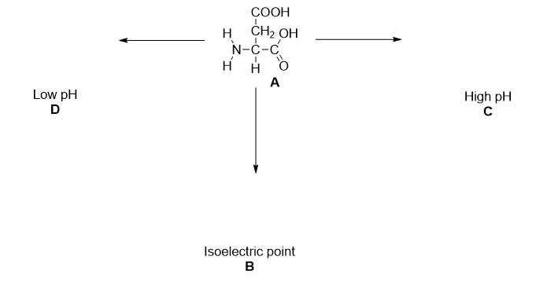
- What is the general name for amino acids in the form shown in B?
(1 mark)
- State and explain 2 properties of amino acids that occur as a result of the formation of structure B.
(6 marks)

Amine preparation

Complete the diagrams with structures, names and reagents where appropriate.

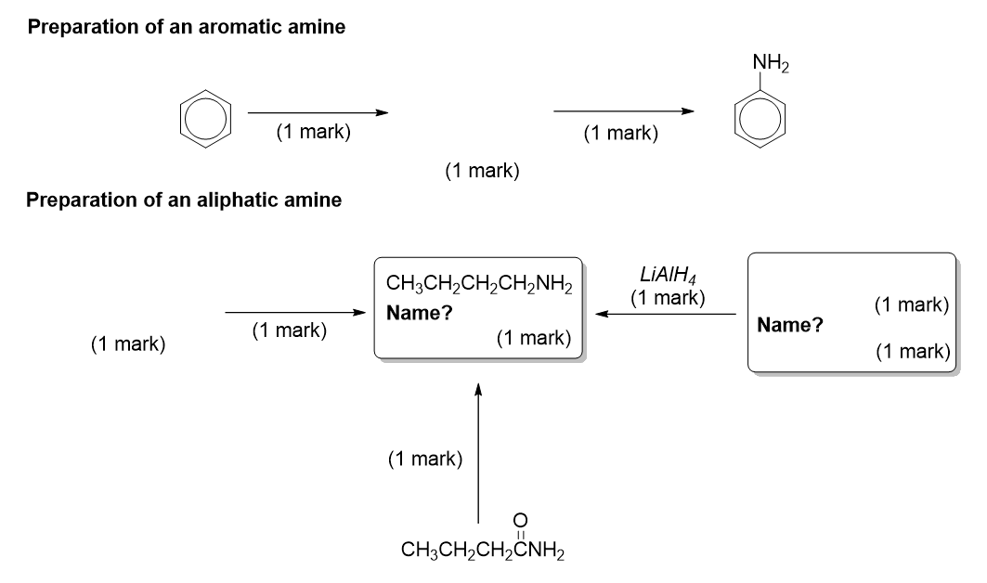

Compounds with amine groups – Answers

Classification of amines and amides

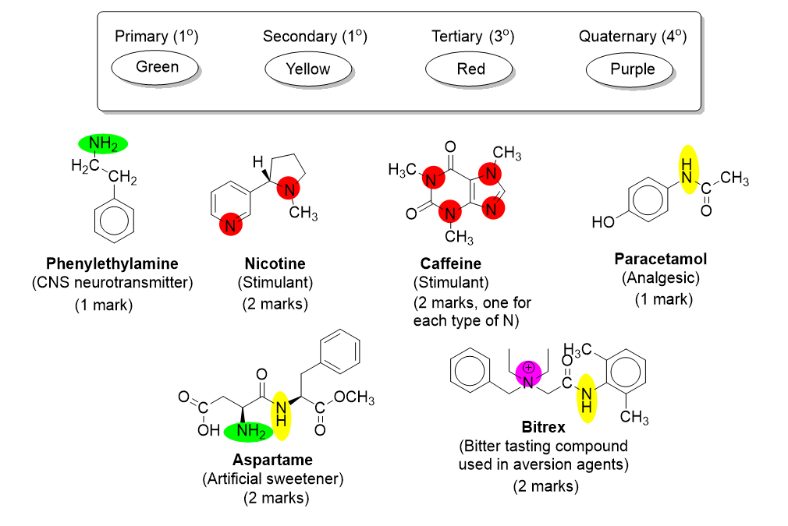

Properties of amines

- Ammonia is volatile
- Addition to HCl causes the formation of ammonium chloride/quaternary ammonium salt
- Ammonium chloride/quaternary ammonium salts are non-volatile
- Addition of NaOH restores the basic conditions and volatile NH₃ is reformed

- NH₃ reacts with water molecules to form NH₄⁺ and OH⁻ (or equation for the formation of both)
- OH⁻ causes the universal indictor to change colour

- Methylamine is a stronger base than ammonia because the inductive effect of the alkyl/methyl group increases the availability of the lone pair.

Phenylamine is weaker as the lone pair is partially delocalised into the benzene ring.

Amine mechanisms

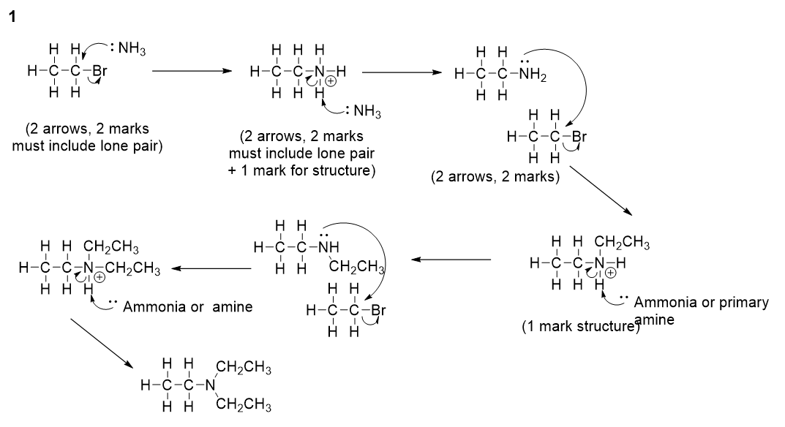

2. Substituted amines are more nucleophilic than ammonia (due to the inductive effect)
(1 mark)
3. Use an excess of ammonia

Amino acids

Alanine A
Arginine H
Aspartic acid D
Cysteine E
Glutamic acid F
Glycine B
Histidine I
Phenylalanine N
Proline O
Tryptophan R

This starter is a good opportunity to discuss some chemistry beyond the curriculum.

Properties of amino acids

1 (1 mark for each correct structure)
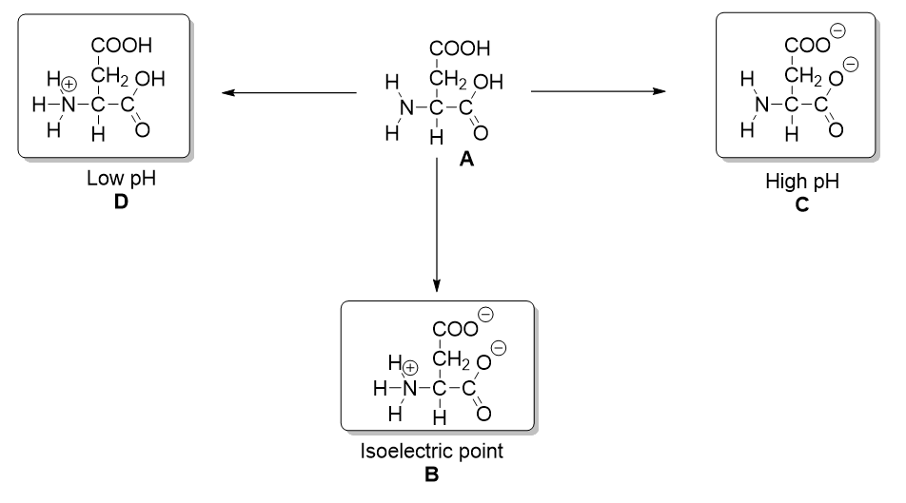

2. Zwitterion
(1 mark)

3. High melting point/solid at room temperature (1) because strong (1) electrostatic attraction (1) between oppositely charged ions/ionic regions (1).

Soluble in water (1) because the charged regions are attracted to the δ+ and δ– regions of water (or water is a polar molecule) (1)

Preparation of amines

