The melting point of aspirin – teacher notes

Introduction
A pure substance usually has a specific melting point – ie a narrow temperature range during which it changes from a solid to a liquid.
Any impurities in the substance cause a lowering and broadening of this characteristic temperature.

Substance | Melting point
2-Hydroxybenzoic acid | 158–160 °C
Aspirin | 138–140 ° C

Apparatus
- Melting point tubes
- Watch glass
- Bunsen burner and heatproof mat
- Melting point apparatus: this may consist of a small beaker containing oil or glycerol in which is supported a 0–360 °C thermometer with small rubber bands for attaching the melting pointing tubes, or a commercial apparatus.

Health, safety and technical notes
- Read our standard health and safety guidance here https://rsc.li/3L06RGe
- Wear eye protection.
- 2-Hydroxybenzoic acid (salicylic acid) is harmful by ingestion and is irritating to the skin and eyes. See CLEAPSS Hazcard HC052

Answers
- This answer will depend on the students’ results.
- The crude product may have a significantly lower melting point (126–132 °C) than pure aspirin as it contains certain impurities.
- Possible impurities are water, ethanoic anhydride, ethanoic acid, 2-hydroxybenzoic acid and polymerised 2-hydroxybenzoic acid.
- Forces within crystals of 2-hydroxybenzoic acid may include hydrogen bonding, dipole-dipole forces between polar molecules, and van der Waals forces. These are listed in order of decreasing strength. These forces hold the molecules together in a crystal lattice. When a substance melts these forces have to be overcome. By heating the solid the molecules are given sufficient kinetic energy to overcome these intramolecular forces.
- The two molecules are the same apart from one having a phenolic OH group and the other having an ester group.
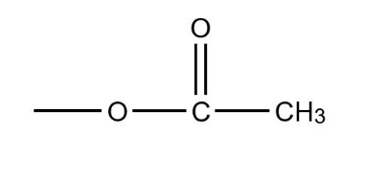
The phenol can form hydrogen bonds with other molecules whereas the ester cannot. This means that more energy is required by the phenol to overcome these intramolecular forces.

Further investigation
An extension to this Activity might include determining mixed melting points, using 2-hydroxybenzoic acid, the crude aspirin from activity 3 and the purified aspirin.

