R0 What is it and how do our actions affect it? Answer sheet
Education in Chemistry
June 2020
rsc.li/2z6Tnrn
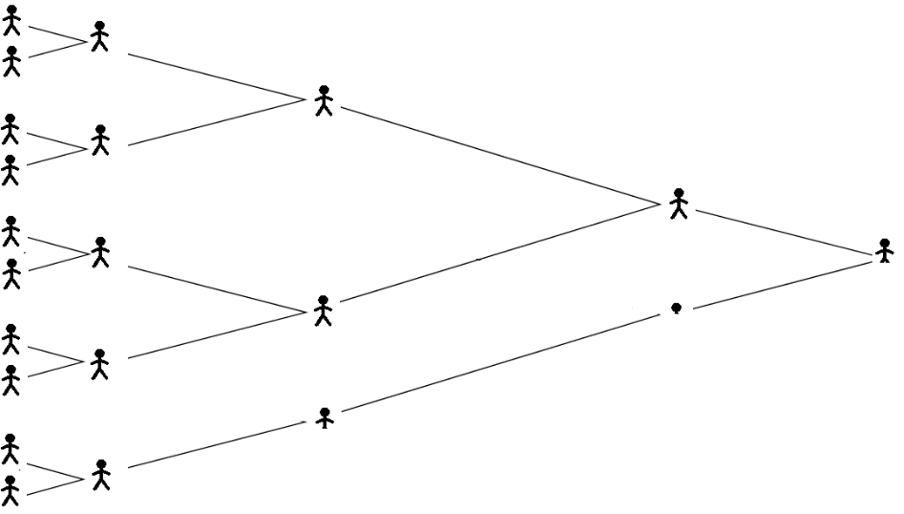
1. a.
1st
transmission
10
5
2.5
1.25
0.625
4th
transmission
2nd
transmission
3rd
transmission

b. i. 150,000 × 0.8¹⁰ = 16,106 people
ii. 150,000 × 0.5¹⁰ = 146 people
ii. 150,000 × 0.2¹⁰ = 0.015 people
2. a.
Table 1
Intervention | Reduces the number of contacts per unit time | Reduces the proportion of contacts that produces infection
Cancelling sporting events | ×
Disinfecting trolley handles in the supermarket |  | ×
Closing schools | ×
Limiting outdoor exercise to once a day | ×
Closing restaurants | ×
Handwashing |  | ×
Finding a vaccine |  | ×

b. i. R0 would decrease as the proportion of contacts that produce infection would be decreased assuming the face mask prevents the transmission of the virus.
ii. R0 would increase as the number of contacts per unit time would increase.
c. If sufficient people have immunity to an infection the proportion of contacts that produces infection will be reduced as even though a contact might be made and the virus transmitted no infection will result.

