Organic chemistry

General and mechanism

Functional groups

In each of the speech bubbles write the general name for the functional group ringed. (In the structures below the rings are shown in a ’skeletal’ form. Where you can see a corner then there is a carbon with the appropriate number of hydrogens).

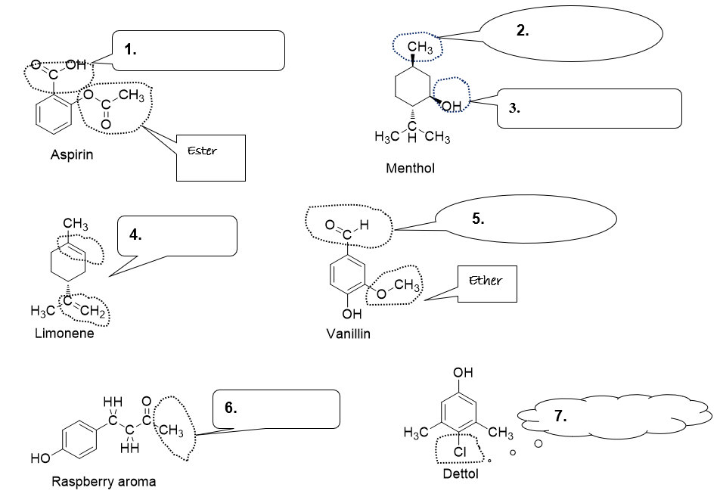

8. Considering the limonene molecule given above.
(a) Draw the displayed formula
(1 mark)
(b) Calculate the molecular formula
(1 mark)
(c) Deduce the empirical formula
(1 mark)

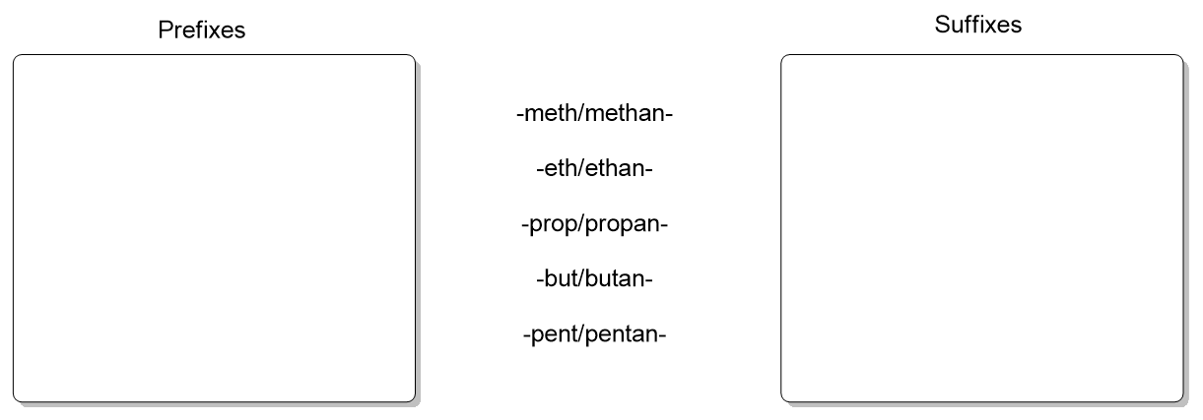
Nomenclature
- Group the following functional groups into prefixes (where the functional group goes before the naming stem) and suffixes (goes after the naming stem).
(4 marks)
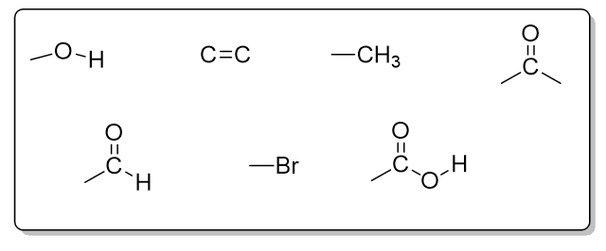
- Name the following compounds
(6 marks)
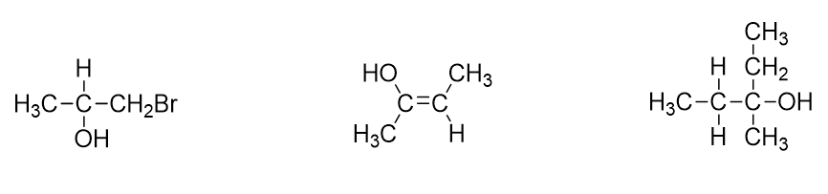

Formula

- Define the term empirical formula (1)
- An algebraic formula that can describe any member of a family of compounds is a way of describing a type of formula in organic chemistry.
- Which formula does this definition refer to?
(1 mark)
(b) What would this formula be for the family of –
i.Alkanes
(1 mark)
iiAlkenes
(1 mark)
- The empirical formula of the compound 3-methylpentan-2,2-diol is C₃H₇O
- Deduce its molecular formula
(1 mark)
(b)Write the structural formula for this compound
(1 mark)
(c)Show the displayed formula of this compound
(1 mark)
- A hydrocarbon is shown to contain 92.3% carbon and 7.7% hydrogen by mass
- Calculate the empirical formula of the hydrocarbon
(1 mark)
- The relative molecular mass of the hydrocarbon is 78. What is its molecular formula?
(1 mark)
- Cyclohexane and hex-1-ene have the same molecular formula. What is it?
(1 mark)

Isomerism
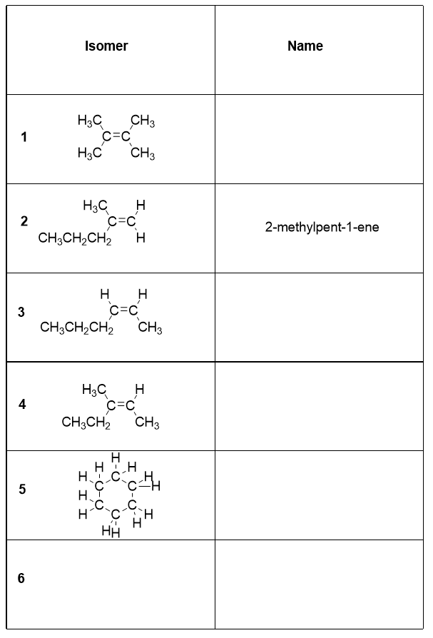
The table shows 5 isomers.
- Complete the table by giving the names of the isomers shown (4)
- State the molecular formula of the isomers (1)
- Isomer 6 is an alkene with the same molecular formula as the other isomers. Draw one possible structure for this in the box and name it. (2)
- Give the numbers of the isomers which show geometric isomerism (3)

Mechanisms and curly arrows

Mechanisms aren’t difficult to remember if you understand the principles behind them. Just learning the arrows doesn’t help, you need to develop chemical common sense and decide what is sensible based on electron flow. To do this you need to know areas of high electron density and low electron density.

- Assign $δ$ + and $δ$- to the following bonds.
- marks)
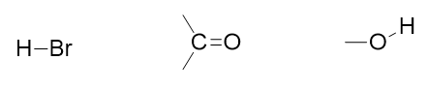
- Draw curly arrows to show how electrons move in the following transformations (you don’t need to have learnt these mechanisms, look at what’s happening and use your intuition!)

(4 marks)

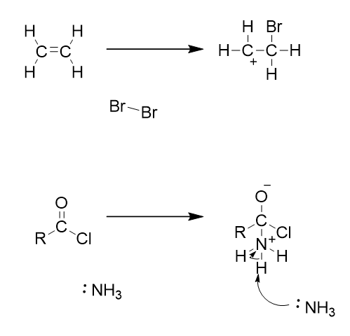

Electrophiles and nucleophiles
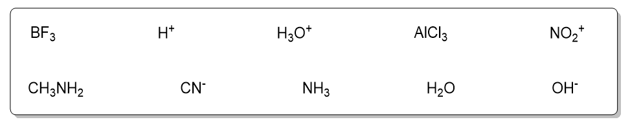
Sort the above molecules and ions into electrophiles and nucleophiles
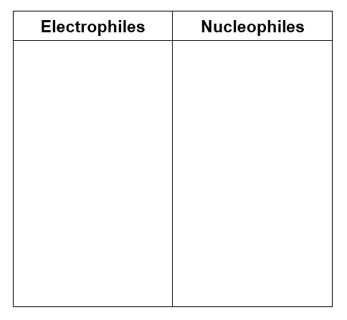

Group 2

Fractional distillation and cracking

Fractional distillation is used to separate the components in a mixture of crude oil.

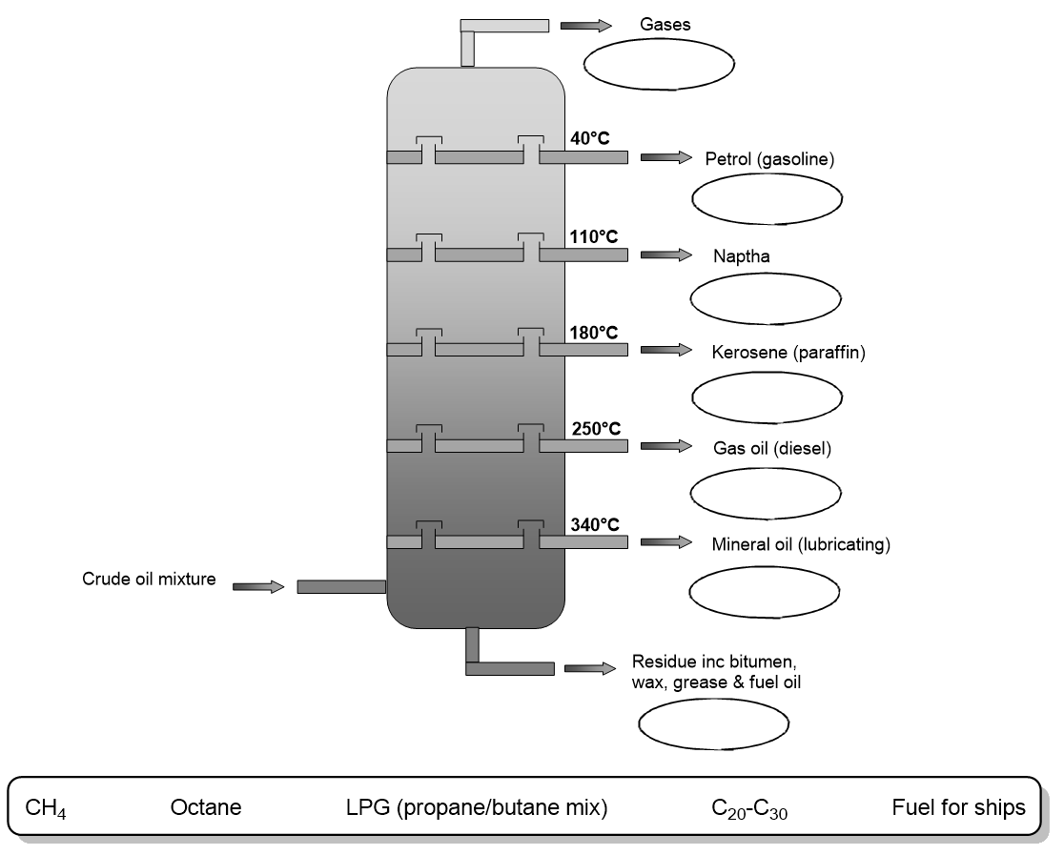

- The diagram shows a fractioning column.
- Place the formulae and words in the appropriate places on the column.
- marks)

- Longer chain hydrocarbons are less useful and therefore less commercially attractive than shorter chain hydrocarbons. Cracking can be used to create shorter hydrocarbons from longer ones. There are two methods of cracking, thermal cracking and catalytic cracking. The following statements could apply to either method, next to the statement write a T for thermal or C for catalytic to indicate the appropriate method.
  - Produces lots of alkenes
  - Produces mainly alkanes and some aromatic compounds
  - High pressure (up to 70 atm)
  - Temperature of approximately 450°C
  - Moderate pressure

Air pollution

Alkanes are really useful fuels, producing a lot of energy during combustion. Unfortunately combustion can also lead to the formation of pollutant gases.

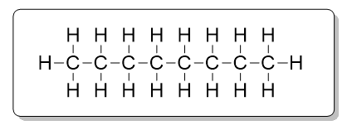
1. Octane C₈H₁₈ is a component of motor fuel.
- Write an equation to show the complete combustion of octane.
(1 mark)
- Write an equation to show the incomplete combustion of octane.
(1 mark)
- Both process produce gases that could be described as polluting. Identify one pollutant gas from each process and state the problem associated with it.
(2 marks)

2. In the internal combustion engine, other polluting gases such as NO and SO₂ can be formed which aren’t products from combustion of hydrocarbons.
- Give a reason for the formation of NO in the internal combustion engine
(1 mark)
- Write an equation to show how NO is formed
(1 mark)
- SO₂ is formed from the combustion of sulfur containing impurities in fossil fuels. What environmental problem is associated with the formation of SO₂?
(1 mark)

3. The emission of polluting gases can be reduced by catalytic converters fitted to cars.
- Write equations to show how NO₂ and CO are transformed into less harmful products in a catalytic converter.
- marks)
- Name the metal(s) used as catalysts in catalytic converters.
(1 mark)

Greenhouse effect

Most scientists now believe that global warming is caused by increased levels of greenhouse gases in the atmosphere. The most widely publicised of these is carbon dioxide, CO₂.
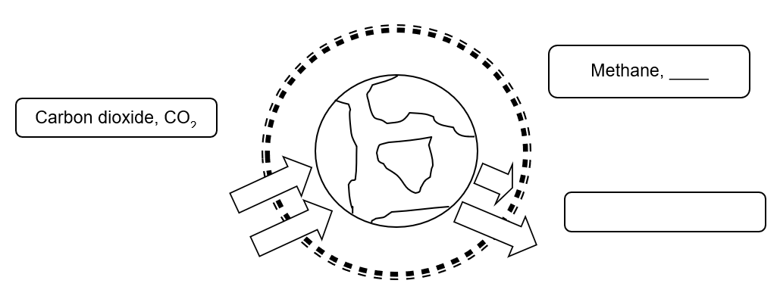
1. Complete the diagram with the names and formula of the other greenhouse gases
(2 marks)
2. Explain how carbon dioxide contributes to global warming by explaining its contribution to the greenhouse effect.
(6 marks)
3. Write an equation to show how combustion of octane (C₈H₁₈), a major component of petrol produces greenhouse gases.
(1 mark)
4. Suggest why global meat production contributes to global warming.
(1 mark)

Alkanes
- Give 3 features of a homologous series
(3 marks)
- Name the method used to separate hydrocarbons
(1 mark)
- The boiling point of alkanes increases as chain length increases. Explain this trend.
(2 marks)
- n-pentane (CH₃CH₂CH₂CH₂CH₃) is the straight chain isomer of pentane.
- Draw the other 2 isomers
(1 mark)
- State the difference in boiling point between these isomers and n-pentane.
(1 mark)
- Explain this difference
(2 marks)

Alkanes summary
Alkanes are saturated hydrocarbons often used as fuels. Alkanes from pentane to octane are generally refined to form petrol and those from nonane to hexadecane refined to form diesel fuel and kerosene.

- What is the meaning of the term saturated?
(1 mark)
- State the general formula for alkanes.
(1 mark)
- Give the molecular formula for octane.
(1 mark)
- n-Hexane (CH₃CH₂CH₂CH₂CH₂CH₃) is the straight chain isomer of hexane.
- Draw the other isomers of hexane.
(4 mark)
- Write an equation for the complete combustion of hexane.
(1 mark)
- Write an equation for the incomplete combustion of hexane and state an environmental problem associated with this.
(2 marks)

Free-radical mechanisms

Free radicals are formed from homolytic bond breaking, where a bond breaks and each atom gets one of the electrons. Alkanes react via a free radical substitution mechanism which has 3 stages, initiation, propagation and termination.

For methane initiation and propagation steps are as follows;

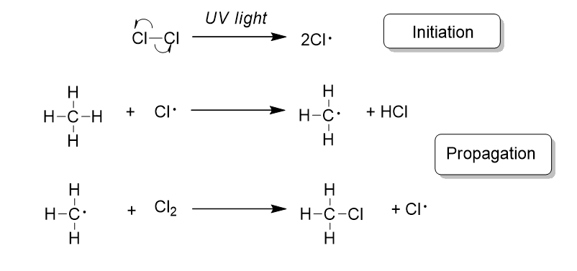

- Using your knowledge of the free radicals in the mixture, predict the 3 possible termination steps.
(3 marks)
- If chlorine is in excess then substitution of the product chloromethane can occur through a series of propagation steps. Show by a series of reactions how this can lead to the formation of the carcinogen tetrachloromethane (CCl₄).
(6 marks)
- Predict a termination step that could lead to the formation of a product with the empirical formula CHCl₂.
(1 mark)

Ozone layer

1. Ozone is an allotrope of oxygen.
(a) Give the chemical formula for ozone
(1 mark)
(b) Illustrate how ozone is formed from oxygen
(2 marks)
(c) state the essential condition in the production of ozone
(1 mark)

2. Chlorofluorocarbons (CFCs) were widely used chemicals in the past and are now known to cause damage to the ozone layer. State one use of CFCs.
(1 mark)

3. Halothane is an inhalational general anaesthetic commonly used in veterinary surgery and in the developing world. Its IUPAC name is 2-bromo-2-chloro-1,1,1-trifluoroethane.
(a) Draw the structure of halothane
(1 mark)
(b) Show using an equation how halothane could decompose to form chlorine free radicals in the upper atmosphere
(1 mark)
(c) Illustrate using equations how the free radical generated can lead to the decomposition of ozone
(1 mark)
(d) State an effect to humans of the decomposition of the ozone layer
(1 mark)
(e) Hydrofluorocarbons (HFCs) have been developed to replace CFCs in many applications.
Why are HFCs not believed to cause decomposition of the ozone layer?
(1 mark)

Electrophilic additions 1
Consider the following schemes showing the reaction of two different alkenes.

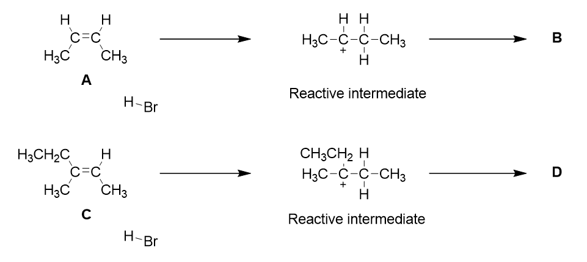
- Name the geometric isomer A.
(1 mark)
- Complete the mechanisms by addition of arrows, reacting species and final products.
(6 marks)
- What is the name of the reactive intermediate formed in this mechanism?
(1 mark)
- Name the products formed, B and D.
(1 mark)
- The second reaction proceeds according to Markovnikov’s rule.
What is the driving force behind this rule?
(1 mark)

Electrophilic additions 2
Draw the structures of and name the missing reactants and products A to E

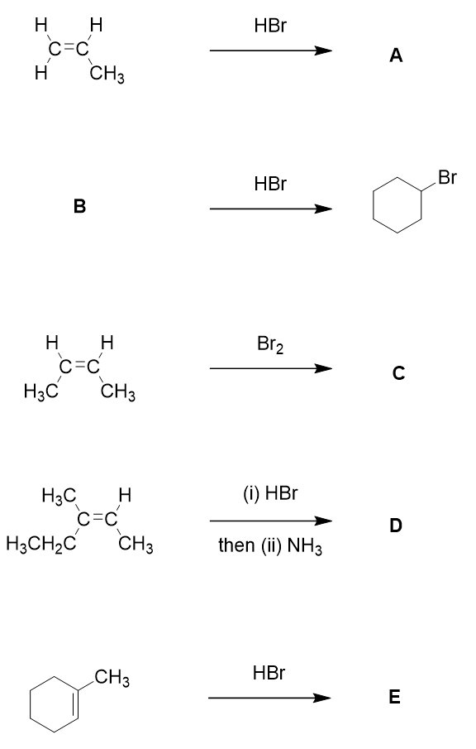

Isomerism in alkanes and alkenes
1. The simplest alkane to show isomerism is C₄H₁₀.
Predict the number of isomers C₄H₁₀ displays
(1 mark)

Draw the isomers of C₄H₁₀
(1 mark)

2. The next member of the homologous series is C₅H₁₂
Predict the number of isomers C₅H₁₂ displays
(1 mark)

Draw the isomers of C₅H₁₂
(2 marks)

3. There are 2 geometric isomers of the alkene C₄H₈. Draw both isomers and label them E and Z.
(1 mark)

4. Draw a pair of geometric isomers for the alkene C₅H₁₀ and label them E and Z.
(2 marks)

5. Draw 2 isomers of the alkene C₅H₁₀ that do not show geometric isomerism.
(2 marks)

Polymers from alkenes
- Complete the following table to show the alkene and the polymer it makes.
(4 marks)
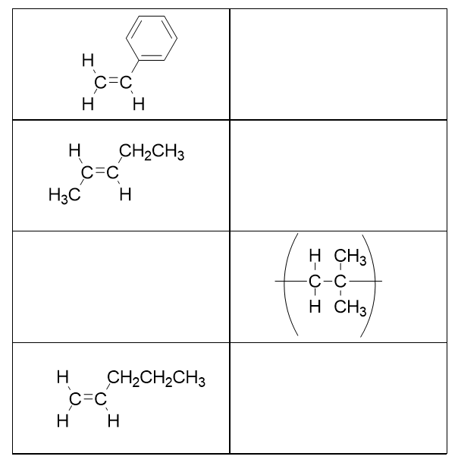
- In recent years the sustainability of plastics derived from crude oil has become a focus for chemists. There are now many polymers derived from plant sources. Using your knowledge of reactions in AS chemistry, suggest a route to poly(ethane) that is derived from a plant source. Include reagents and conditions where appropriate.
(6 marks)

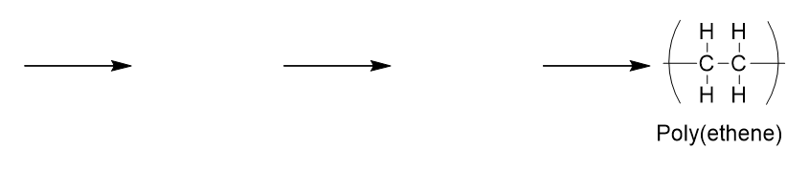

Group 7

Substitution reactions

Haloalkanes are useful intermediates in synthesis because they are able to be transformed into many different compounds via substitution reactions.

- Complete the spider diagram to show the products that can be formed from 2-bromopropane. Each product should be drawn (A and B) and named (A-D) and missing reagents completed.
(8 marks)
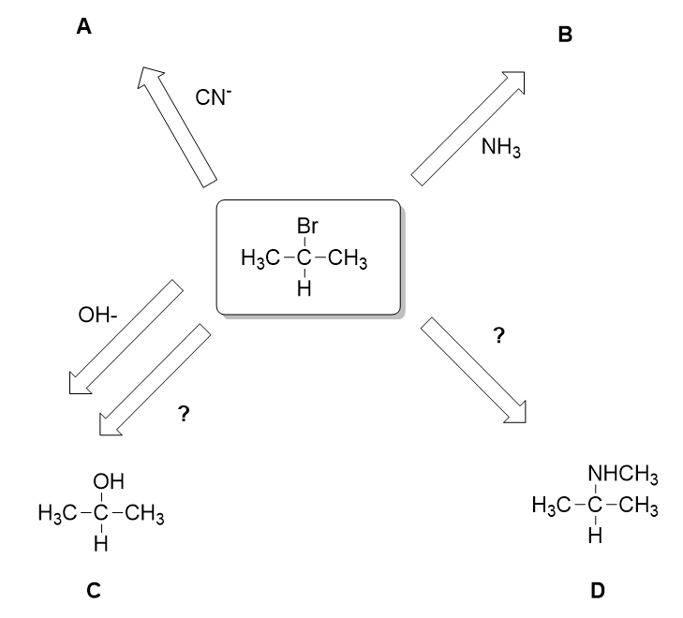
The reactions proceed via the nucleophilic substitution mechanism. The beginning of this mechanism is outlined below.

- Complete the mechanism using the appropriate species to show how D is formed from 2-bromopropane.
(2 marks)
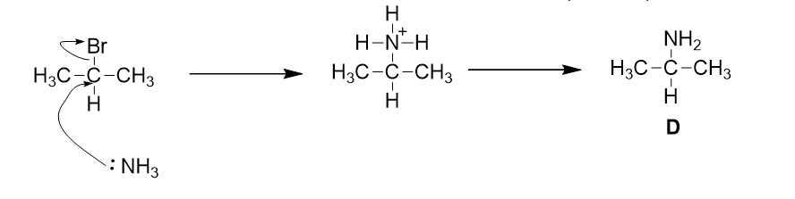

Haloalkanes – substitution vs elimination

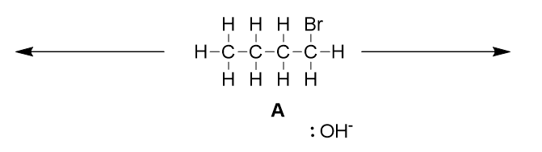
- Haloalkane A is treated with sodium hydroxide
  - Predict the 2 possible products arising from OH⁻ carrying out a substitution or elimination mechanism, draw the structures and name them.
(4 marks)
- State the role of OH⁻ in the mechanisms leading to these products
(2 marks)
- How do the reaction conditions change in order to select one product over the other one?
(2 marks)
- If you wanted to regenerate A from the elimination product, what reagent would you use and what mechanism would it proceed by?
(2 marks)

Alcohols
Consider the following alcohols.

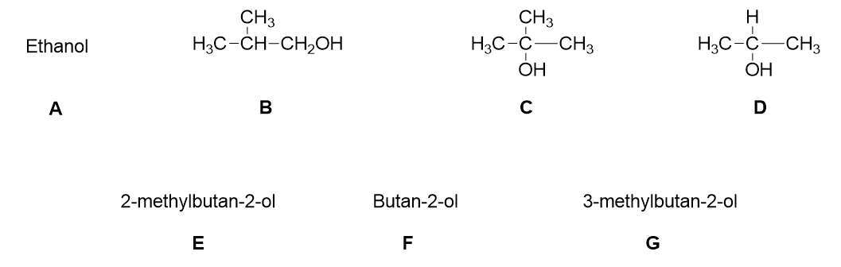
Give the letters of the alcohols which…..
- Are tertiary alcohols
- Are oxidised to carboxylic acids
- Show a colour change orange to green when treated with acidified potassium dichromate solution

Alcohols as intermediates
Alcohols are useful intermediates. The scheme below shows how ethanol can be formed and reacted to give various products. Complete the diagram with the structures of A-C and the missing reagents.
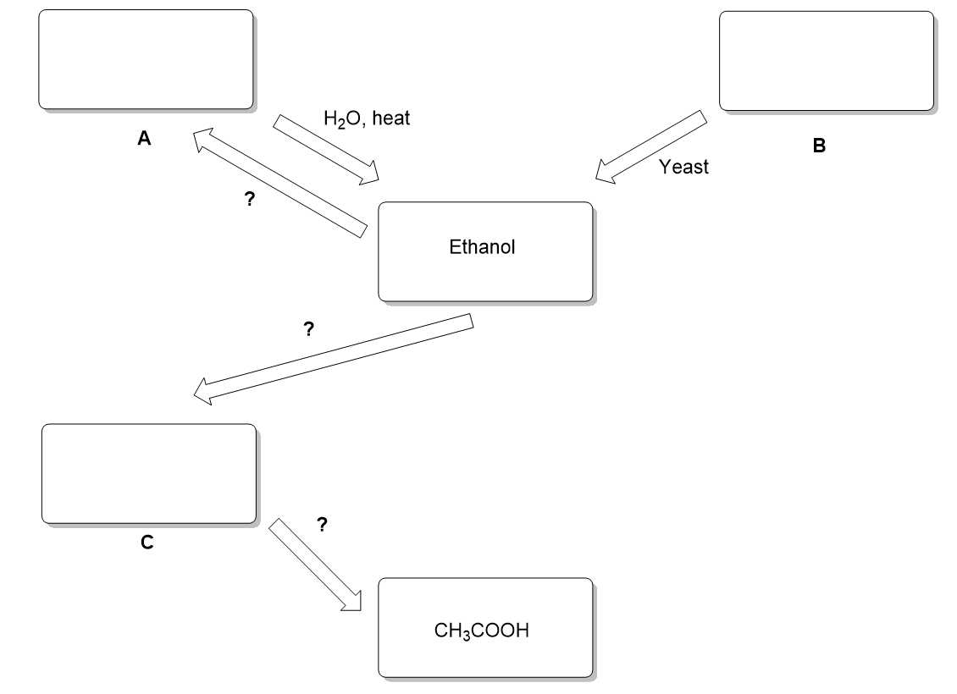
(5 marks)

- Name the process by which the source material B is transformed into ethanol and write a balanced equation for this process.
(2 marks)
- Of the two source materials A and B, B is considered to be more sustainable. Explain why.
(1 mark)
- The conversion of ethanol to A can be classed as dehydration. Explain why this is the case.
(1 mark)
- Which substance can be tested for using aqueous sodium bicarbonate solution?
(1 mark)

Oxidation of alcohols

The structures below show a range of different alcohols.
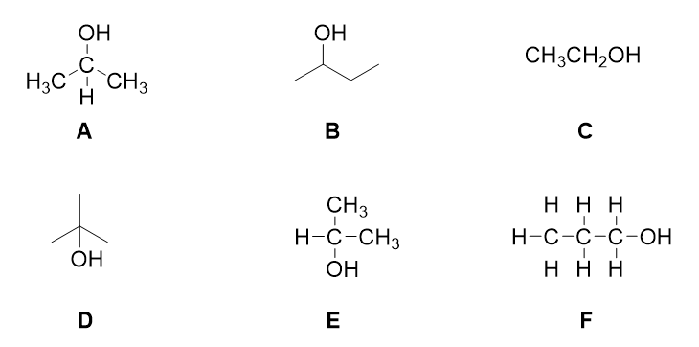

1.Give the letters of all the structures of primary alcohols
2. State the reagent used to confirm the functional group present when primary alcohols are oxidised and the product distilled. Give the expected result.
3. Give the letters of all the alcohols that could be oxidised by acidified potassium dichromate
4. Give the letters of all the alcohols that would be oxidised to give a ketone
(8 marks)
5. Write an equation for the oxidation of the alcohol F, carried out under reflux. Use [O] to show the oxidising agent.
(2 marks)

Biofuels

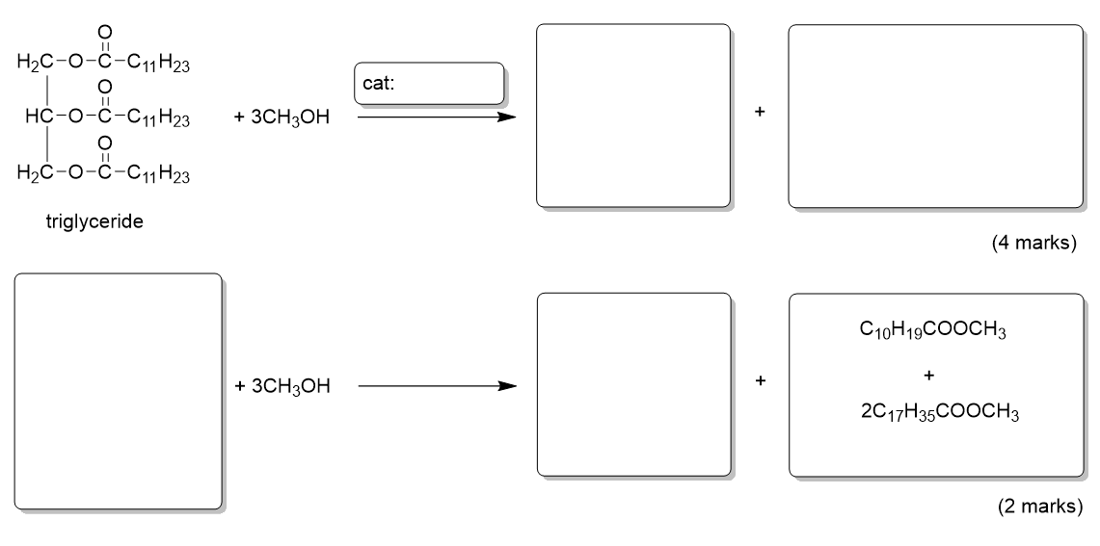
1. Complete the equations below to show the formation of biodiesel.

2. Suggest a structure for the ester C₁₀H₁₉COOCH₃.
(1 mark)
3. Define the term carbon neutral and explain why biodiesel is sometimes considered to be carbon neutral and sometimes considered not to fit that definition.
(3 marks)

Synthetic schemes

Synthetic scheme 1
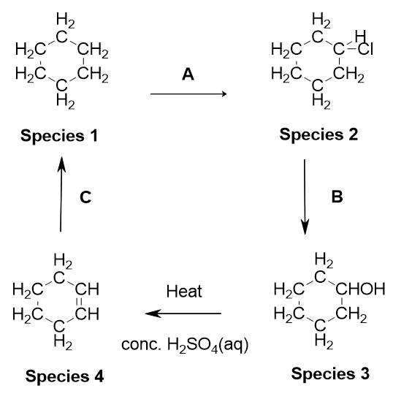
- Name species 1 to 4.
(4 marks)
- Indicate the reagents and conditions required for each of the reactions A to C
(3 marks)
- Name the mechanism by which reaction A proceeds
(1 mark)
- Species 3 contains the alcohol functional group. What class of alcohols does this species belong to?
(1 mark)
- How could the presence of the double bond in species 4 be confirmed?
(1 mark)

Synthetic scheme 2

- Fill in the lab book below to show the number of moles of each species.
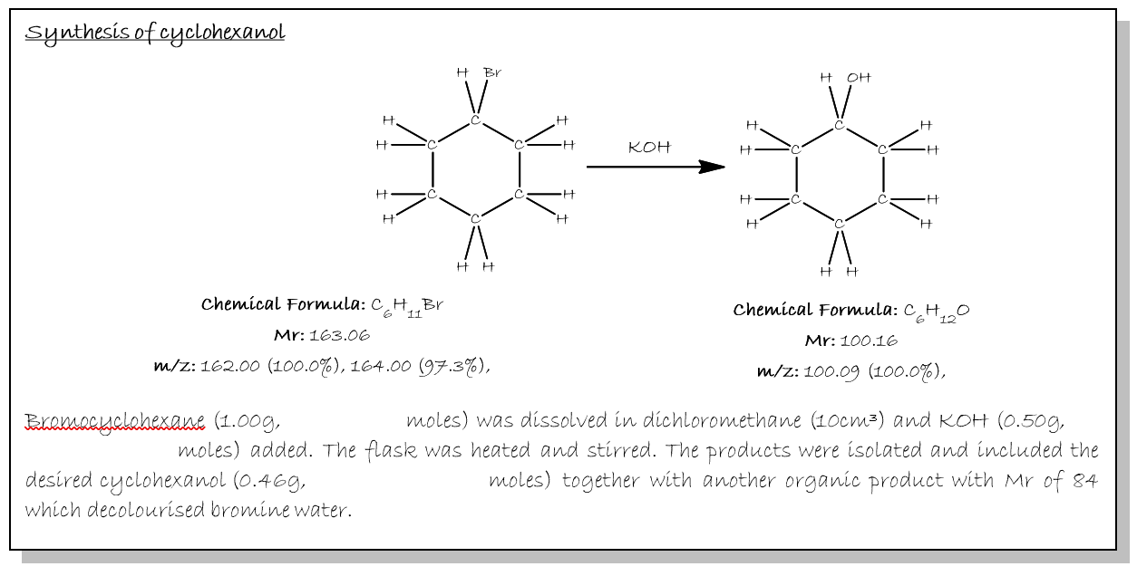
(3 marks)
2. Calculate the percentage yield of cyclohexanol
(1 mark)
3. Name and outline the mechanism for the conversion of bromocyclohexane to cyclohexanol
(3 marks)
4. Suggest a way the student could confirm the presence of the OH group in the cyclohexanol product
(1 mark)
5. Identify the other organic product and name the mechanism by which it was formed.
(2 marks)

Synthetic scheme 3
Consider the following reaction scheme.

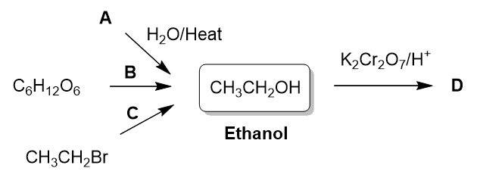

1. Suggest the identity of reactant A
(1 mark)
2. Give the name of process B and state the reagents and conditions
(2 marks)
3. State the reagents and conditions for reaction C
(1 mark)
4. State the class of alcohols that ethanol belongs to
(1 mark)
5. Suggest the identity of product D
(1 mark)
6. Describe the colour change seen when ethanol is converted to product D
(1 mark)
7. Name the class of reactions to which the conversion of ethanol into D belongs
(1 mark)
8. Of the three synthetic routes to ethanol, state which you feel is the most sustainable
and explain your answer
(2 marks)

Organic Chemistry – Answers

Functional groups
- Carboxylic acid
- Methyl
- Alcohol
- Alkene
- Aldehyde
- Ketone
- Halogen, or chloride
- (a) displayed formula should show all the bonds (look for all the C-H bonds on the methyl groups drawn out)
(b) C₁₀H₁₆
(c) C₅H₈

Nomenclature
- Prefixes – OH, -Br, CH₃, Suffixes C=C, RCOR, RCHO, RCOOH, -OH (½ mark each)
- 1-bromo-propan-2-ol (or numbers the other way around), 2-hydroxybut-2-ene (or but-2-en-2-ol), 2-methylpentan-2-ol
(2 marks each, one mark for getting the correct naming stems in there, the other for the correct order)

Formula
- The simplest whole number ratio of elements in a substance
- (a) General formula (b) (i) C_{n}H_{2n+2}, (ii) CH₂
- (a) C₆H₁₄O₂ (b) CH₃C(OH)₂CH(CH₃)CH₂CH₃ (c) All bonds should be drawn out, look for –O-H bonds drawn.
- (a) CH (b) C₆H₆
- C₆H₁₂

Isomerism
- 2,3-dimethylbut-2-ene
- –
- Hex-2-ene
- 3-methylpent-2-ene
- Cyclohexane
Question 2 C₆H₁₂
Question 3 Hex-3-ene CH₃CH₂CH=CHCH₂CH₃
Question 4 Isomers 3, 4 and 6

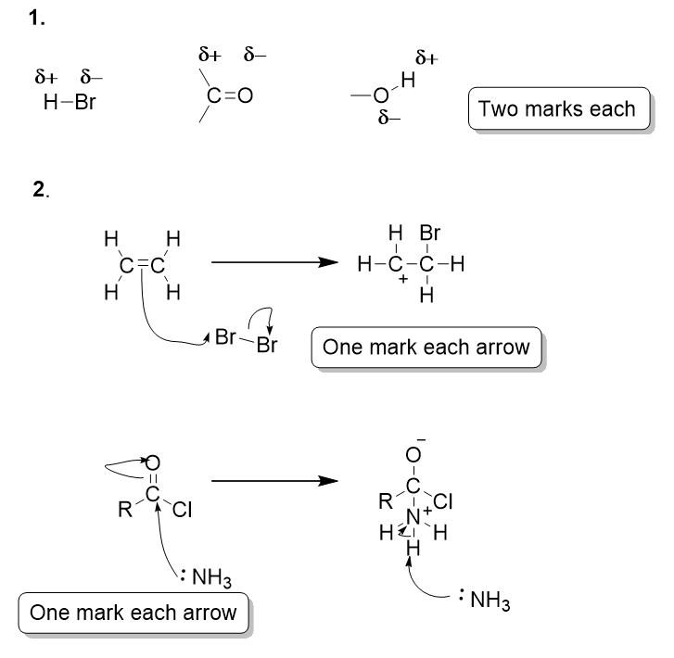

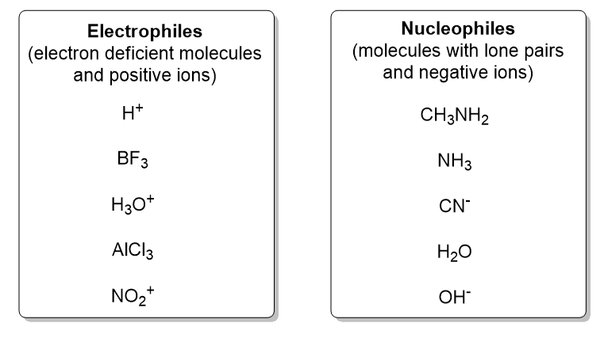
1. CH₄ and LPG in Gases (2)
Octane in petrol (1)
C₂₀-C₃₀ in lubricating oil (1)
Fuel for ships in residues (1)

2. T C T C C (5)

1. (a) C₈H₁₈ + 12.5O₂ → 8CO₂ + 9H₂O
(b) C₈H₁₈ + 8.5 O₂ → 8CO + 9H₂O
(c) Complete – CO₂ (or Water vapour) formed, greenhouse gas
Incomplete – CO formed, poisonous or water vapour formed, greenhouse gas

2. (a) Reaction of N₂ and O₂ from the air at high temperature/in the presence of a spark
(b) N₂ + O₂ → 2NO
(c) Acid rain

3. (a) 2NO₂ → N₂ + 2O₂ CO + 0.5O₂ → CO₂
(b) Platinum/Rhodium

1. CH₄ (1 mark)
Water, H₂O (1 mark)

2.
- EM radiation is emitted from the sun
- Earth re-emits infra-red radiation
- The C=O bonds in CO₂ absorb the IR
- Not all the IR escapes
- Heat energy from IR is trapped
- Increases global temperatures

3. C₈H₁₈ + 12.5O₂ → 8CO₂ + 9H₂O

4. Methane is produced by animals/decomposition of animal waste produces methane

1. Any 3 from
- Same functional group
- Same general formula
- Each member differs from the next by the addition of a CH2 unit
- Similar chemical properties
2. Fractional distillation
3. Longer chain length → more atoms (and therefore more electrons) → more VdW forces
4. (a)
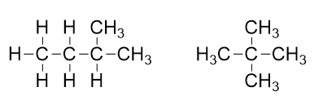
(b) Branched chain isomers have a lower bpt/straight chain alkanes have a higher bpt
(c) Straight chain alkanes have a higher surface contact (1 mark) therefore greater VdW forces (1 mark)

1. No C=C bonds
2. C_{n}H_{2n+2}
3. C₈H₁₈
4. (a)
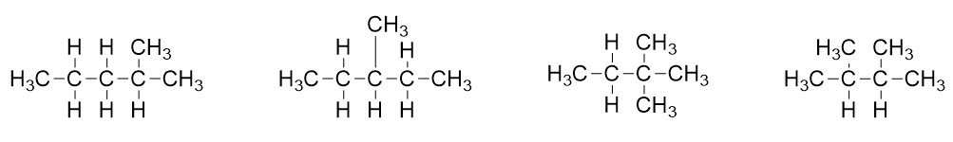
(b) C₆H₁₄ + 9.5O₂ → 6CO₂ + 7H₂O
(c) C₆H₁₄ + 6.5O₂ → 6CO + 7H₂O
CO is poisonous/water vapour is a greenhouse gas
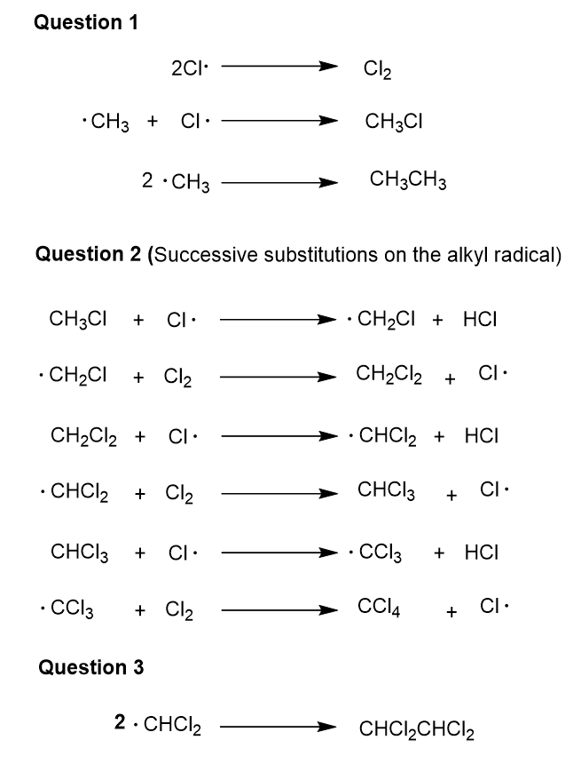
1. (a) O₃
2. 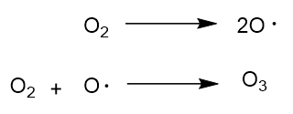
3. (c) UV light

2. Propellants in aerosols/dry cleaning solvents/coolants in fridges/manufacture of foam plastics/fire extinguishers

3.
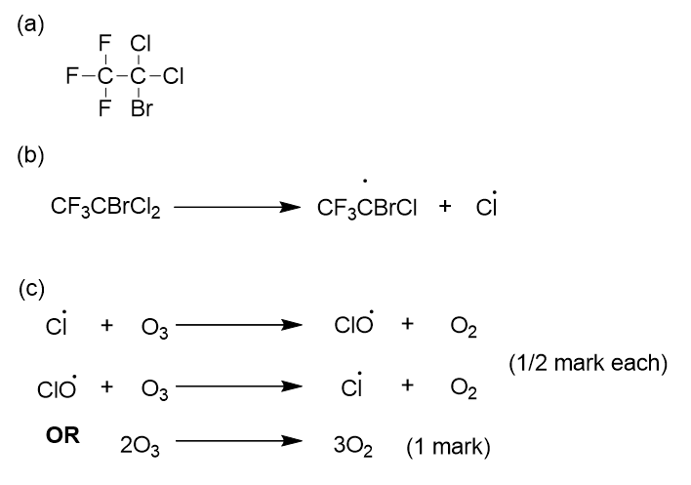
(d) Increased UV exposure/skin cancer
(e) No chlorine/No C-Cl bond

1. But-2-ene
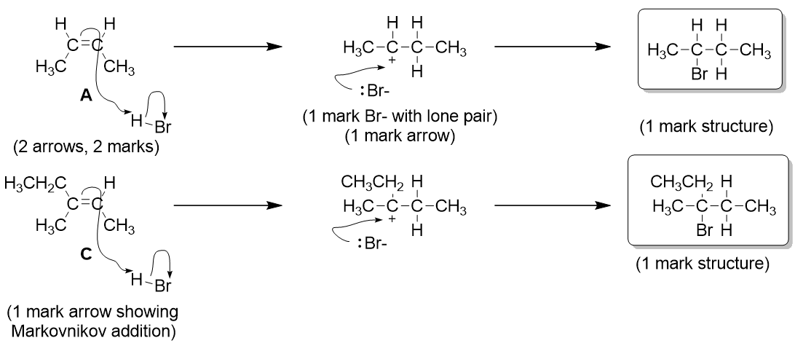
2.

3. Carbocation (1mark)
4. B = 2-bromo-butane, D = 3-bromo-3-methylpentane (½ mark each)
5. Stability of carbocation (1 mark)

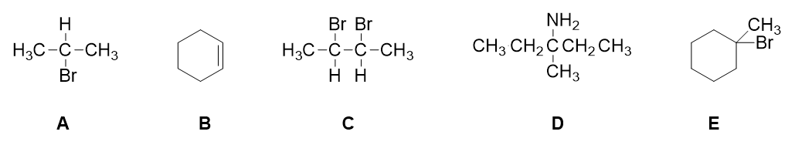

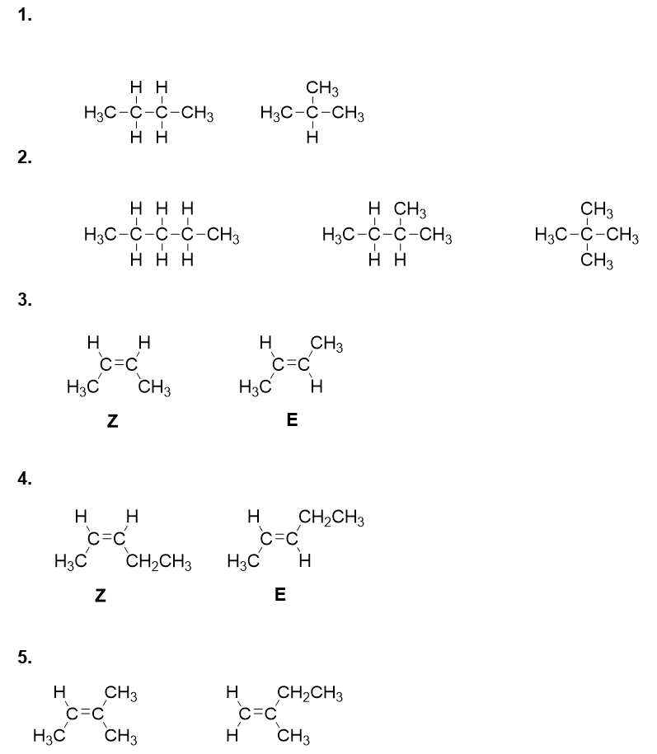

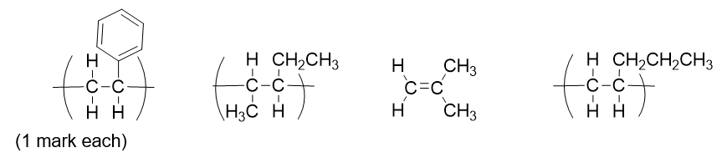

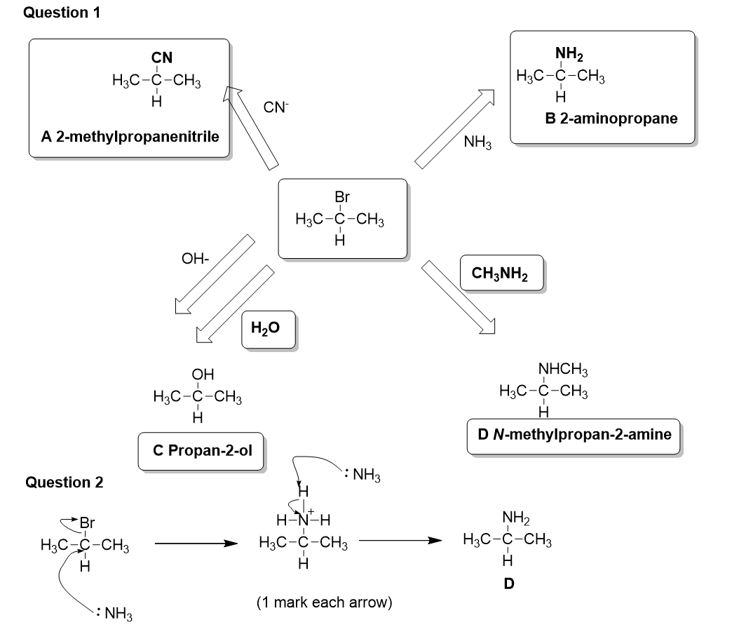
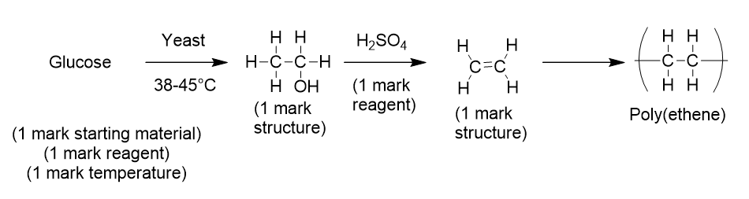

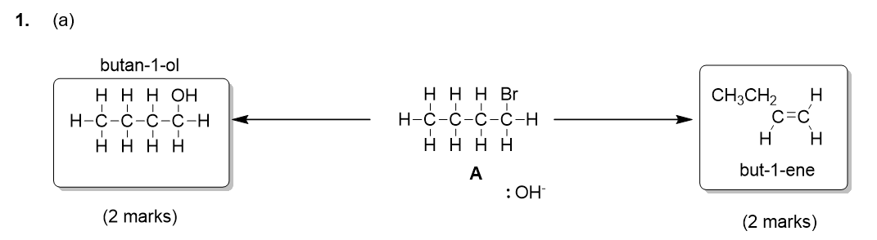
2. Substitution – the OH⁻ acts as a nucleophile
Elimination – the OH⁻ acts as a base
3. Substitution – aqueous NaOH
Elimination – ethanolic NaOH
4. H-Br, electrophilic addition

1. C + E
2. A + B
3. A, B, D, E, F, G

1.
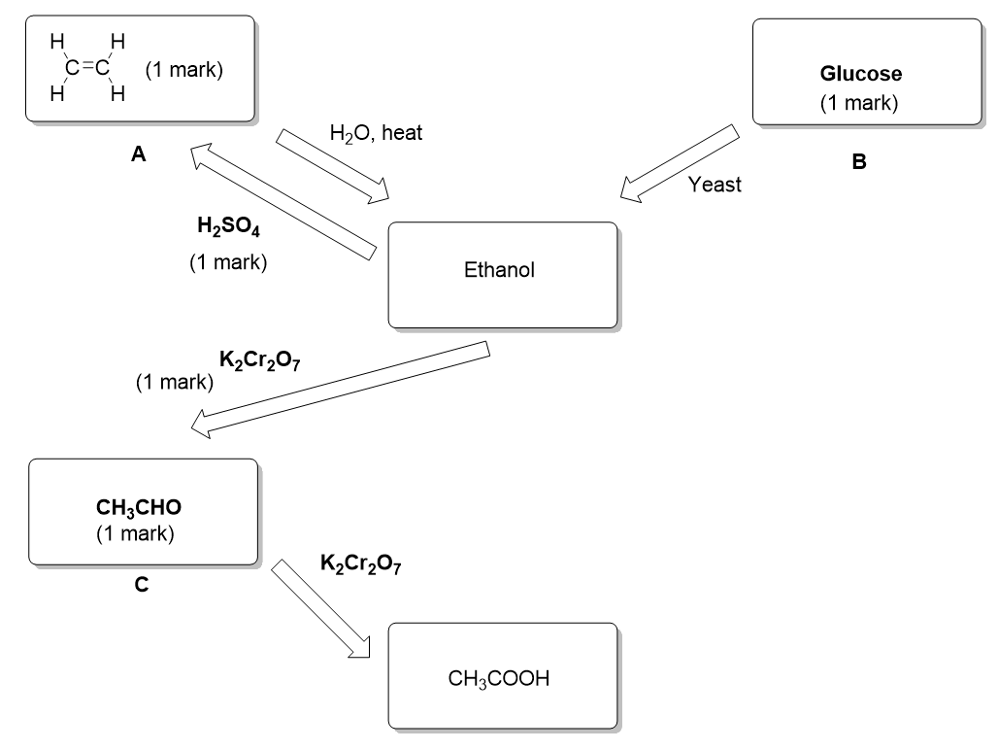
2. Fermentation (1 mark)
C₆H₁₂O₆ → 2C₂H₅OH + 2CO₂ (1 mark)
3. The source material is renewable
4. Ethanoic acid/the acid

1. C and F (0.5 marks each)
2.
- Tollens’ reagent
- Silver mirror formed (allow silver precipitate or black solid formed, NOT silver solid formed)
OR
- Fehling’s solution
- Brick red precipitate formed (from blue solution)
3. A, B, C, E and F (1 mark for getting both A and B, 1 mark for getting both C and E, 1 mark for F)
4. A, B and E (all 3 = 2 marks, any 1 = 1 mark)
5. CH₃CH₂CH₂OH + 2[O] CH₃CH₂COOH + H₂O (1 mark for presence of H₂O, 1 mark for balanced)

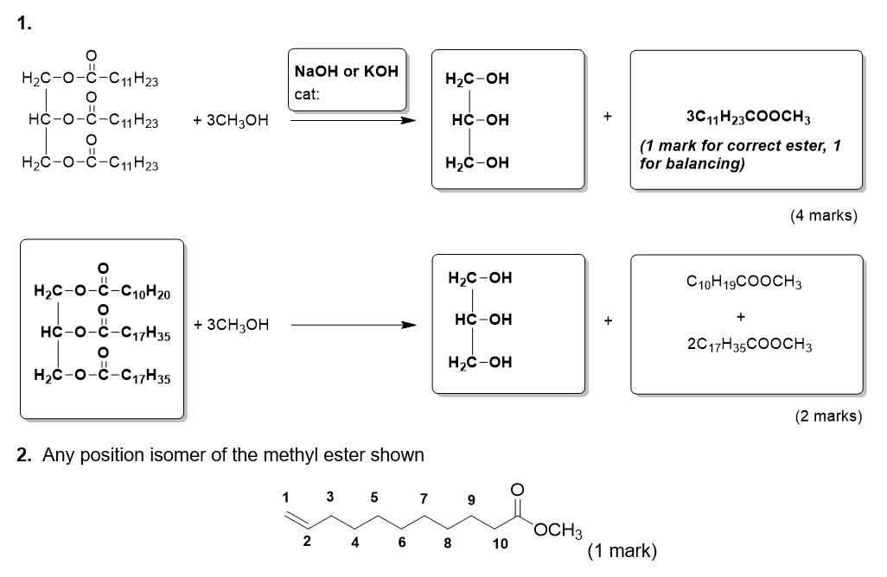
3.
- Carbon neutral = a process which has no net production of carbon dioxide
- Biodiesel could be considered carbon neutral because carbon dioxide is taken in by plants from which oils are extracted as they grow due to photosynthesis, which is then released when the fuel is burned. (0.5 mark for mention of absorption by plants, 0.5 mark for mention of release during combustion of fuel).
- Biodiesel may not be considered to be carbon neutral as associated activities such as transport will result in carbon dioxide emissions.

1. Species 1 = cyclohexane
(1 mark)
Species 2 = chlorocylclohexane
(1 mark)
Species 3 = cyclohexanol
(1 mark)
Species 4 = cyclohexene
(1 mark)

2. A Cl₂ + UV light
(1 mark)
B aqueous sodium hydroxide
(1 mark)
C H₂(g)/Pt
(1 mark)

3. Free radical substitution
(1 mark)
4. secondary
(1 mark)
5. Bromine water
(1 mark)

1. 1 mark for correct calculation method mass/Mr
Bromocyclohexane = 1.00/163.03 = 6.13 x 10⁻³ moles
(1 mark)
Cyclohexanol = 0.46/100.16 = 4.59 x 10⁻³ moles
(1 mark)
2. 74.9%
(1 mark)
3. Nucleophilic substitution
(1 mark)
Arrow from OH⁻ with lone pair shown to the C of the C-Br bond
(1 mark)
Arrow from the C-Br bond to the Br atom
(1 mark)
4. Infrared spectroscopy
(1 mark)
5. cyclohexene
(1 mark)
Elimination
(1 mark)

1. A is ethane (CH₂=CH₂)
(1 mark)
2. Fermentation
(1 mark)
Yeast (or zymase)
(1 mark)
Any one from
(1 mark)
Temperature between 38-45°C
Anaeobic conditions
3. Aqueous NaOH
(1 mark)
4. Primary alcohol
(1 mark)
5. Ethanoic acid
(1 mark)
6. Orange to green
(1 mark)
7. Oxidation
(1 mark)
8. Any method could be argued here provided that the explanation is linked to a suitable reason such as
  - Sustainability of feedstocks
  - Atom economy
  - Energy needs
  - Side reactions/waste
(1 mark for method with appropriate explanation)

