Fractional distillation and hydrocarbons:
teacher guidance
This resource forms part of the Review my learning series from the Royal Society of Chemistry. The worksheets assess learner’s understanding of content from the common 11–14 and 14–16 curriculums. They can be used to identify knowledge gaps and misconceptions once that part of the curriculum has been taught.
The Fractional distillation and hydrocarbons worksheets cover the following topics:
- fractional distillation of crude oil
- chain length, intermolecular forces and boiling points of hydrocarbons
- properties of the fractions
- hydrocarbons and alkanes
- hydrocarbons as fuels
- complete and incomplete combustion.
Scaffolding
Level 1 (*) is a scaffolded worksheet which supports learners in a variety of ways, such as selecting words from a word bank, providing answer options to choose from or completed examples. Level 2 (**) is a partially scaffolded worksheet with a reduced level of support, such as partially completed sentences or a wider range of answer options to select from. Level 3 (***) is an unscaffolded worksheet in which most of the tasks involve answering questions with a minimum of prompts.
Metacognition
The ‘What do I understand?’ page is common to all levels of worksheet and can be used both to identify areas needing whole class attention and as an indicator for learners to help guide their revision.
Below you will find model answers for each level and guidance on learners’ misconceptions. Learners can use the model answers to self- or peer assess.
When to use
The worksheets can be used in a variety of ways:
- To assess learners’ knowledge at the beginning or end of a period of teaching. Match the level of the worksheet to the support needs of the learners.
- To assess knowledge during a period of teaching once learners have completed the relevant topic.

- As part of revision.
- As a refresher exercise for teachers or non-subject specialists.
There is also scope to increase the level of worksheets used as learners progress through their curriculum.
Further support
For more resources to support teaching of this topic and address any misconceptions identified, go to rsc.li/3ToR3RM.

Answers

Fractional distillation and hydrocarbons: knowledge check
- (Level 1, 2 and 3)
liquified petroleum gas

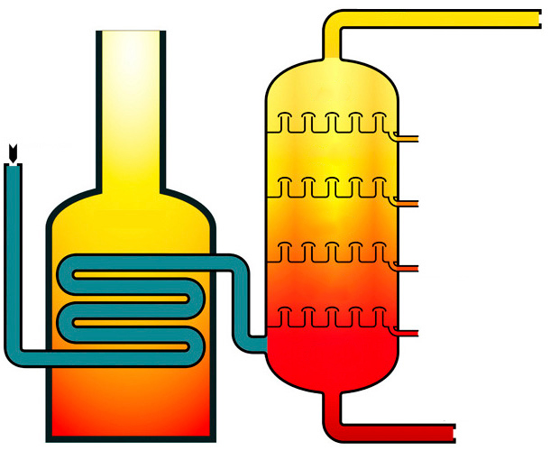
hot
cool
petrol
kerosene
diesel
heavy fuel oil
bitumen
gas
furnace
crude oil

Guidance: Misunderstandings include:
- Confusing the order of the fractions. Creating a mnemonic may help with this.
- Finding alternative names for the fractions in other sources – for example, gasoline for petrol and refinery gases for LPG.

- (Level 1)
Crude oil contains … | D
Fractional distillation is used to … | C
During fractional distillation, the hydrocarbon fractions … | A
The hydrocarbons are separated according to … | E
The fractionating column is … | B
(Level 2)
Crude oil contains … | H
Fractional distillation is used to … | D
During fractional distillation, the hydrocarbon fractions … | A
The hydrocarbons are separated according to … | F
The fractionating column is … | E
(Level 3)
Learners may provide alternative answers, but they reflect the following:
- Crude oil contains a mixture of hydrocarbons.
- Fractional distillation is used to separate the hydrocarbon fractions from crude oil.
- During fractional distillation, the hydrocarbon fractions evaporate and then condense.
- The hydrocarbons are separated according to their different boiling points/chain lengths.
- The fractionating column is hotter at the bottom.

Guidance: Misconceptions include:
- thinking fractional distillation involves breaking covalent bonds
- not using terms to describe changes of state correctly
- not remembering the correct temperature gradient inside the fractionating column.
- (Level 1, 2 and 3)

fractions; hydrogen; carbon; C_{n}H_{2n+2}; two; C₂H₆

(For Levels 2 and 3, hydrogen and carbon may be given in either order.)

Guidance: Misconceptions include:
- confusing hydrocarbons with carbohydrates
- thinking that a fraction only contains one type of compound
- not substituting in a general formula correctly
- confusing alkanes with alkenes.
- (Level 1, 2 and 3)

intermolecular forces; condense; liquified petroleum gas; stronger; higher

Guidance: One misconception is confusing weak intermolecular forces with the much stronger covalent and ionic bonds. Although larger alkane molecules have stronger intermolecular forces, these are still very weak compared to covalent and ionic bonds.

Fractional distillation and hydrocarbons: test myself
- (Level 1)
C₅H₁₂
(Level 2 and 3)
C₂H₄ and C₅H₁₂

Guidance: A common misconception is not understanding that a hydrocarbon contains hydrogen and carbon only.
- (Level 1 and 2)
C₇₀H₁₄₂
(Level 3)

butane

Guidance: To answer this correctly, learners need to understand that alkanes with longer carbon chains have higher boiling points.

For Level 3, learners need to remember that butane is the alkane with four carbons compared to methane with one, ethane with two and propane with three.
- (Level 1)

easy to ignite
(Level 2 and 3)

Any two properties from: low boiling points; low viscosity; easy to ignite.

Guidance: See guidance for question 2.2. Viscosity will be a new term for some learners.

- (Level 1)

carbon and water
(Level 2 and 3)
water and carbon or carbon monoxide

Guidance: One misconception is not understanding the difference between complete and incomplete combustion. Learners may give either carbon or carbon monoxide as the second product.
- (Level 1)

oxygen
(Level 2)
hydrocarbon + oxygen → carbon dioxide + water
(Level 3)
hydrocarbon + oxygen → carbon dioxide + water

Guidance: A common misconception is not understanding the nature of a general equation. General equations need to be able to be applied to all similar reactions. See also guidance for question 2.4.
- (Level 1)
C₃H₈(g) + 5O₂(g) $→$ 3CO₂(g) + 4H₂O(l)
(Level 2)
C₃H₈(g) + 5O₂(g) $→$ 3CO₂(g) + 4H₂O(l)
(Level 3)
C₃H₈(g) + 5O₂(g) $→$ 3CO₂(g) + 4H₂O(l)

Guidance: Not balancing the equation correctly is a common error. Other misconceptions include adding subscripts in an attempt to balance the equation and, hence, changing the formulas.

Fractional distillation and hydrocarbons:
feeling confident?
- (Level 1)
Fraction | Temperature range over which the fraction was obtained /°C | Colour | Viscosity | Ease of ignition
1 | 20–100 | very pale yellow | low viscosity | very easy to ignite
2 | 100–150 | yellow | flows quite easily | easy to ignite
3 | 150–200 | light brown | doesn’t flow very easily | difficult to ignite
4 | 200–250 | brown | high viscosity | very difficult to ignite
(Level 2 and 3)
Fraction | Temperature range over which the fraction was obtained/°C | Colour | Viscosity | Ease of ignition
1 | 20–100 | very pale yellow | low viscosity | very easy to ignite
2 | 100–150 | yellow | flows quite easily | easy to ignite
3 | 150–200 | light brown | doesn’t flow very easily | difficult to ignite
4 | 200–250 | brown | high viscosity | very difficult to ignite

Guidance: Misconceptions result from not knowing the trends in the properties of alkanes, and misunderstanding the term ‘viscosity’.
- (Level 1, 2 and 3)
Alkane | Molecular formula | Displayed formula
methane | CH₄ | 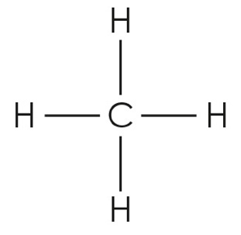
ethane | C₂H₆ | 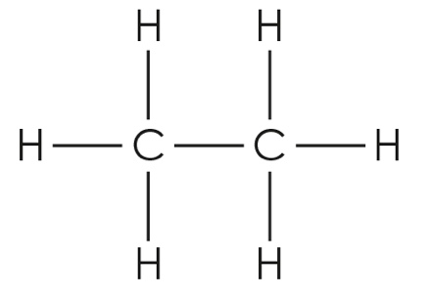
propane | C₃H₈ | 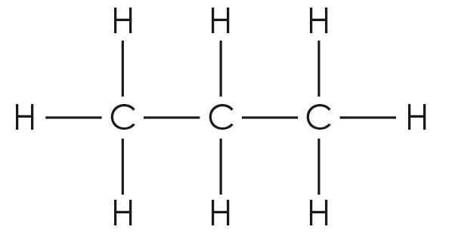
butane | C₄H₁₀ | 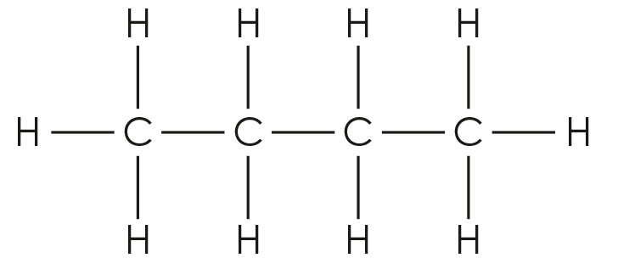

Guidance: Errors result from not:
- understanding different representations of a substance, molecular formulas and displayed formulas
- showing all the bonds in a displayed formula
- drawing the bonds so that they do not clearly show the atoms bonded together
- substituting correctly in a general formula.
Fractional distillation and hydrocarbons:
what do I understand?
Mini-topic | Assessed via:
I can describe the process of fractional distillation. | 1.1, 1.2, 1.3
I can explain why crude oil can be separated into fractions. | 1.4
I can identify a hydrocarbon from its molecular formula. | 1.3, 2.1
I can write the general and molecular formulas for alkanes. | 1.3
I can describe how the length of the hydrocarbon chain affects its boiling point. | 1.4, 2.2
I can compare the physical properties of the fractions. | 2.2, 2.3
I can compare complete and incomplete combustion. | 2.4, 2.5, 2.6
Feeling confident? topics | Assessed via:
I can predict the results of an experiment in which a crude oil alternative undergoes fractional distillation. | 3.1
I can give the molecular and displayed formulas of the first four alkanes. | 3.2

