Chromatography challenge

Learning objectives
- Plan a chromatography investigation to separate coloured components in a variety of samples, such as sweets.
- Identify whether each sample contains more than one component.
- Compare and contrast the components from each sample using R_{f} values.
- Understand how chromatography can be a powerful identification tool when coupled with other analytical techniques, eg spectrometry and spectroscopy.

Introduction

Many confectionery products contain a range of additives for a variety of purposes. These might be to help improve the consistency and texture of the product, improve the flavour, prolong the shelf-life or improve its appearance by adding dyes.

Chromatography is a powerful technique used by chemists to separate and identify components of a mixture. Analysts can also use the technique to estimate the relative abundances of components.

In this activity, you will plan and carry out a chromatography experiment to decide whether different sweets have added food dyes and, if they do, identify them. You will also compare the coloured additives in a range of sweets and decide whether, in some cases, they are the same.

The sweets you may like to investigate are M&M’s®, Smarties®, red liquorice and jellybeans. You will also need to decide whether you want to use paper or thin-layer chromatography (TLC). Discuss your options with your teacher.

Planning your investigation

Before you begin your investigation, you may like to consider the following questions:
- What chromatography technique will you use: paper chromatography or TLC?
- Are you working independently or in a group? If you decide to work with others, how will you distribute tasks and collaborate?
- What equipment will you use? Are you going to do repeats? If so, you may need more apparatus.
- Have you considered a risk assessment? CLEAPSS has student safety sheets and SSERC may also have information that you can apply to your investigation.
- If you want to compare R_{f} values for each component, do you know how to do this? Do you have (or could you produce) standards for food colourings? (Maybe use common food dyes that contain paprika, turmeric and anthocyanins).

Once you have produced and analysed your chromatograms, can you draw any conclusions? For example, what coloured dyes do the different sweets contain? Are the dyes used in different sweets the same? Write up your findings as a scientific report (you may need to research what this might look like, or you may prefer to create your own style) or poster.

Research activity

Investigate how chemists might use other analytical techniques together with chromatography to help identify colour components? (Hint: mass spectrometry, nuclear magnetic resonance spectroscopy, infrared spectroscopy and ultraviolet spectroscopy.)

Remember that chemists can only use chromatography to identify components using R_{f} values if they have standardised these values. Chromatography can be useful in estimating relative abundances of components in a mixture. Scientists can also use a range of analytical techniques to identify the components once they’ve separated a mixture. They can use a combination of these techniques very effectively to identify reaction products, for example during the synthesis of medicines, and in forensic science.

Questions

- The diagram shows a TLC plate at the start of an experiment. Complete this chromatogram to show that the sample green ink has components b1 and y1. b2 is more soluble in the solvent (mobile phase) than b1, y1 is the most soluble component and has the strongest attraction for the mobile phase. Label the key features of the chromatogram.

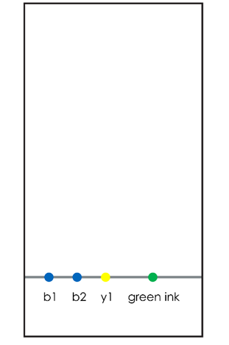

For some mixtures, you may not be able to separate the components using only one solvent. The following example shows how you can rotate a TLC plate after you complete the first run and perform a second run using a different solvent. Look carefully at the illustration below and then answer the questions.

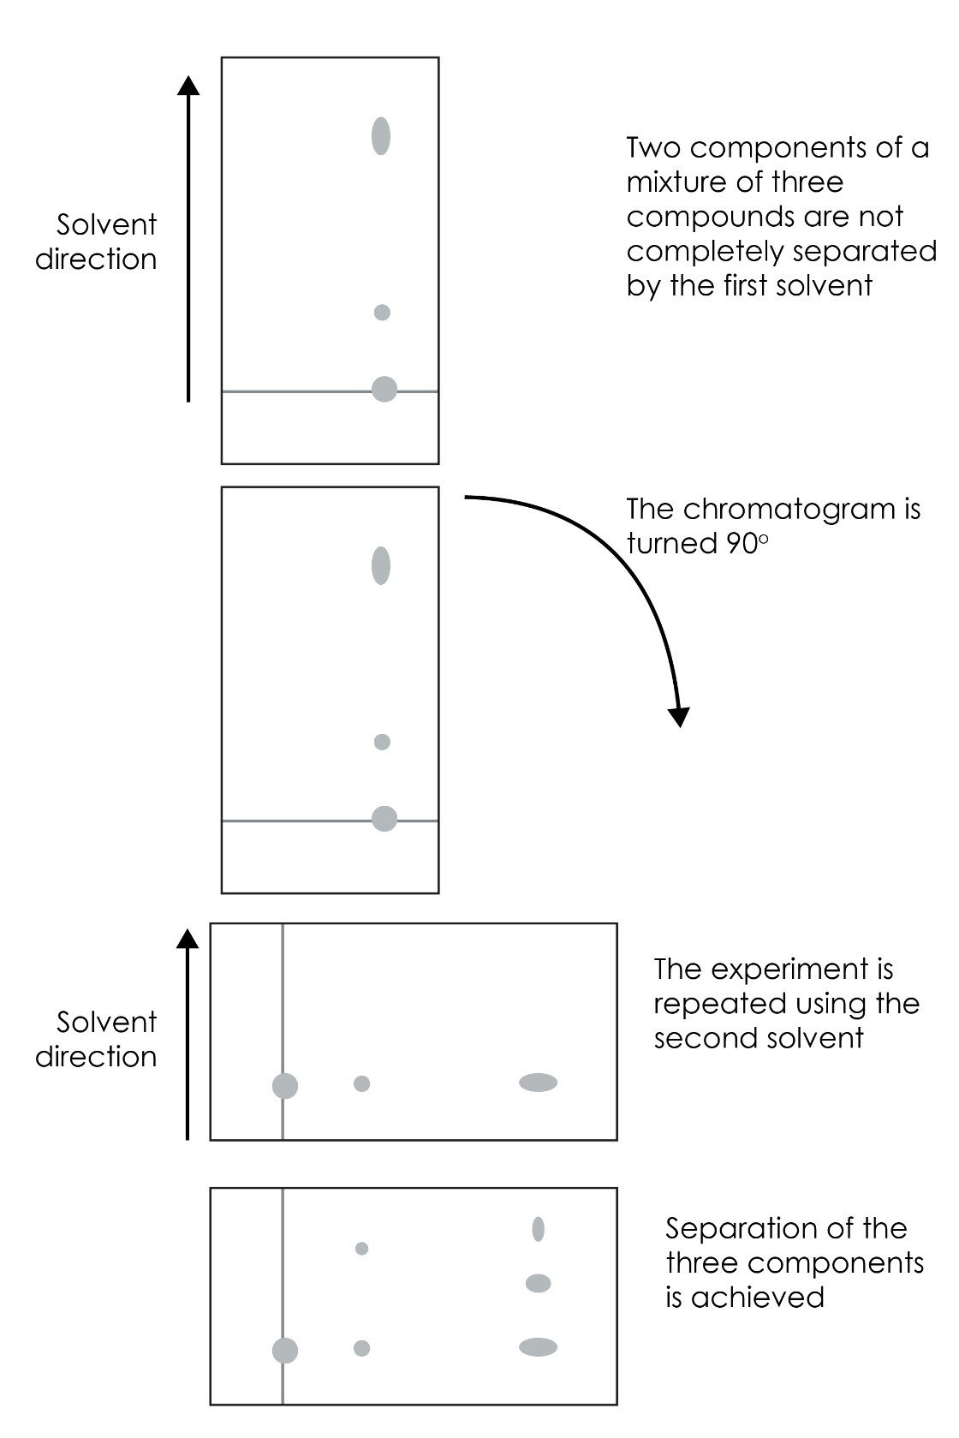

- How many components did the original mixture contain?
- Can you suggest a possible reason why it was necessary to use two different solvents using your understanding of intermolecular forces?
- In gas chromatography, we measure the retention times for components and compare them with known retention times and standard chromatograms for suspected components. Look carefully at the standard gas chromatogram of a sample of amino acids.

Standard chromatograms for amino acids

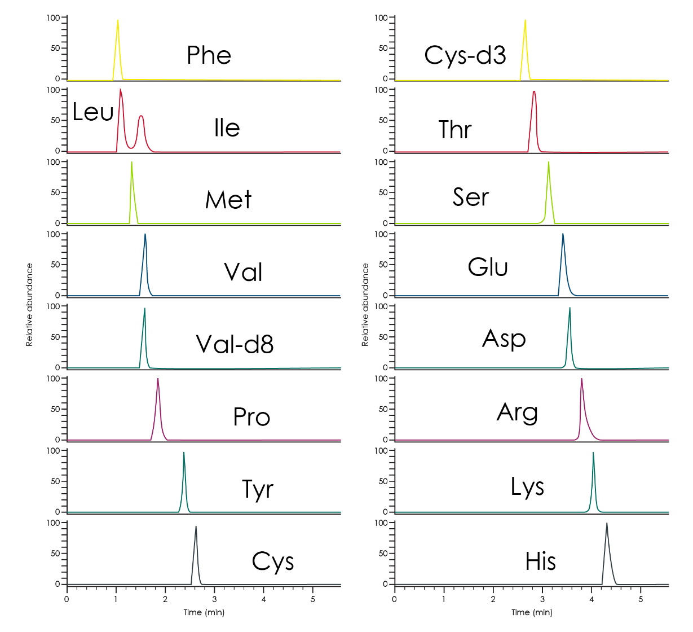

Reproduced from C-X Du and Z Huang, RSC Adv., 2019, 9, 36539 (doi.org/10.1039/c9ra05956c) under the terms of the CC BY 3.0 license https://creativecommons.org/licenses/by/3.0/

Chromatogram for a sample that contains amino acids
- This chromatogram contains three known amino acids, one unknown amino acid and one mobile phase. Identify the three known amino acids and justify the assignment of the unknown amino acid and possible solvent peaks. 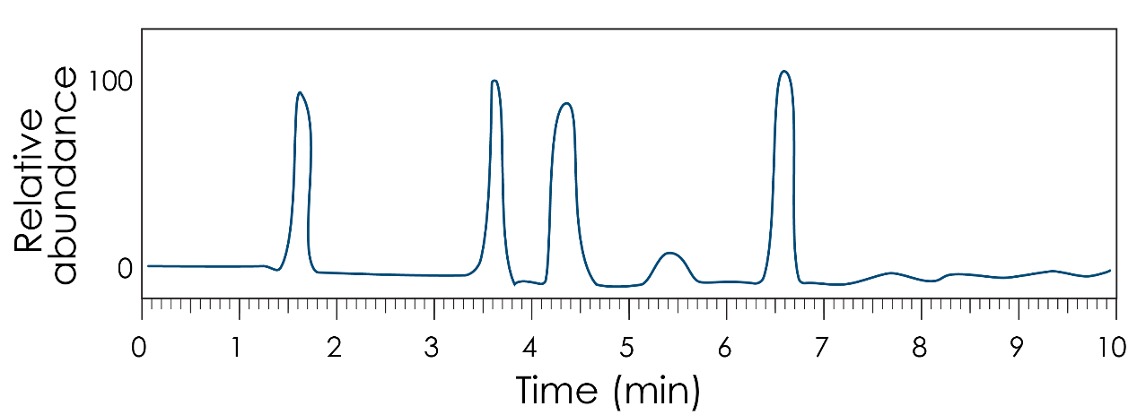
- What were the main errors you encountered in completing this activity and how might you minimise them?

- Chemists use high performance liquid chromatography to accurately analyse complex mixtures of compounds. Chromatogram A is a standard for the compounds theobromine and caffeine, both components in beverages. Chromatograms B and C are from samples of tea and drinking chocolate extracts respectively.
- Estimate the retention times for both theobromine and caffeine from the standard chromatogram A.
- Compare these times with those you obtain from chromatograms B and C.
- What might the widths of each peak represent? You may need to research this.
- What conclusions can you draw from this evidence?

Chromatogram A
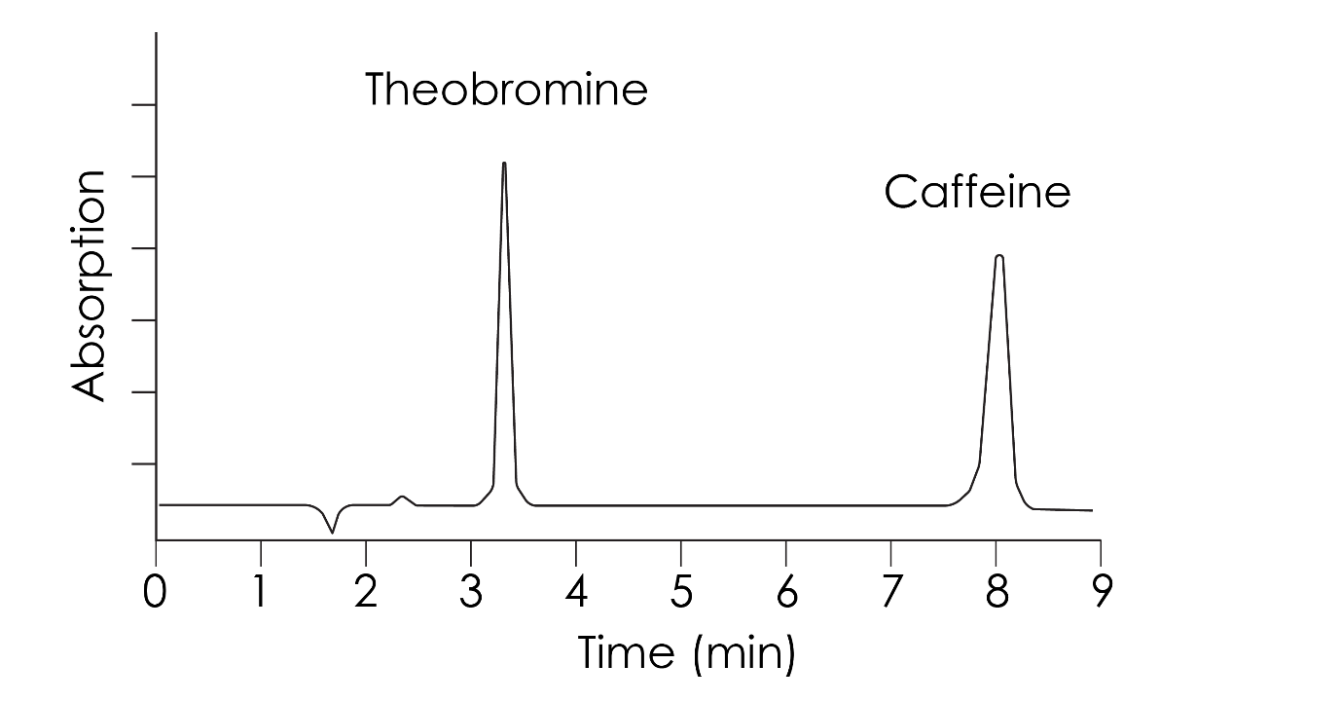

Chromatogram B – leaf tea extract 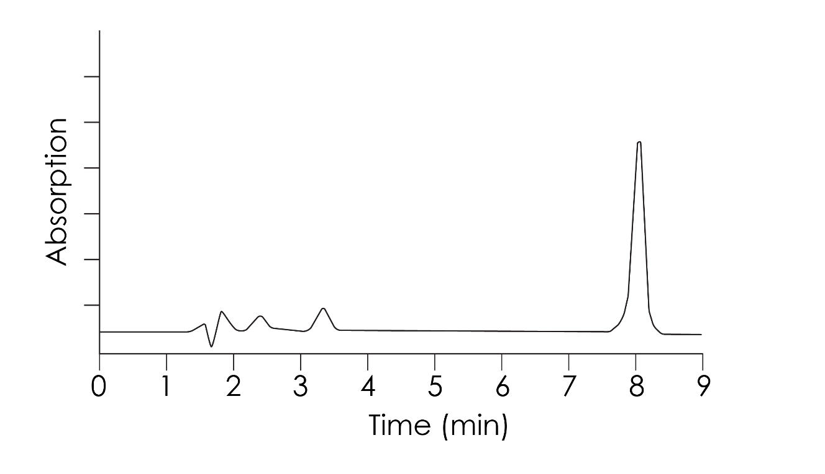

Chromatogram C – drinking chocolate extract
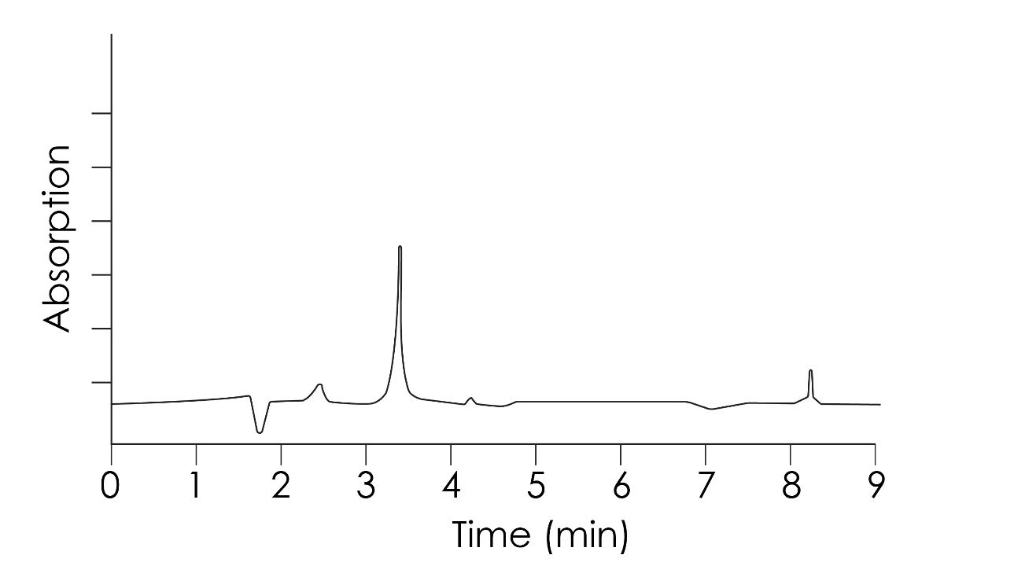

All images © Royal Society of Chemistry

