A hydrogen economy
Education in Chemistry
March 2019
rsc.li/2BBwGcR
To provide energy for a vehicle hydrogen can be used either in a fuel cell or an internal combustion engine. In this worksheet you will consider the chemistry behind both technologies.
1. a. Calculate the enthalpy change for the combustion of hydrogen:
H₂ + ½O₂ → H₂O
Bond | Bond enthalpy / kJ mol⁻¹
H−H | 436
O=O | 496
H−O | 463

b. i. The enthalpy of combustion of petrol is about 43.5 kJ g⁻¹.
If petrol has a density of 0.80 g cm⁻³, calculate the amount of energy released by the combustion of 1 dm³ of petrol.
ii. Calculate the volume of hydrogen that would need to undergo combustion to release the same amount of energy as 1 dm³ of petrol under standard conditions.
Molar volume of any gas under standard conditions = 24 dm³
iii. Calculate the volume this amount of gas would occupy if stored at 700 bar of pressure (70000 kPa) and 298K.
Ideal gas constant, R = 8.31 J K⁻¹ mol⁻¹

2. An alternative to burning hydrogen as a fuel, is the hydrogen fuel cell. This uses hydrogen and oxygen as ‘fuels’ to produce electricity to drive an electric motor.
Hydrogen–oxygen fuel cells can operate in acidic or in alkaline conditions but commercial cells use porous platinum electrodes in contact with concentrated aqueous potassium hydroxide
Figure 1 shows a hydrogen/oxygen fuel cell operating in alkaline conditions.
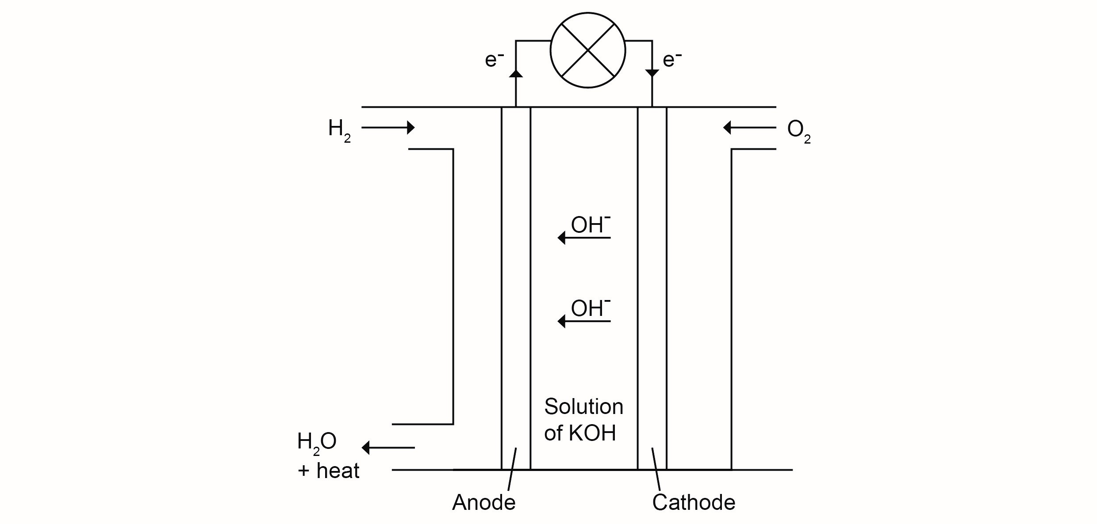
a. i. At the anode hydrogen combines with hydroxide ions to produce water and electrons.
Write a half equation for this reaction.
ii. At the cathode oxygen gains electrons and reacts with water to make hydroxide ions.
Write a half equation for this reaction.
iii. Combine the two half equations to determine the overall cell reaction.
b. Complete the standard cell representation for a hydrogen fuel cell operating under alkaline conditions.
Pt ⏐ H₂ ⏐ H₂O ⏐⏐
c. Explain why hydrogen fuel cells are more efficient than hydrogen combustion engines.

3. ‘Hydrogen fuel cells are better for the environment than petrol combustion engines.’
Evaluate this statement, providing pros and cons.

Answers

1. a.
Bonds broken |  | Bonds formed
1 × H−H | 1 × 436 | 2 × O−H | 2 × 463
½ × O=O | ½ × 496
TOTAL IN | 684 | TOTAL OUT | 926

Enthalpy change = 684 – 926 = – 242 kJ mol⁻¹
b. i. 1 g has a volume of 1.25 cm³ (1 g ÷ 0.80 g cm⁻³).
43.5 kJ g⁻¹ = 43.5 kJ per 1.25 cm³
1000 cm³ will therefore release $\frac{43.5 kJ}{1.25 {cm}^{3}} ×1000 {cm}^{3}$ = 34800 kJ
ii. Amount in moles of hydrogen that must undergo combustion
= 34800 kJ ÷ 242 kJ mol⁻¹
= 143.8 mol
If 1 mole of a gas has a volume of 24 dm³ under standard conditions then volume of hydrogen needed;
= 143.8 mol × 24 dm³
= 3450 dm³ (to 3 sig fig)
iii. $V= \frac{nRT}{P}= \frac{143.8 mol × 8.31 J K^{-1}{mol}^{-1} × 298 K}{70000000 Pa}$ = 5.087 × 10⁻³ m³ = 5.09 dm³ (to 3 sig fig)

2. a. i. H₂ + 2OH⁻ → 2H₂O + 2e⁻
ii. O₂ + 2H₂O + 4e⁻ → 4OH⁻
iii. 2H₂ + O₂ → 2H₂O
b. Pt ⏐ H₂ ⏐ H₂O ⏐⏐ O₂ ⏐ OH⁻ ⏐ Pt
c. Most of the energy in a hydrogen fuel cell is given out as electricity. Very little heat is evolved. In an internal combustion a lot of energy is lost as heat.
3.
Pros | Cons
Water is the only by-product from the reaction. | CO₂ is released in the production of hydrogen for use in the fuel cell (either from the reaction of methane with steam, or in the production of electricity to produce hydrogen from water).
Fuel cells do not produce pollutants such as NO_{x}, CO, SO₂ or unburnt hydrocarbons. | Catalysts may be toxic metals.

